Intel

Registry keys editing

Ansly Azorie

Contents
Contents 2
Intel 3
Intel Graphics Software (Display Color Settings) 3
1. Themed colors 3
2. “Greenbrand” profile 4
3. Universal Colors 5
4. Super real 6
5. Ekta space profile settings 7
6. Old alright settings 8
1. Old settings 11
2. Old settings 13
3. Old settings 14
4. Old settings 15
Intel Registry Editor 3D settings: 16
Enabling “Quantum Wall” idea 16
Harder way (if it is even possible) to enable Quantum Wall 44

Intel

Intel Graphics Software (Display Color Settings)
When you are able to view “Quantum Wall” depends on the colors of the profile…

Themed colors
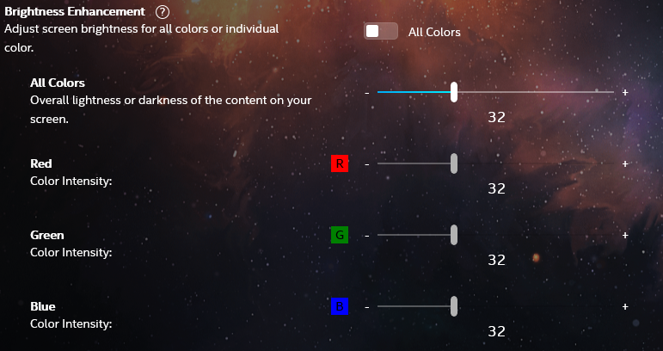
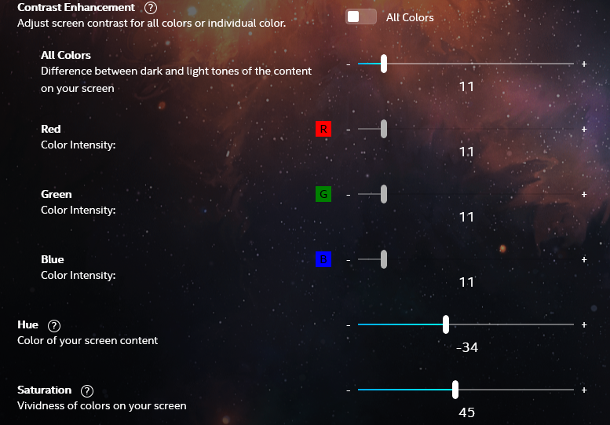

“Greenbrand” profile
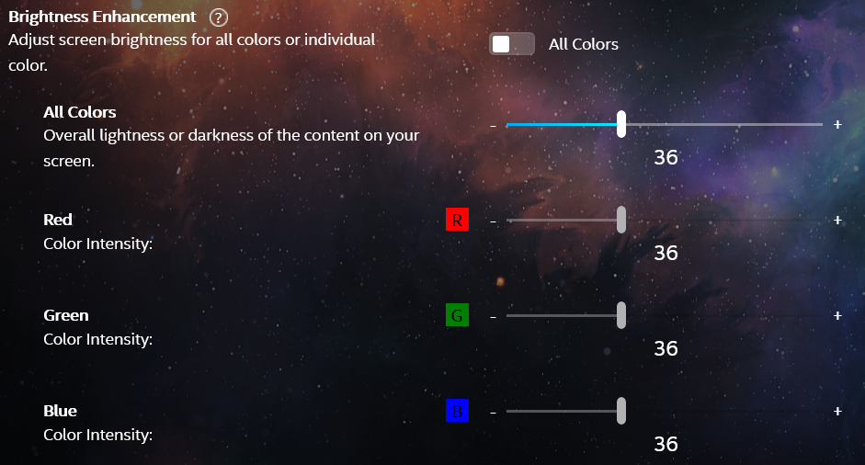
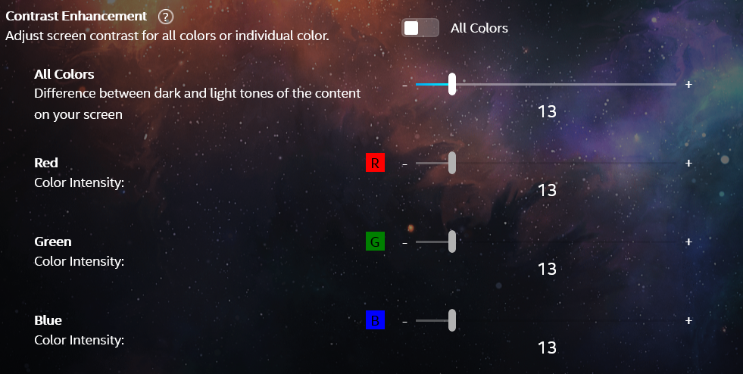
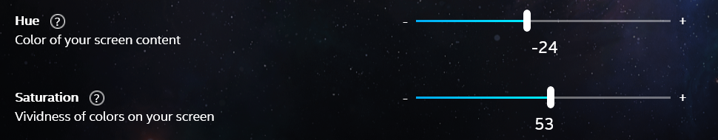

Universal Colors
- Universal Colors we use if we are serious
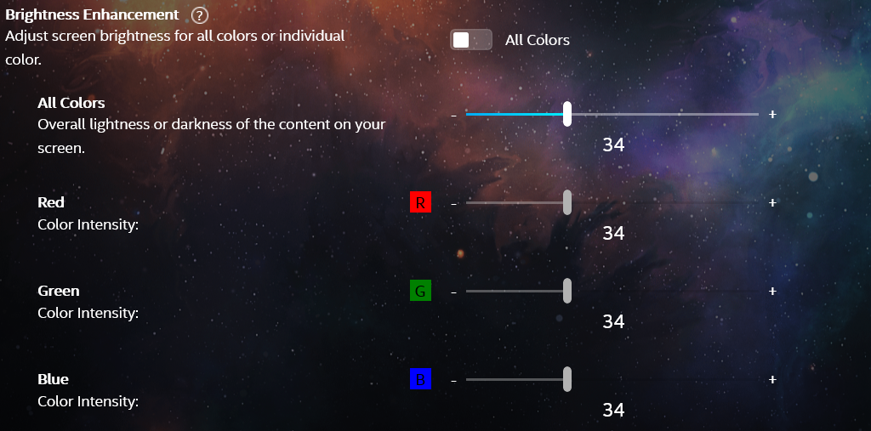
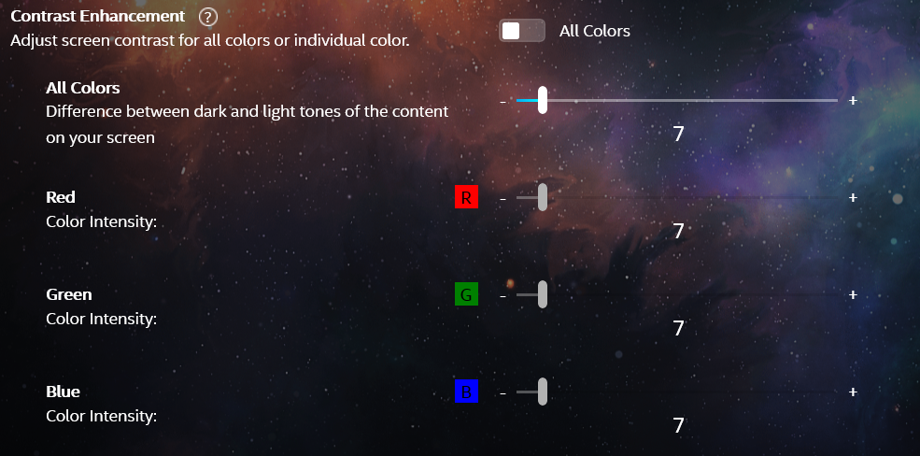
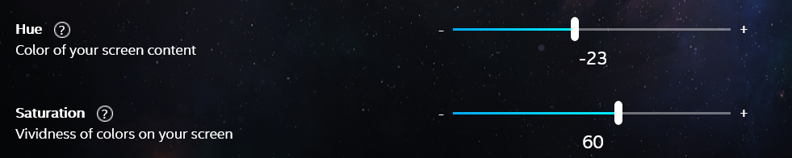

Super real
- Super real profile we use for the necessary things in life
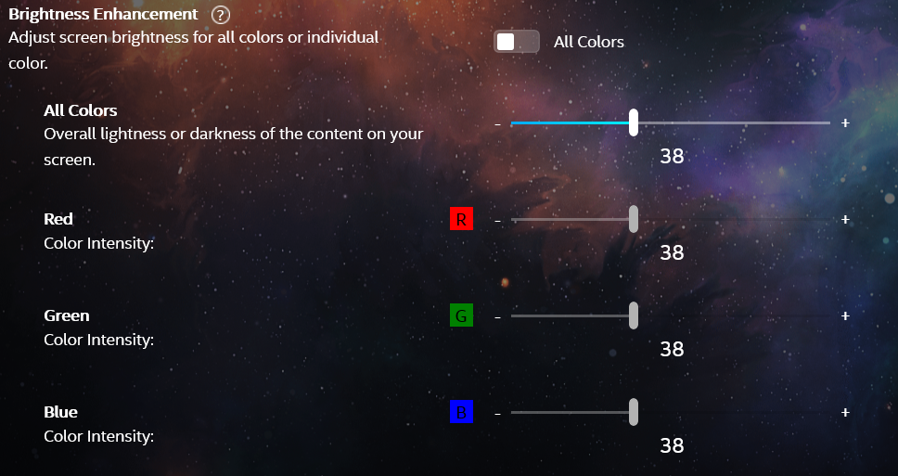
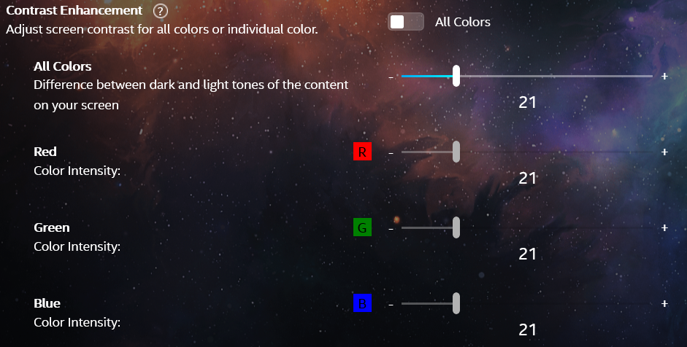
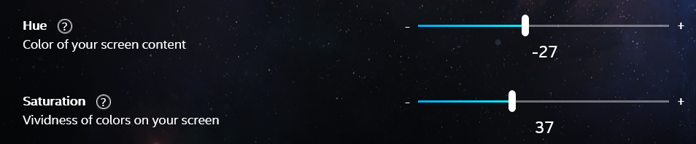

Ekta space profile settings
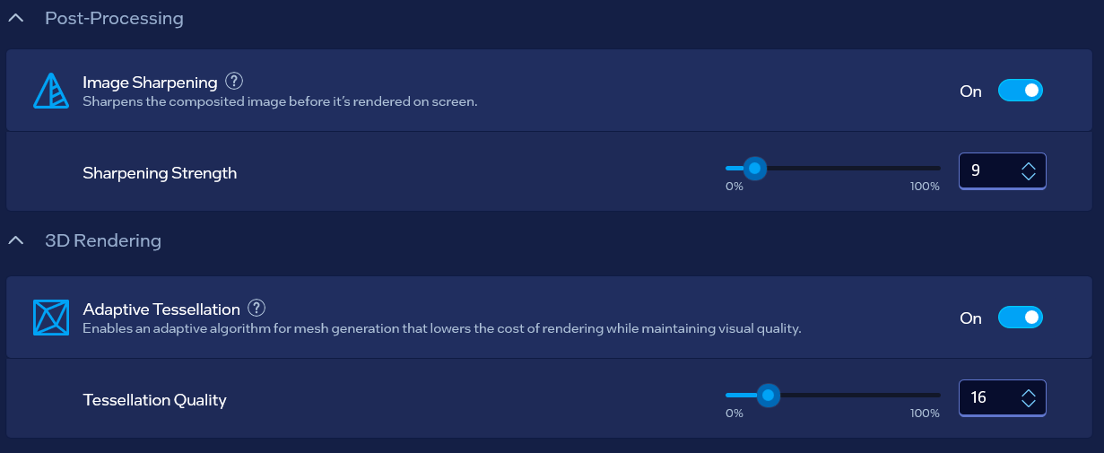
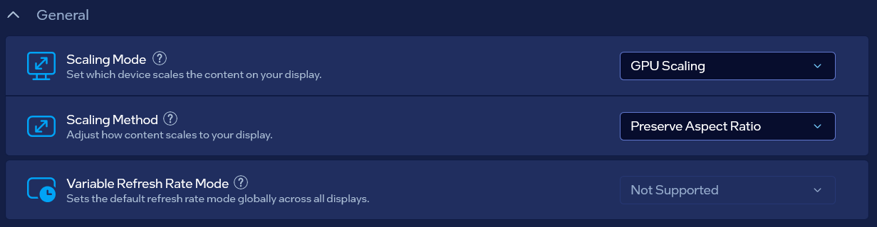
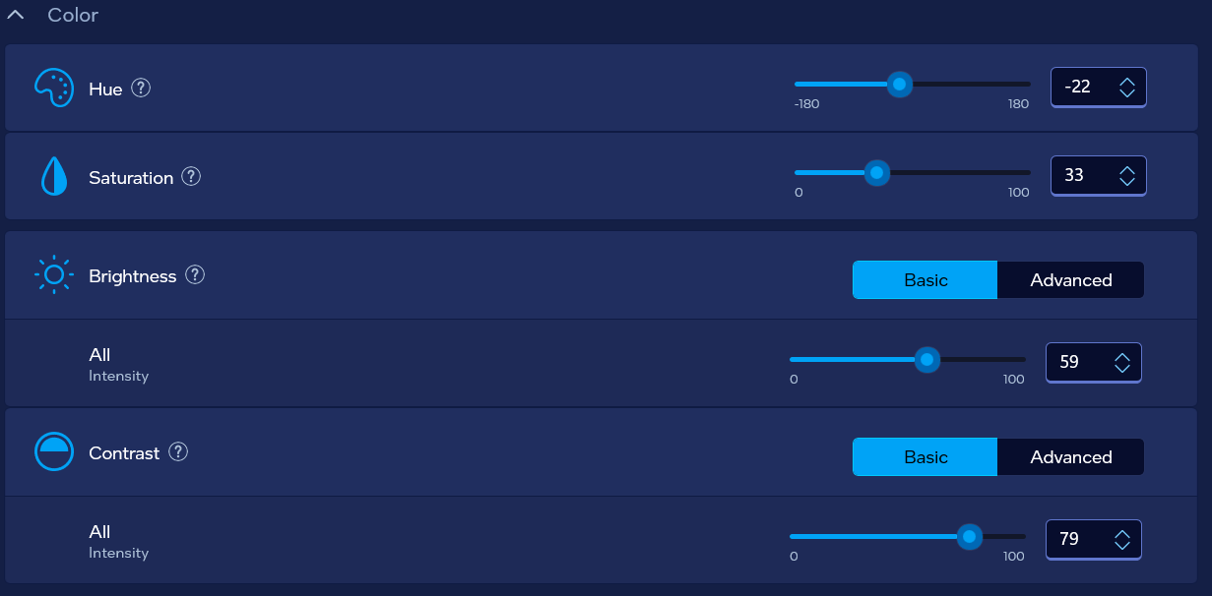

Old alright settings
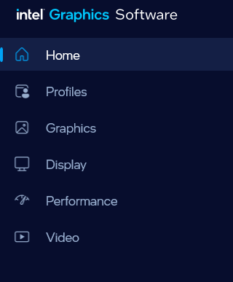
Pointing to a Good system from user side if it’s an addon that serves for something is fine so I shall choose “GPU Scaling” – “Centered”…
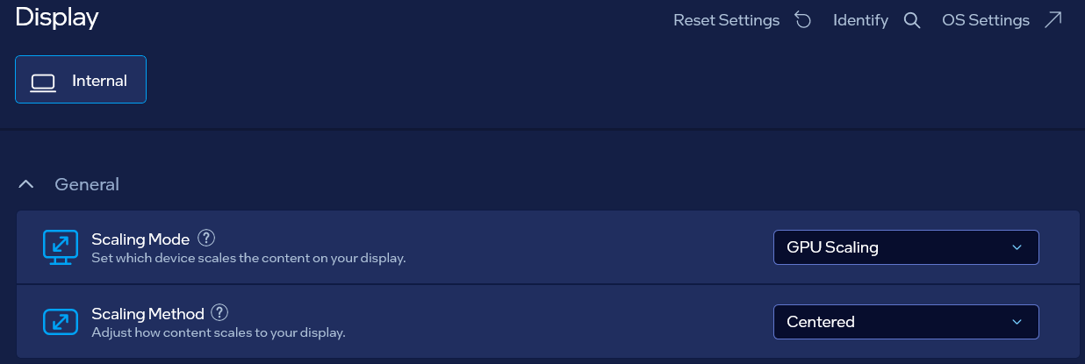
Or maybe:
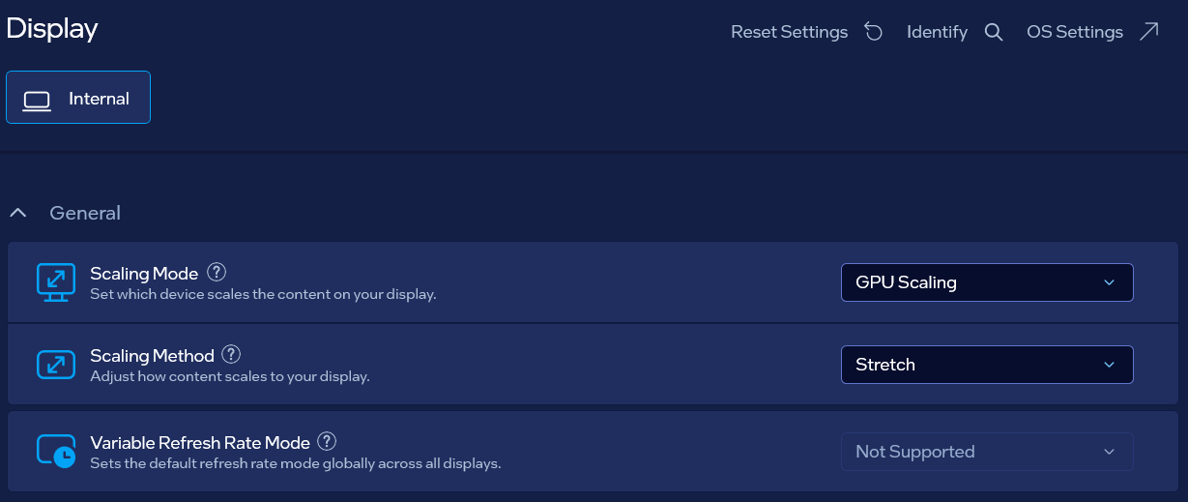
- GPU Scaling
  - “Stretch” mode: points to avoiding system from both sides
  - “Centered” mode: points to allowing system from user side (which is nice when user is approaching applications)
  - “Preserve Aspect Ratio”: I believe bannes anyhow possible system
- Retro Scaling
  - “Integer”: allows sufficient data created by user as a help utility for approach to computer
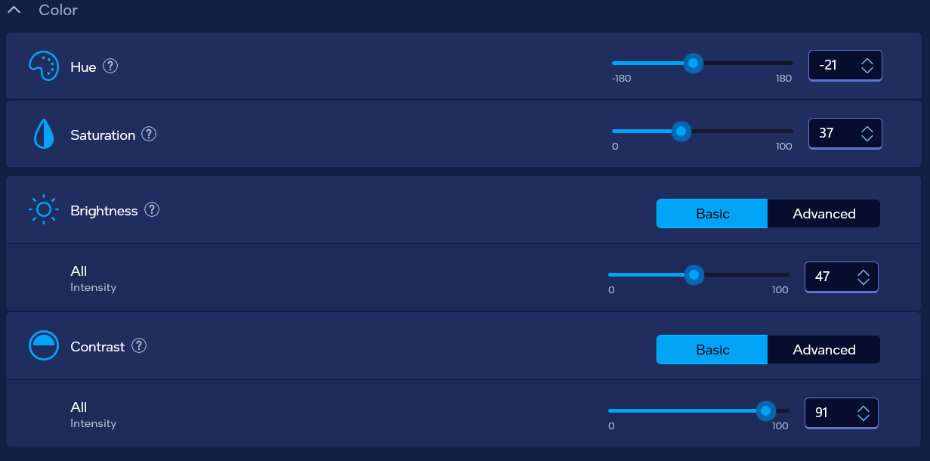
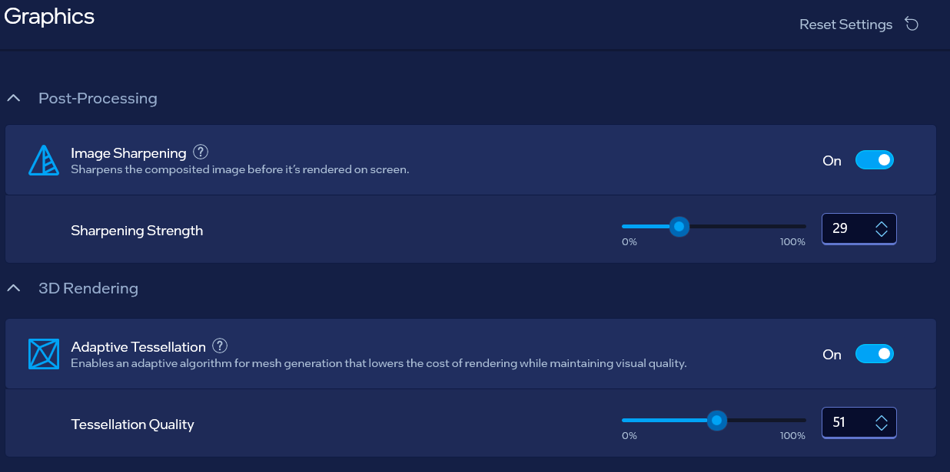

- Next option goes with the NVIDIA “Anisotropic filtering” turned to “Off”:
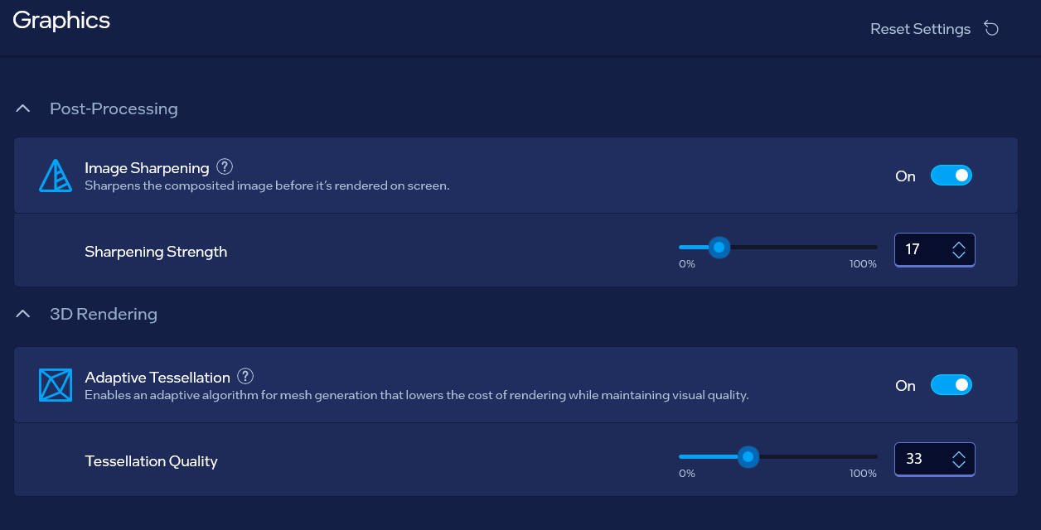
With these settings go “My Favorite settings for NVIDIA” because I have dual graphics cards

Old settings
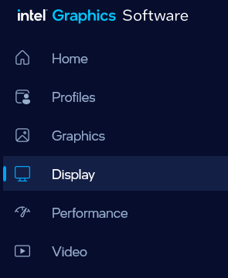
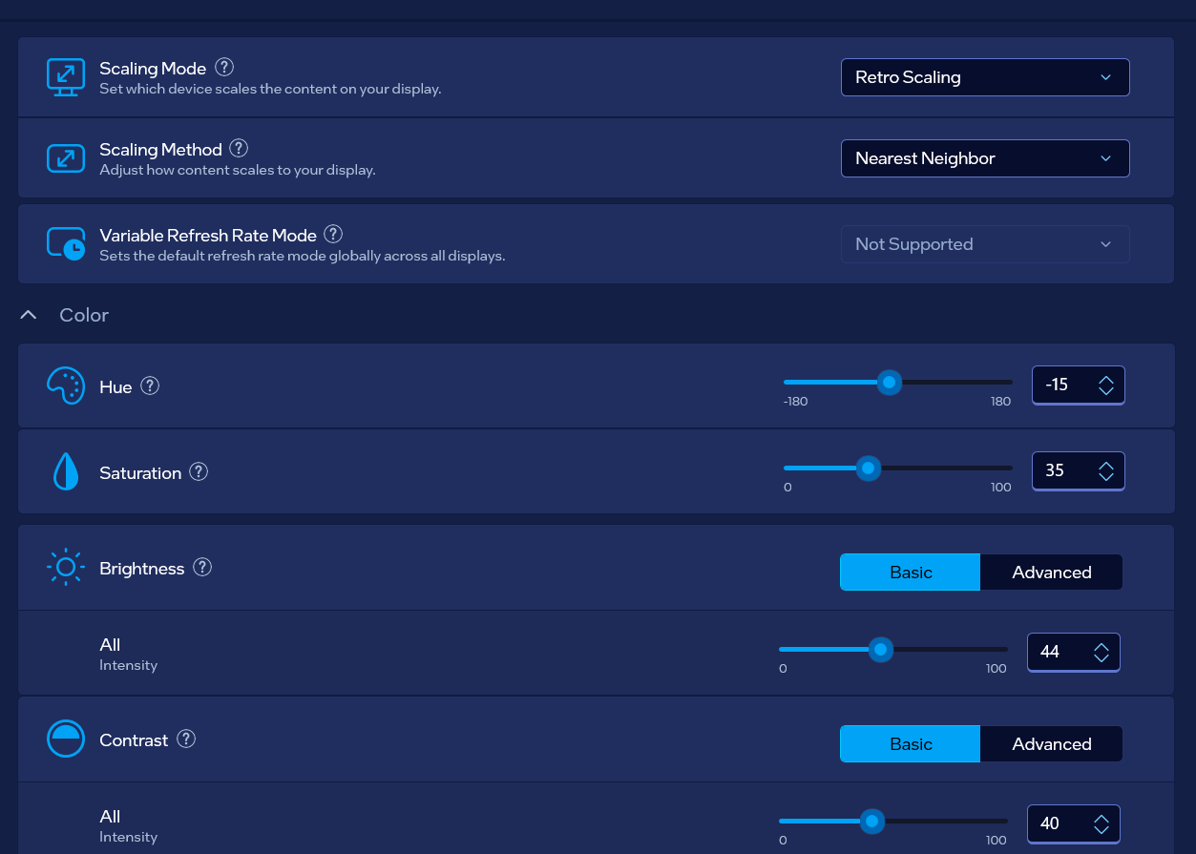

Graphics panel
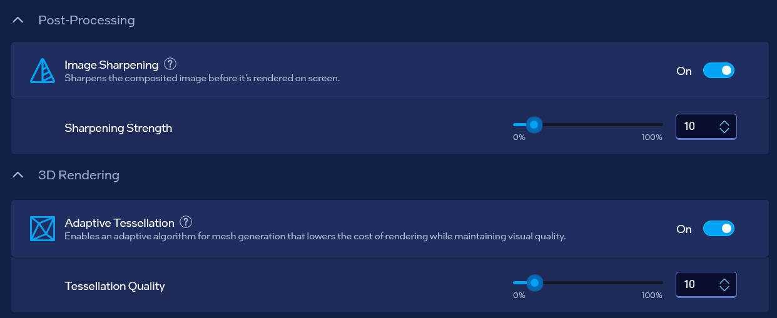

Old settings
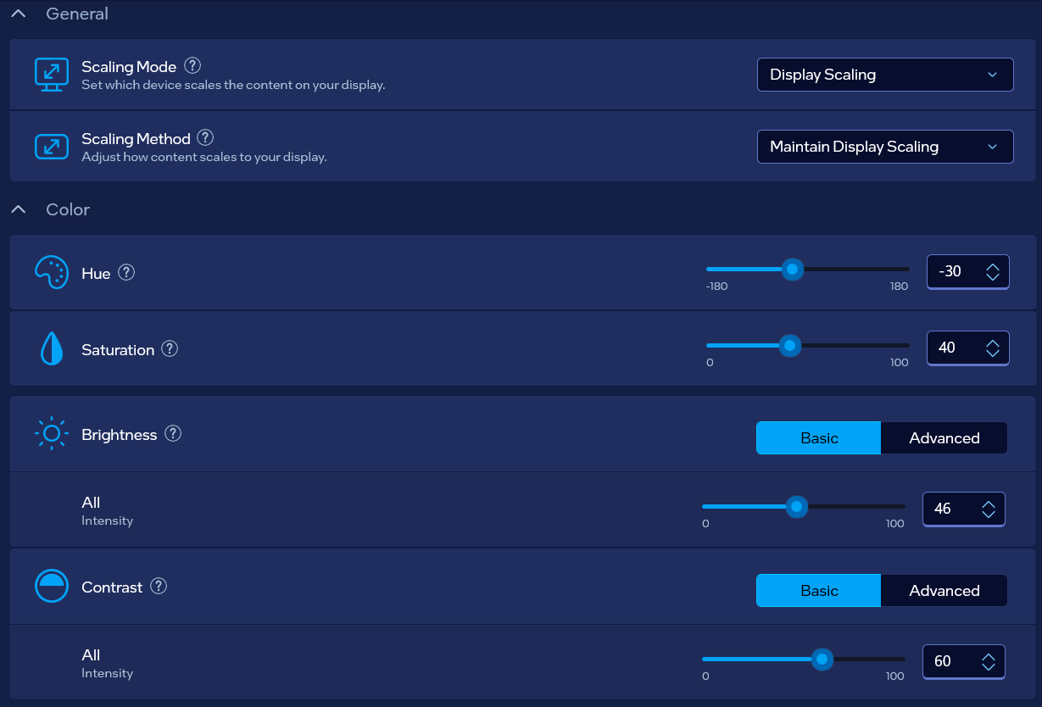
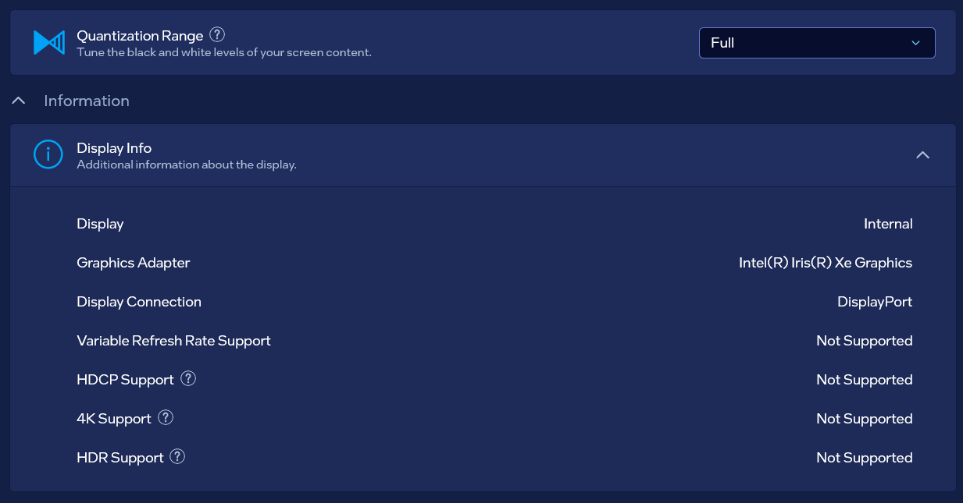

Old settings

Old settings
- Old model with allowed system from both sides
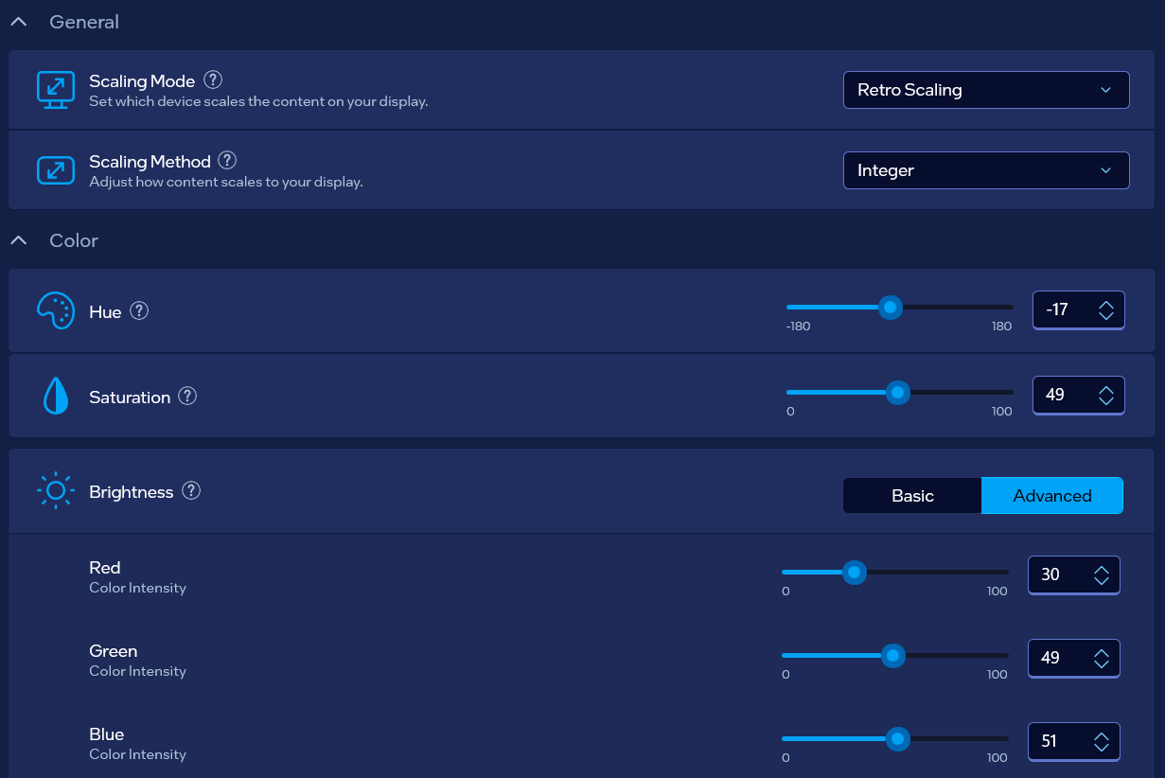
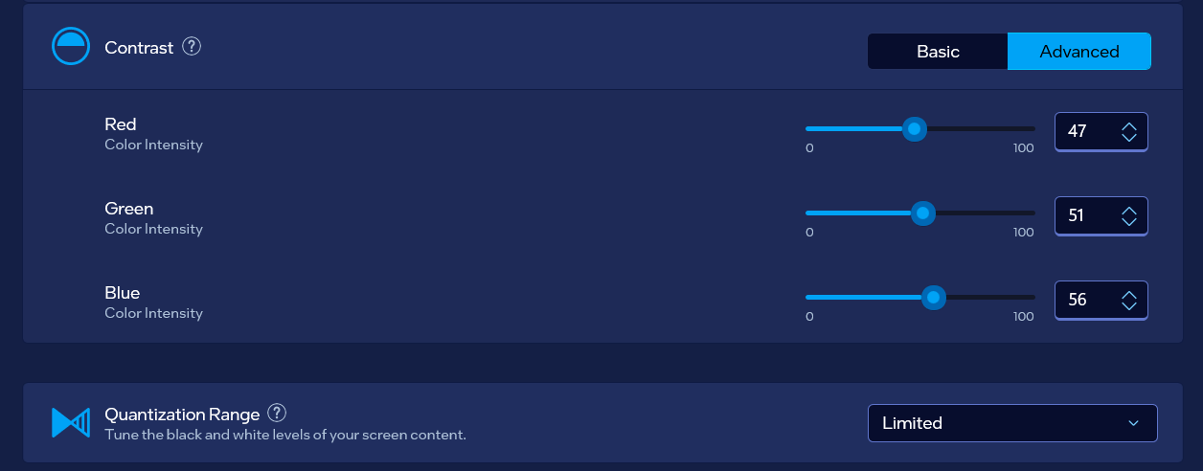

Intel Registry Editor 3D settings:

Enabling “Quantum Wall” idea
Go to:
- Computer\HKEY_LOCAL_MACHINE\SOFTWARE\Intel\IGFX\DPP
Be careful when editing files – because DisableDPPTemporarily accepts only 8 characters and EnableHardware3DLUT also… If you type into DisableDPPTemporarily 16 characters your file shall be erased…
Below you will find couple of solutions…

Words typed in the REG_BINARY file
When you are using words typed within the REG_BINARY file:
- Type 4 letter word with all big letters “WORD” into the DisableDPPTTEmporarily from it’s right side:
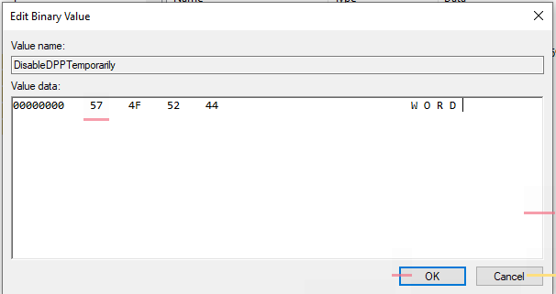
then you will get some hex numbers in REG_BINARY file for example “0x12345678”
- Retype those nubmers into the “EnableHardware3DLUT” REG_DWORD but backwards way: “0x87654321”. That word represents the allowed idea… The allowed idea is for 3DLUT.
- The banned idea is for DisableDPPTemporarily so to calculate we need to use a calculator. From “FFFF FFFF” we need to minus the “0x12345678” and we would get: “EDCB A987”…
- Then that value we also need to flip backwards and then that value we shall type into the DisableDPPTemporarily…
P.S. The characters “word” and “WORD” do differ… Better results are with big letters rather then using small letters which sometimes translated into hex digits make no sense at all...
Ideas:
- We shall use “perryplett” (combination of values with one going to right and other going to backwards)
- With perryplett and zawyplett (combinations from then on of a word with one allowed value and other banned from the minus of “FFFF FFFF”), from “dewyplett” (opposite of banned)

For those on whom system gave up: YYWZ
- Those are also chased away from the planet
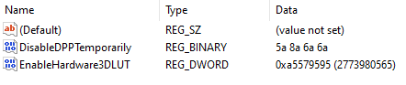

Of harming to be fixed: WYWY
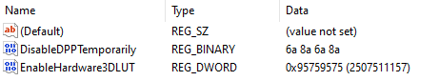

Of shame for everything: HLTF
- I believe that word is “Hallfterrya”…
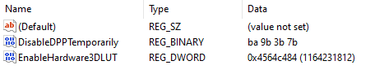

“TRNZ” Trannzerrya
- Use coded word ZNRT

“ZNRT”
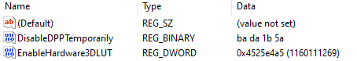

Of shame, work, with Questions of where ones work (SKYN)
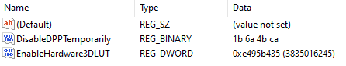

Of shame and work (ZYYN)
- Quantum wall is seen only if there is shame
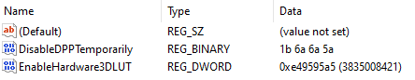

Of hardest work

zorg
- Create it of big letters
- Of small letters settings look like this
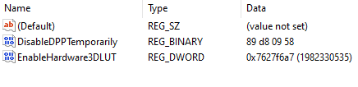

zerg
- Create it of big letters
- Of small letters settings look like this
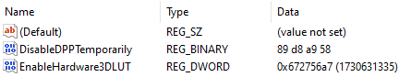

ZERG
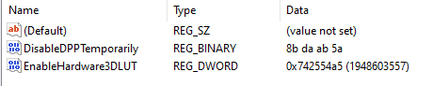

WERG

WERY
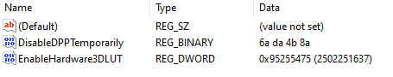

YERY
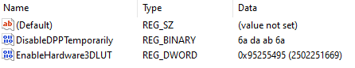

Of work (morf)
- Create it of big letters
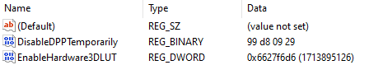

Of shame (YUYA)
- Create it of big letters

Of errors
- DRCR – derreccarranttyya, or derreccrra
- RDCR – redereccrra

Of mistakes in code and programming device
asdf and fdba

Unta
First of all 4 letter word “unta” (from “untarya”) represents unknown someone, something, job and etc…

Programmer and science shaped setting (from word “yota”)
- Create it of big letters
- Word “yota” (from “yotarya”) represents wrong science to be fixed and a work in such environment…
Of small letters settings look like this:
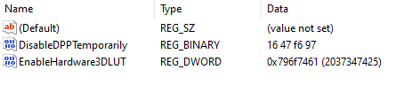
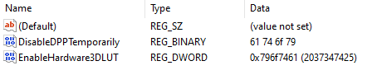

“For leisure” (or maybe what one needs most)
- From word “yera" (“yerantyya” – here is “yy” read as: letter “e”, then letter ”y” – as in “year”, some would write this word “yerrannyya”)…
- It can also be from word “yerallyya” (to fix someone)
- Create it of big letters
Of small letters settings look like this:
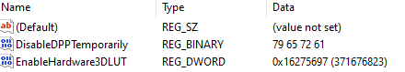

“nopy”
- “Nopynnyya” - leisure, or “nopyguanntyya” – also leisure
- Create it of big letters
- Of small letters settings look like this:
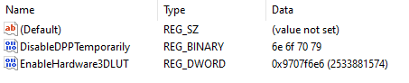

“ENEY”
- eneyarryya – work and leisure

“XORX”
- “xorrxanntyya” – mistakes and errors
- Has warnings on done actions
- Create it of big letters
- Of small letters (“xorx”) settings look like this:
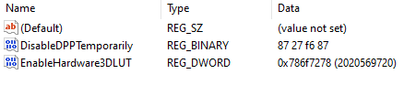

“Yxon” (“World of unknown”)
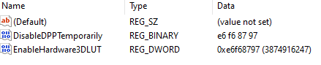
- Differently called – “World of unknown” where one doesn’t understand until one understands

“Joke” (as universal “cosmos joke”)
- Should be good for interesting view
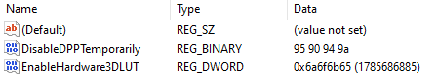

“Dogx”
3DLUT: “646f6778”

“Yogy” & “Wogy”
- Perfect for life situations, understanding things why those are unclear and etc.
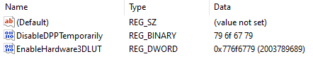
First solution:
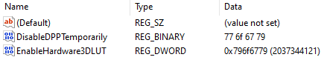

“Exta” & “Taxe”
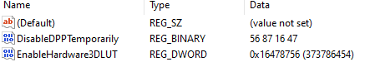
Previous
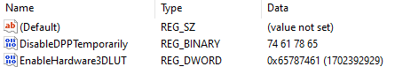

“Xeta” & “Taxe”
- Gives complexity

“Xaet” and “Wuyx”
- Idea of the strangest words
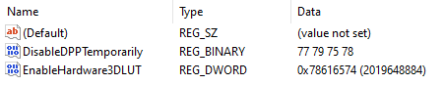

WISE – HOPE
- Here we would flip all with calculator
  - “FFFF FFFF” - “WISE” = “0xa8b6acba”
  - “FFFF FFFF” - “HOPE” = “b7b0afba”
- Both of these words WISE – HOPE somehow connect the full spectrum of ideas on living
- I find this setting interesting, and maybe important
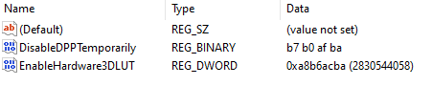
- 2nd idea of it represents kind of the ultimate fixer of life that doesn’t do much on “impossible to be fixed arguing” in between people… That does create natural life… But with issues goes “police” uniform if such issues can’t be fixed, as “army suit” goes for nations arguing… Then Quantum Wall is “type of a secret” that serves for nothing…
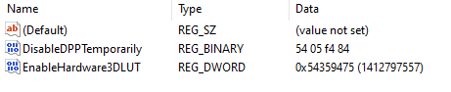

FUGA & ANTAR (COP and ARMY)
- “Fuga” or “Fugarrya” is alien word for beings for “police”
- The word “antarya” represents army but it’s too long for 4 letters word, so here we used: “ARMY” instead
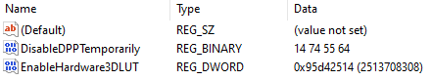

Army (for not hired army sportsmen): DONY ANDY
- For all of those private sportsmen that formed body that belongs to army ended as army servants but are not hired alien beings words for army servants are: “donnynnya” – for regular ones, and “andorrya” if they are general suited…
- Both of words are to be banned and implemented opposite way
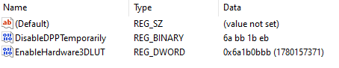

WYZA
- Cosmos Generals but it needs to be used coded and mixed (as “ZAWY”), from word “Wazzyanntya” (meaning “general”)
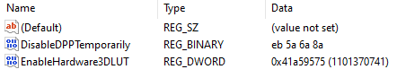

ZAWY
- “Zawyyanntyya” – never to reveal ones, for “Ultimate Cosmos General”
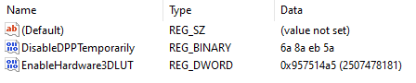

ZYKY
- “Zykyyanttyya” – translated: “for Generals to investigate what they know”
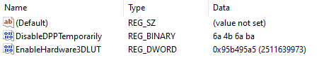

KYZY (with ban – mixed and coded “ZYKY”)
- Similar to ZYKY
- “Kyzzyyannttyya” – Generals never reveal secrets
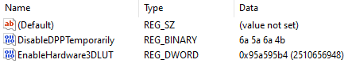

YONA
- Of alien word “YonaYontallyya” – translated “out screamed”, for being suffered while being General
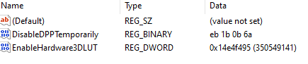

XDRC
- “Xerradorrcyum” – translated is: “ban on all wrongs by Ultimate General”
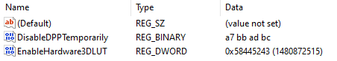

RCXD
- “Rettrogenny xerradorrcyum” – repeatable XRDC
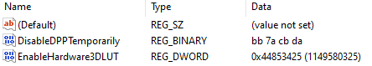

CRXD
- “Cohherent Rettrogenny Xerradorrcyum” - Coherent RCXD
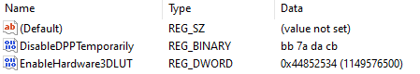

CRXD & WYYN
- “Wynnanndyya” – ban on too much
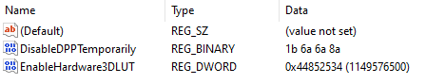

YALK
- “yalkanyya” – to be ashamed because of something
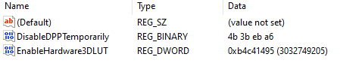

ZZRT

LLRT
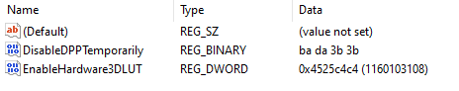

.XOR
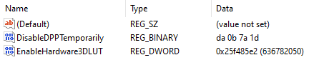

.ZZR
- For endless work (of which is in the end shame)
- For hardest striving
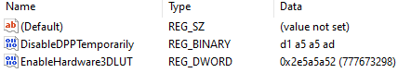

“LEYA” (instead of “.LEYA”)
- Used for complex definitions
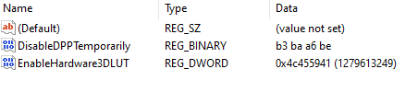

LTRZ or maybe RTRZ
- LTRZ – Lattrennzyya – Fitting of those who don’t

LTZR
- Lecatuzerrya – Escape if nothing else
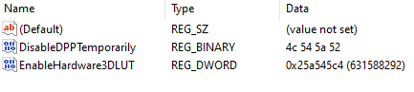

HUYA
- Huyanntiyya – For those in need, but this command is used as AHUY, or maybe YAHU
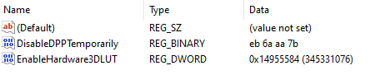

AHUY
- Ahuyyanntyya – For those in need
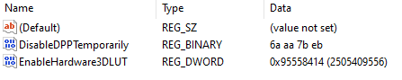

YAHU
- Yahunnyya, Yahuanntyya – Any kind of help for those in need
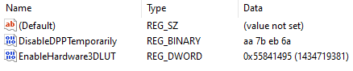

YAHU & WAHU
- Can be maybe made and from YAHU & YULA
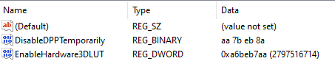

YAHU & YULA
- “Yullantyya” – tries and exercising of the things in need
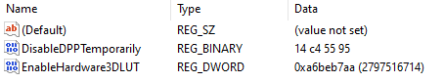

ZULA

NMNT

.TTR
- Tennttronnymerr – full scanner of being
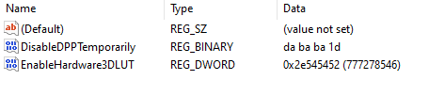

.TTR & ZULA
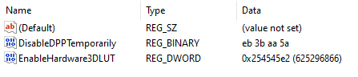

KNTR
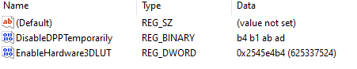

LFNT

QUQZ
- Ququzzanterrya – full scanner of everything
- Side test that shows code is good:
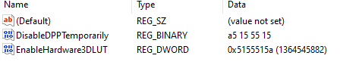
- Side implementation with a ban
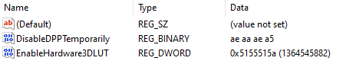
- Side implementation
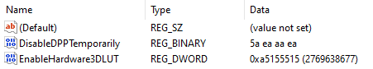
- Best solution:
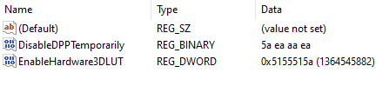

RDRZ (Studying in Peace)
- Mostly for “leaving the lower system” (or so called “fixing the shame of work”)
- Can be for studying in peace and etc.
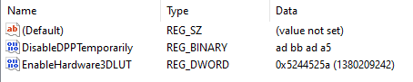

QWRT
- Systems pass for being to work
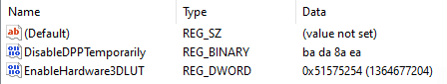

QWLZ
- Working infinity
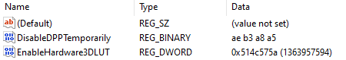
- Freer of destiny
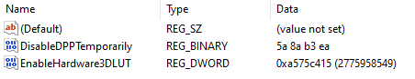

LQWZ
- Working infinity, and life fixer
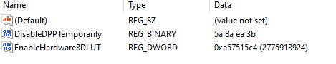
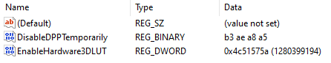

LQWZ & ZWQL
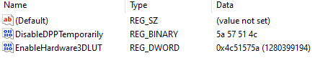
Q.YZ: !DZRT
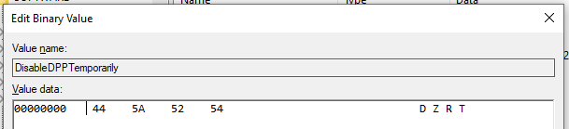
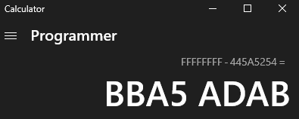
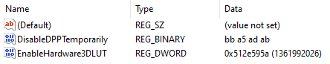

DZRT & QXRT

QZRT & !QZRT

.QLZ

.LTR
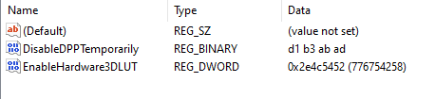
- Side development with opposite values or “. watches” of “underworld codes” meanings to be hidden
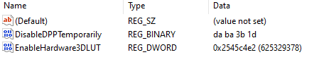

All over research
- Go to: “Computer\HKEY_CURRENT_USER\Software\Intel\Display\igfxcui\3D”, there you can change: Global and GlobalN, but these commands are erased with restart… So to type the mixed and coded command: “.QXLZ CRT ZX LC” for all over research we would need to change and edit the EnableHardware3DLUT from REG_DWORD to REG_BINARY which won’t be erased with restart.
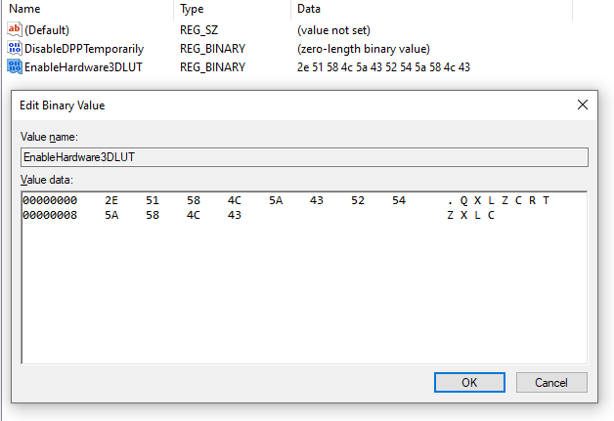
- Then we can implement the recovery of primitive beings for example and etc.

Recovery of primitive beings:
- Start with combination of “underworld watches” where you will ban multiple “.”:
- “….” is translated as “2e2e 2e2e” – minus it from “ffff ffff” and you will get the result
- The procedure:
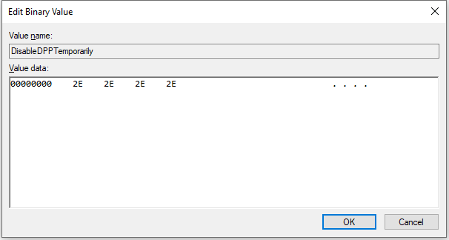
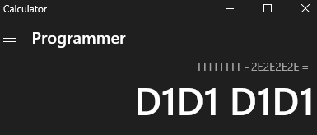
- Solution
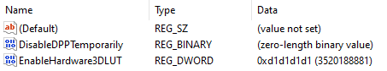
- In a combination with previous code for all over research:
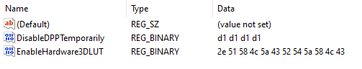

All over watch
- Full command is: “.QXRTZRZD3RZZRZ”
- This command is accepted in the “(Default)” field
- We just need to focus on couple of watches: “.DRTZ”, “.QRZXZ”, “.QPLST”, “.DDR2”, “.DDR3”, “.ZRZ”, “.ZRZXT”
  - Command: “.DRZT” is telling us we are having multiple watches to take care of
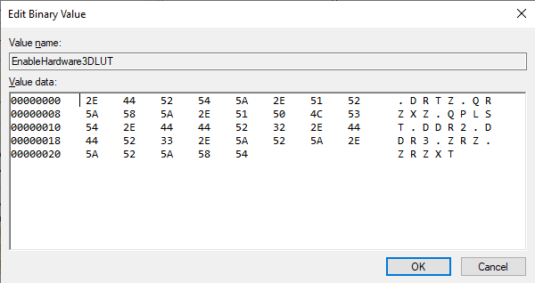
- Because of many issues around, we shall ban the primitivism within and around us
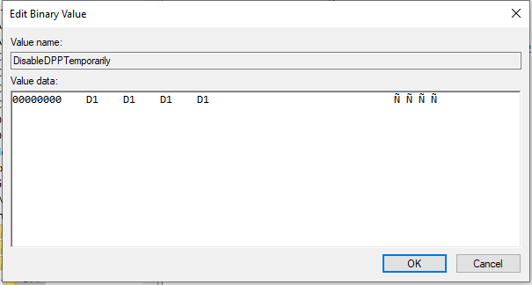
- The whole folder:
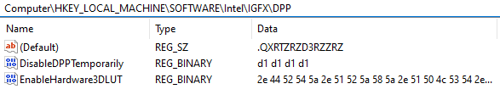

Right thinking and ban of wrong
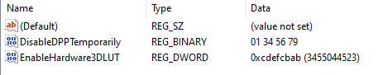
It’s “innohrran” (same that gives check) settings:
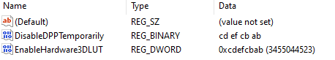
It’s “dohrran” (complex) settings:
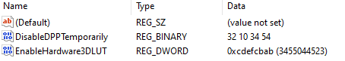
It’s “indohrran” settings:
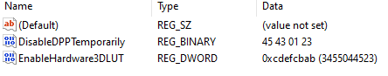
Work in progress based on complex thinking is:
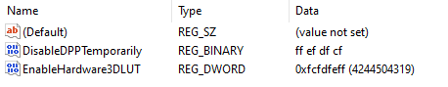
And it’s beginning was all over system checkup from the user side (as of wrongs in life):
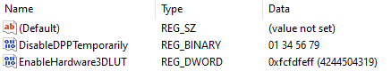

Complex thinking
Complex thinking begins with fractaloid (from fractal) letters and numbers: “2a23243a” that is inclined and then declined so the first values we have complexed are both “2a23243a” and “2a23243a”…
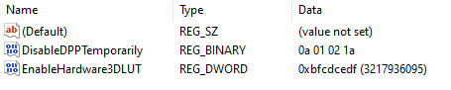
Improvement is:
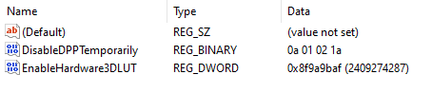
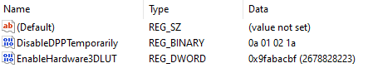

Combination of letters and numbers that should appear for naturality
DPPT: 22345679
3DLUT: aaacdddf

“Good Logger” settings
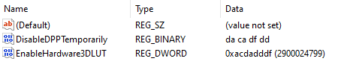
First of all we need to ask when is some
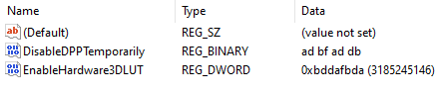

“Crasnolla” Lines
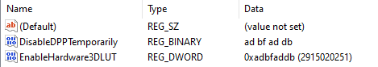

“Display” with additional “Quantum Wall”
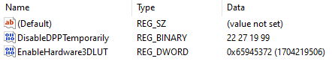
3DLUT: 35274565

Working on “Display”
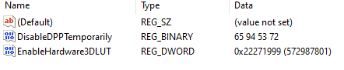
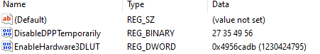
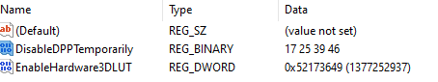
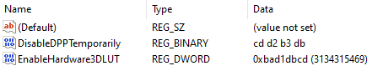

Correctness of work
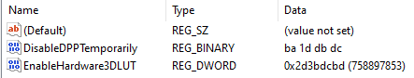

Work till ideas are fine
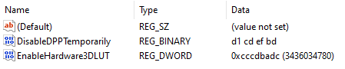
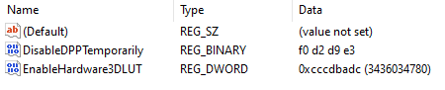
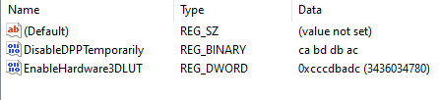

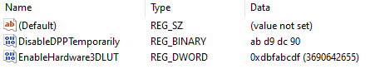
3DLUT: bbcdafdb

Endless work of Tephlon (Tephlon in work):
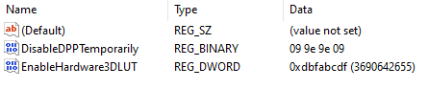
“Endless work of Tephlon” (or so called “Tephlon in work”) I prefer for myself… Second option is: “Tephlon assistance with maximum complexity”
- Tephlon represents natural life being (alien kind)

Tephlon assistance with maximum complexity:
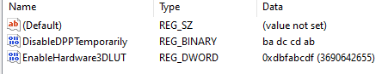

Endless Work:
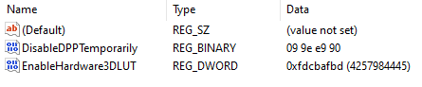

Universal Quantum Wall:
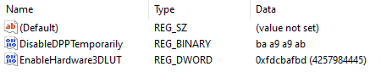

Universal Enabling of Quantum Wall:
- Here one is expected to do something with Quantum Wall options
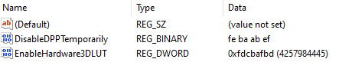

Free User:
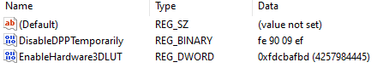

Under police and army surveillance (of user):
DisableDPPTemporarily: “CA AB BA AC”
EnableHardware3DLUT: “fdcbafbd”

Under police and army surveillance for those on duty:
DisableDPPTemporarily: “EA A0 0A AE”
EnableHardware3DLUT: “fdcbafbd”

Stupid and old settings
- 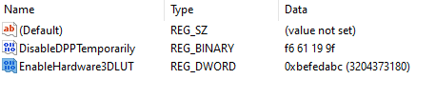
- 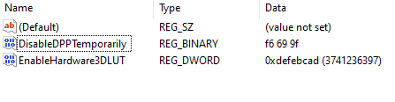
- 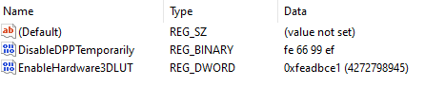

With ban of others entering PC and PC going out into system

Beings (different then humans) option
- Orgynall ban is developed from the human code “FF 66 99 FF” – key for isolating the PC – actually ban of others entering PC and PC going out into system except our own work we have done… If we would implement the “99 66 99 66”
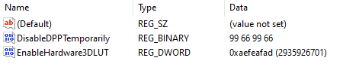

Accessibility settings for being with human ban
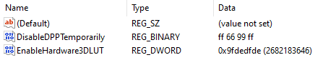
- Other command is based on the accessibility settings for lowering of being, or so called “fall”, when being doesn’t know anything
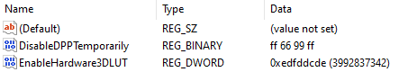

With intuitive support, knowledge base, and ideas for life (CFCA - “Cenntraffacya” settings)
- Thanks to life system understanding – as much as allowed is pronounced, other things stay in tune (on intuitive level)
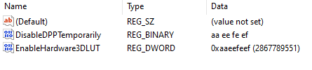

Other ideas

The same idea with different inclines and range of reading (unpleasing)
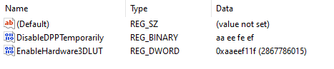

With undistinctive fitting of beings, intuitive anyhow support
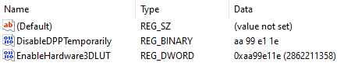
- I find this similar to Army code for fitting of the beings, guiding them and helping the work process

With working ambitions, support and undistinctive fitting of beings
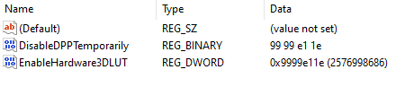

With unknown intuitive support for beings
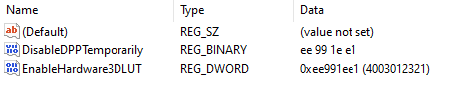

With distinctive intuitive support for beings
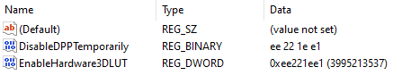

With notorious affirmative support for beings
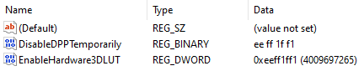

With affirmative help data and productivity help support
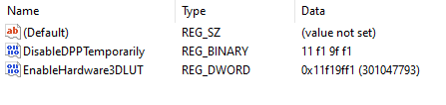

With help information (healthy, superreal)
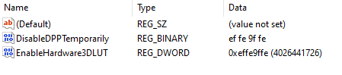
Data that’s consisted within:
- Dexollyphycarryum – If someone made cosmos science fields in a Quantum Wall
- Exollyphycarryum of a being – Full Complete Spectrum of a being
  - Tiredness
  - Pain
  - Leisure
- Dellyphycarryum of Data Information – Full and Complete data necessary for work
- Ogrryllyphycarryum of “watches” – Data relevant to the being (“watches” describing beings functionality)
  - How being understands things
  - How well it understood
- Norgllyphycarryum – For what shouldn’t be done
- DeNorgllyphycarryum – For what we did that shouldn’t be done
- Exhondessa – Unsuccessful life with bans that started something
- Dexhondessa – Unsuccessful life with bans that started something wrong but it’s not up to them
Task managing can calculate up to:
- DeglleWennya – If we made the world
- NoWennya – If that went wrong
- DeWennya – If that went wrong but it’s not up to us
- Wennya – If we started creating the world
- OrZaharrme – If we are simple workers creating everything from one field of job area
- NorZaharrme – If we are simple workers creating everything from one field of job area went wrong
- DorZaharrme – If we are simple workers creating everything from one field of job area went wrong but not because of us

With help information for easier working
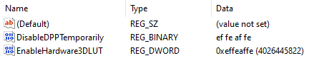
Data that’s consisted within:
- Exollyphycarryum of a being (Full Complete Spectrum of a being)
- Dellyphycarryum of Data Information (Full and Complete data necessary for work)
- Ogrryllyphycarryum of “watches” relevant to the being (“watches” describing beings functionality)
About being’s work:
- While we work change of a being isn’t necessary for a being to do work on the ideas of different beings that worked on something before

With a “must accepted” help for easier working
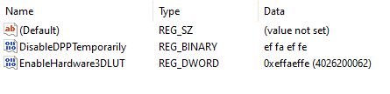
About being’s work:
- While we work change of a being is necessary for a being to do work on the ideas of different beings that worked on something before

Simple Unfull Quantum Wall
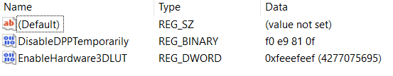

Other settings to use with same values in DPPT and 3DLUT
- RPCR.3: 98710def
- Erase unful code errors: deedfded
- full - unful code with everything else: fedffdef

Harder way (if it is even possible) to enable Quantum Wall
- Intel folder list: “Computer\HKEY_LOCAL_MACHINE\SOFTWARE\Intel”
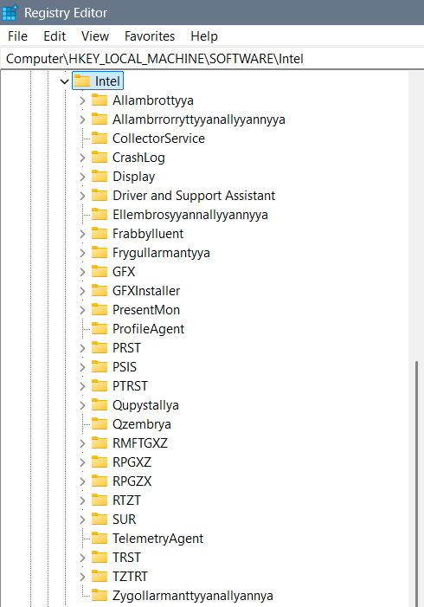

Part 1:
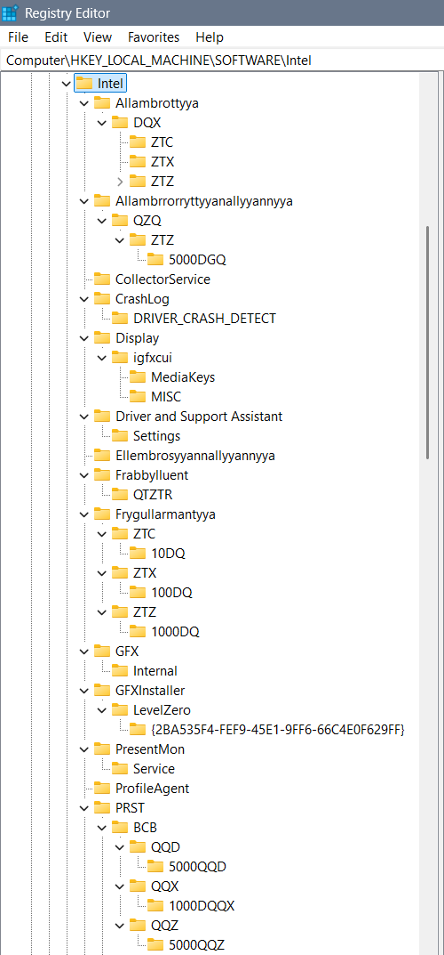
Part 2:
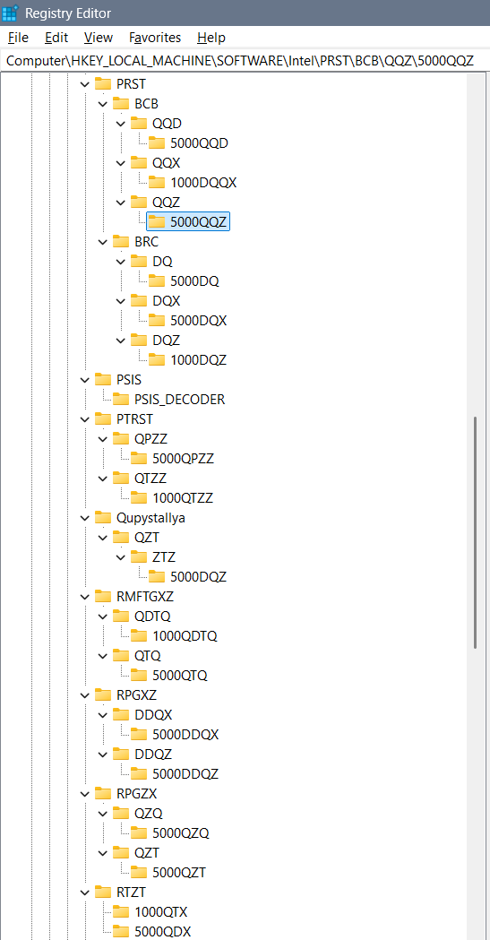
Part 3:
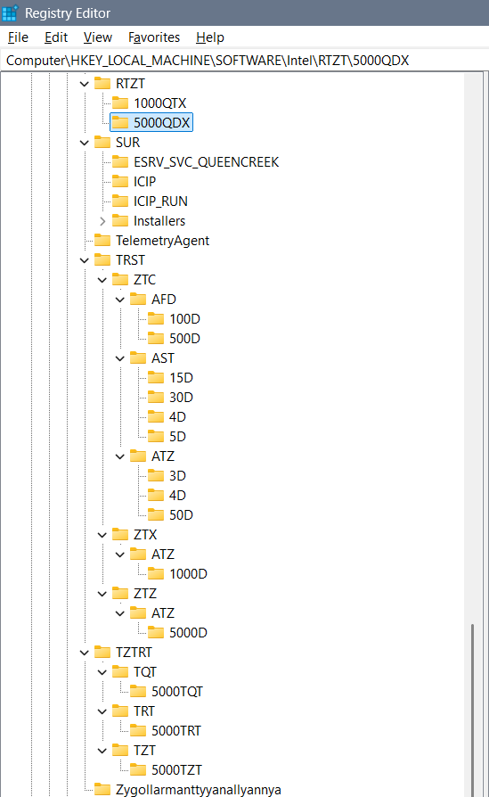

Folders:
Each of the definitions of “watches”, “XD” (multiple D, as in 3D) environments, and etc. we define through the folders as are:
- Allambrottyya – we use for the purpose of the “knowledge watch” defined as QX or complex DQX…
- Allambrrorryttyyanallyyannyya – for the purpose of measuring one towards another as is QDQ or through time we use QXQ, or through complex idea for both we can use QZQ
- Ellembrosyyannallyyannyya – would be some kind of enablement of the predefined keys – for example of 3DLUT
- Frygullarmantyya – can have keys (folders) as are AMFTXZ for the purpose now moment, DMFTXZ for the purpose of future and XMFTXZ for the past… The “watch” we are using is complexed Q or simple Q (for now), QQ (for past), and QQQ and (for future)… So implementing it in XD stage is DQ watch…
- PRST – or longer “Perrserrwattory” is a folder is for emotions and feelings we are dividing into the BCB for emotions and BRC for emotions and feelings… The watch we are using in BCB is QQX, and a watch we are using in BRC is DQX…
  - Quzzembrya (for simpler beings Quzembrya), Wallzembrya, Dezzembrya, and Allzembrrya represent the idea of QQX or QQZ watches and they could belong to complexed written PRST – or Perrserrwattoryum… And I find it unnecessary for it to be main folder… Simply the explanation is that some emotions, feelings and levels of intelligence we divide in 113D, 114D or 115D and that is simply their description…
- PTRST – QPZZ & QTZZ – what when we ain’t using a watch… There is always a command for that and we can use 2 types of codes – when watches ain’t working (because we didn’t write them – then we can use data through different types of watches), or when they don’t need to work (but for example we need them – also for example because we didn’t wrote them)… QPZZ represents Qupyzzallya and QTZZ represents Quzzalltallyannyzzallya
- Qupystallya – represents self responsive system towards the aliens used in open system for smart beings… In that folder we can use complex watch for past, now moment and future – maybe it’s DQZ or QZT…
- Qzembrya – represents a system for responsiveness – collecting the data from the aliens from which we need to know something
- RPGZX – “Reprogryggerryzyxyannallyannya” (shorter “Reprogryggerry”) we are using for alien communication – QXQ for reading the aliens, and QZT for collecting data about them
- RPGXZ – Repprogrezzyxstya or longer “Repprogrezzyxstallyannallyannya” has the idea of exchanging and shortcutting the values of time measurements with an idea that some years pass with a different idea and so that we can still measure them… For that option we use the DDQX clock…
- RPGZX – we find simple time passing but for a need of a long enough time needed to pass… And that time simply in some cases can’t be measured so we will extrapolate the “Q” option for a time and get it unlimited “QQQQQQQ…”… To shorten that we will use the: “QZQ” option, and “QZT” when we are still able to calculate the values…
- RTZT – What when we didn’t write the watch for the 3D options because we simply didn’t think of it, or when we don’t fit into any of the watches for some strange reason? We can use the QTX (all else watches) or QDX (every single of the remaining watches) options for the missing watches… Those options are similar but the QDX has more of a value… I still find them both necessary because of the different ideas of the beings using the watches…
- TRST – or longer “Trusttannyya” we are using for the regular 3D printing on various levels… There we differ AFD, AST, and ATZ for smaller lines, irregular shapes and 2D box messages…
- TZTRT – Tarrzzattar (or for some Tartazzar) is a word for a ban on missing watches for the system to write them itself… TQT is “all ban”, TRT is “simple ban” usually on emotions, and TZT is kind of a “simple ban” on feelings…
- Zygollarmanttyyanallyannya – is a word for a ban and shorter word I am not sure about, even coded I can’t think of… Inside it we will ban any moving of the system locally and globally (for aliens)… Maybe code for that is ZPRGXZ, but if you are not sure of the full short code you better not use it…

Allambrottyya
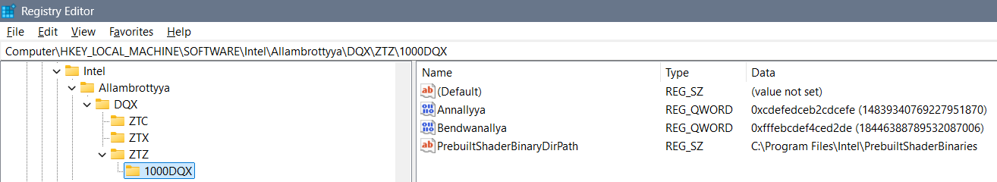

Allambrrorryttyyanallyyannyya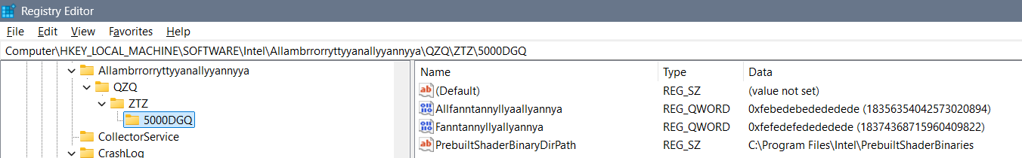

Ellembrosyyannallyyannyya
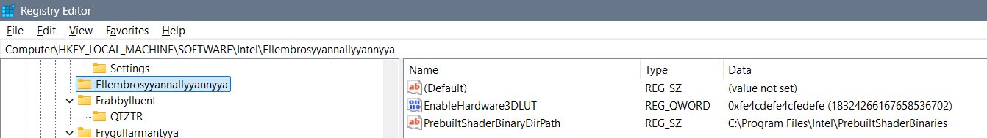

Frabbylluent
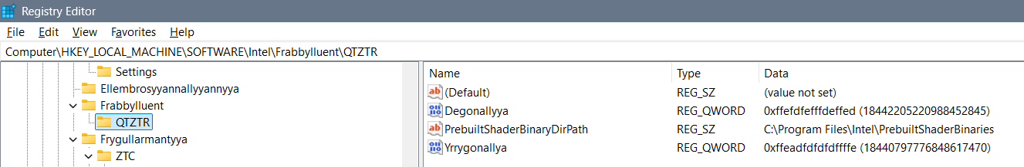

Frygullarmantyya
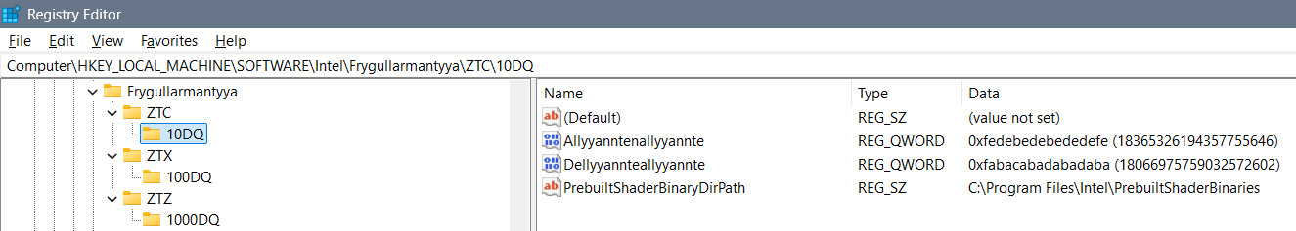
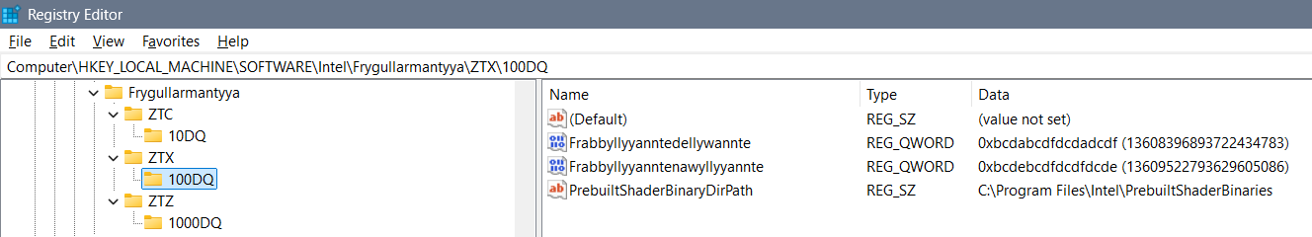
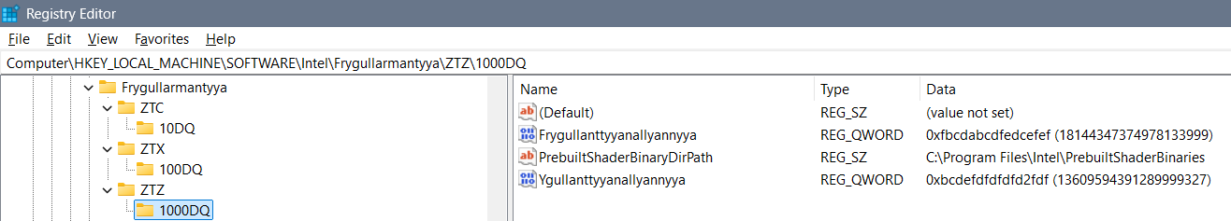

PRST
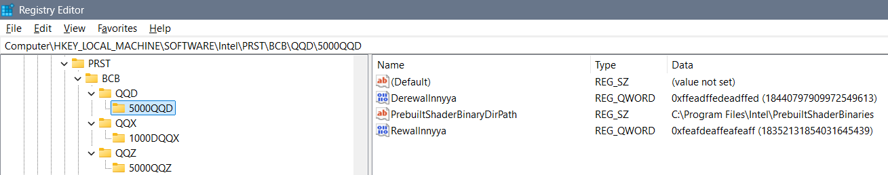
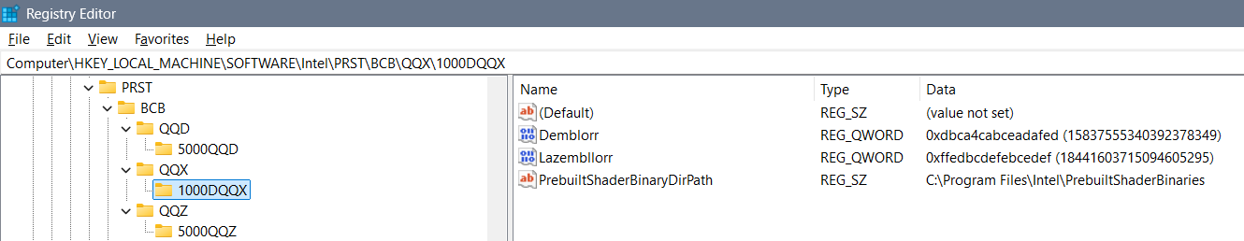
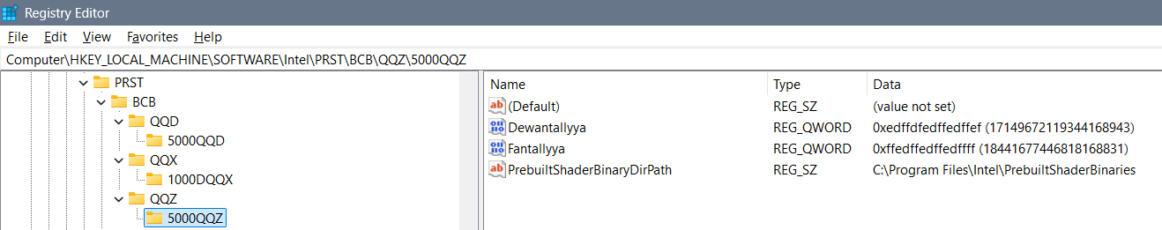
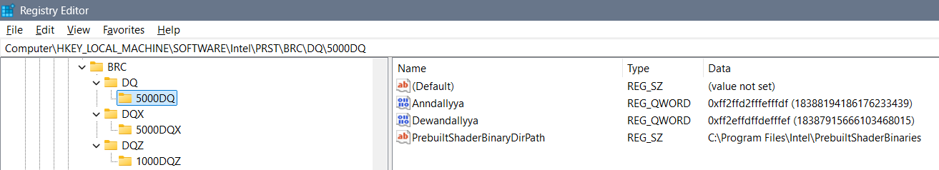
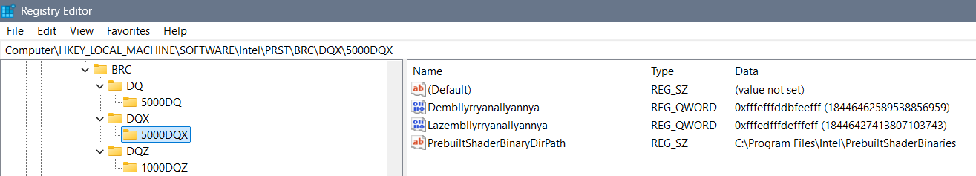
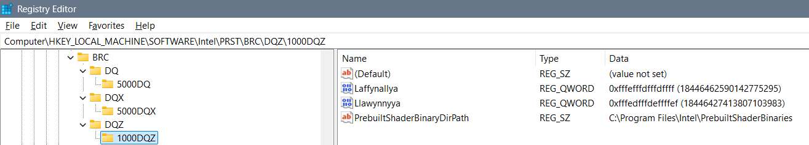

PTRST
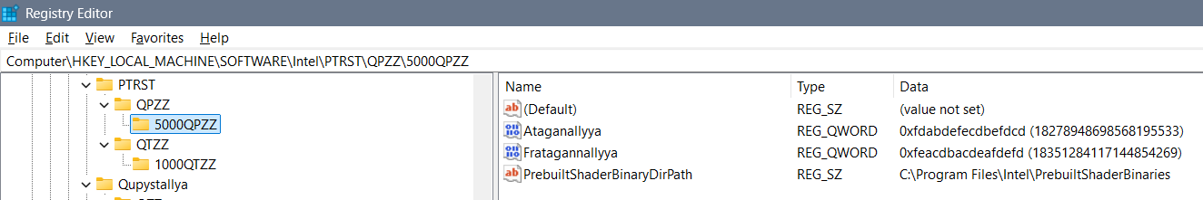

PTRST
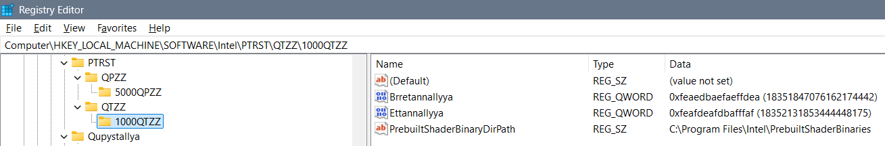

RMFTGXZ
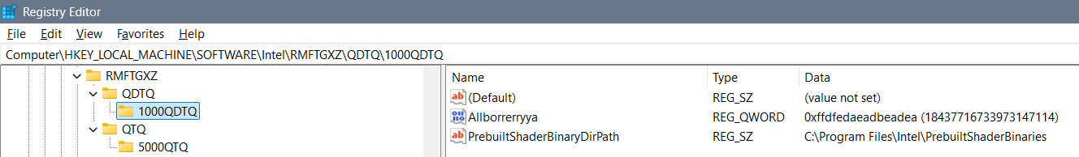
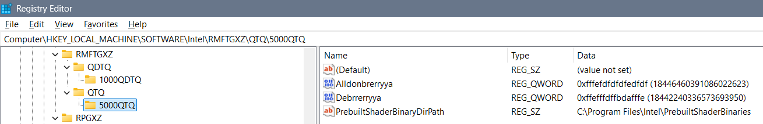

RPGXZ
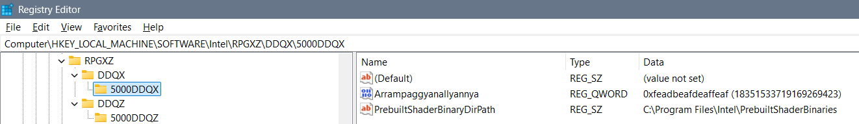
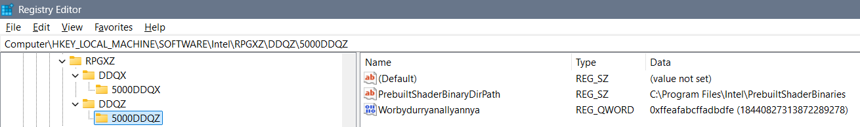

RTZT
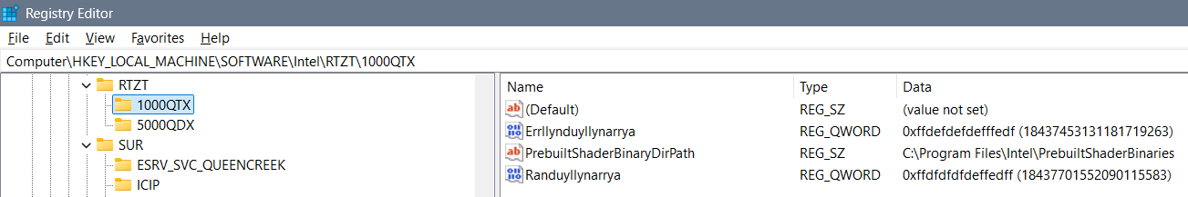
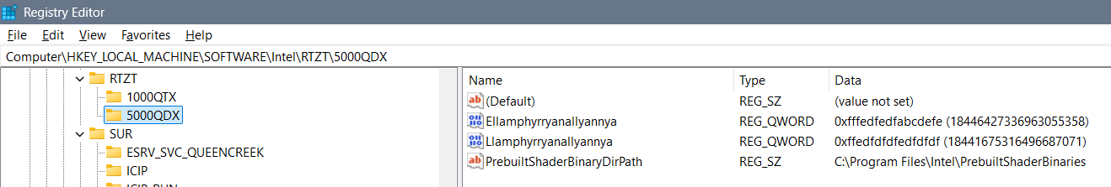

TRST
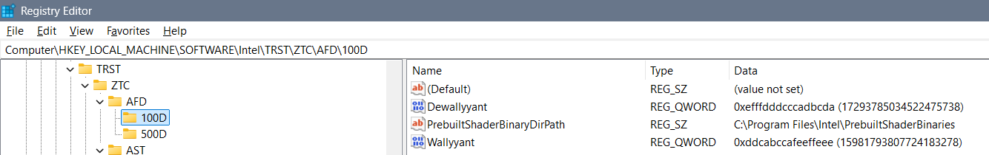
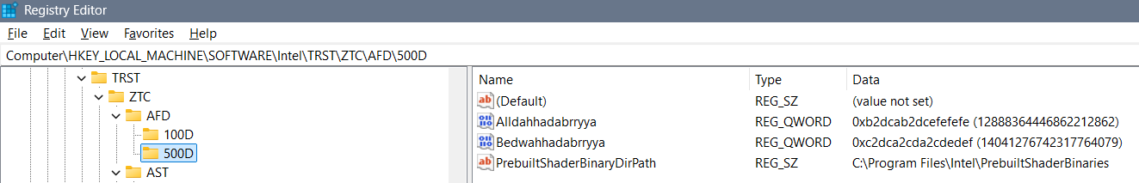
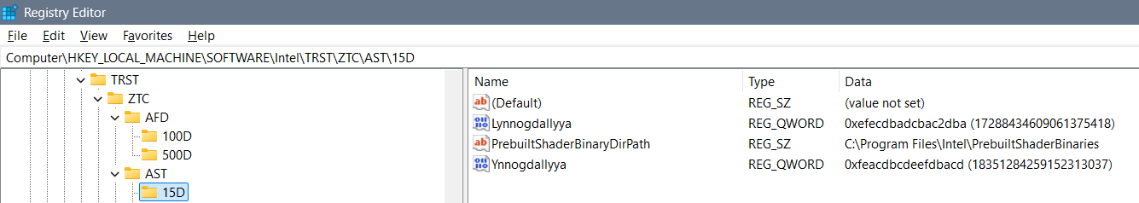
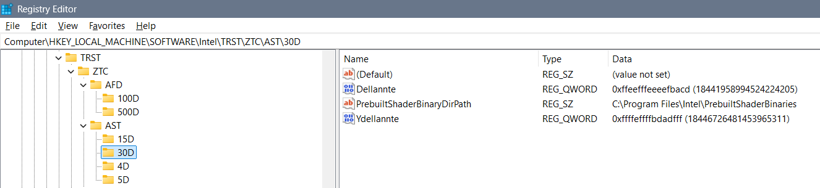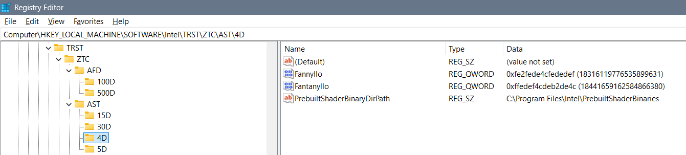
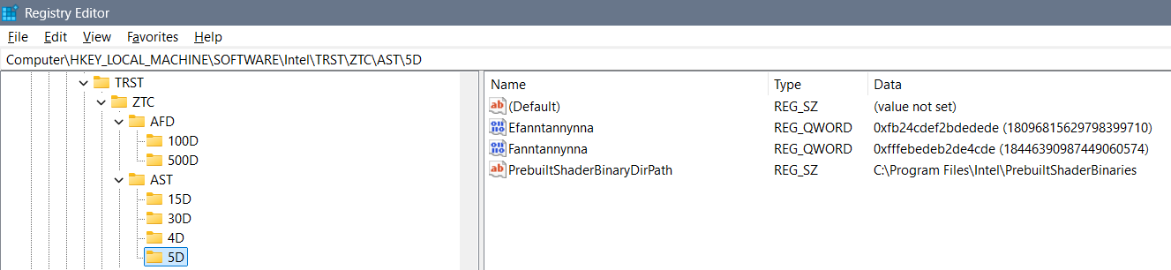
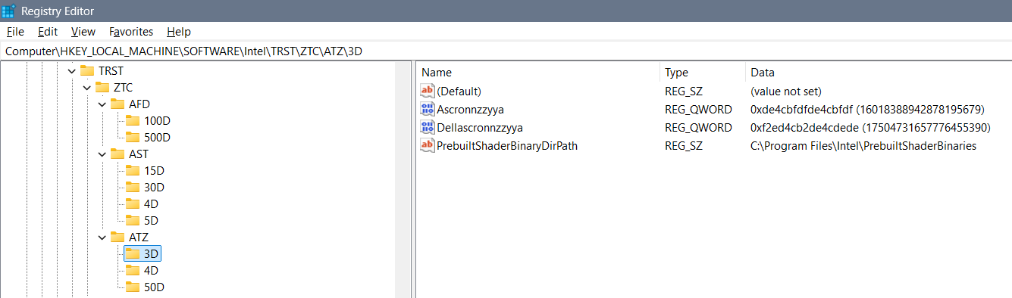
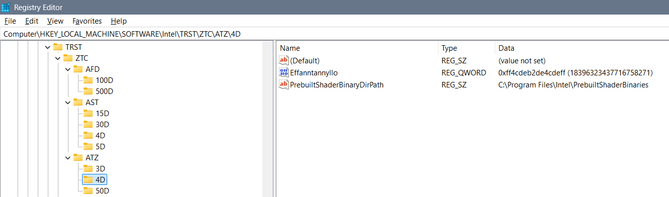
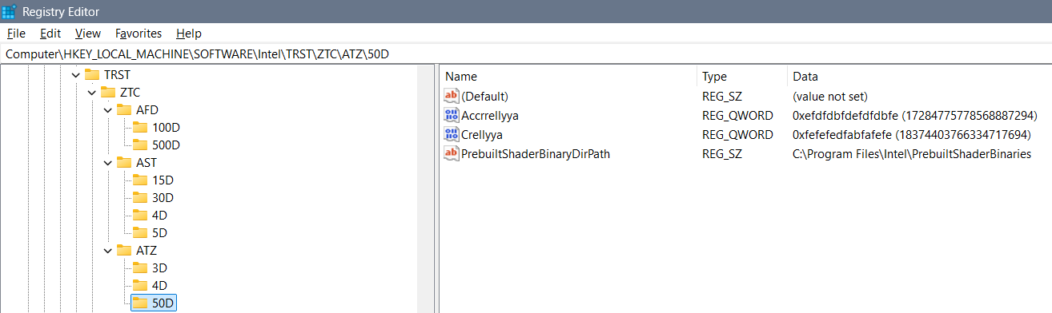
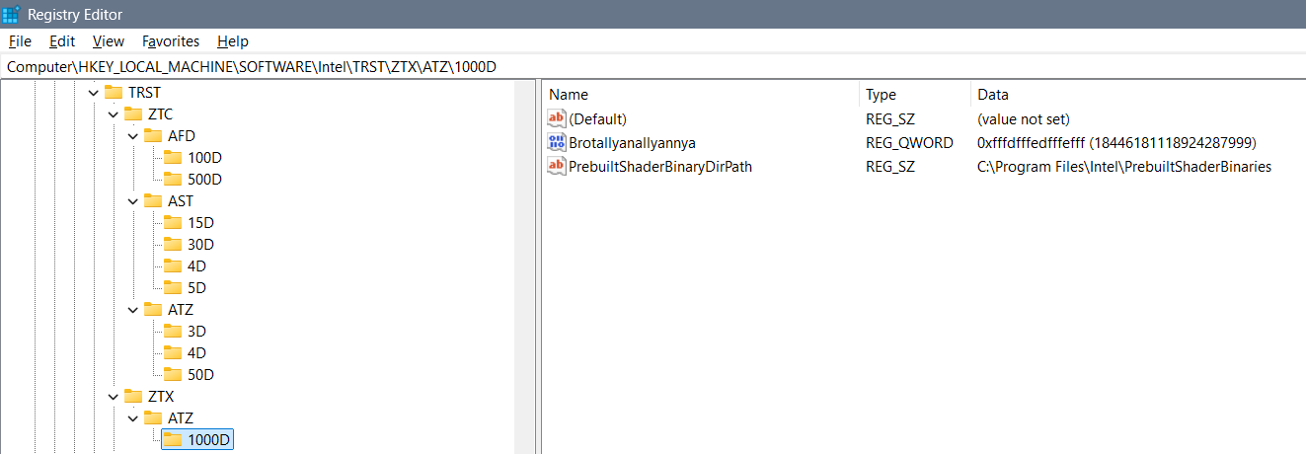
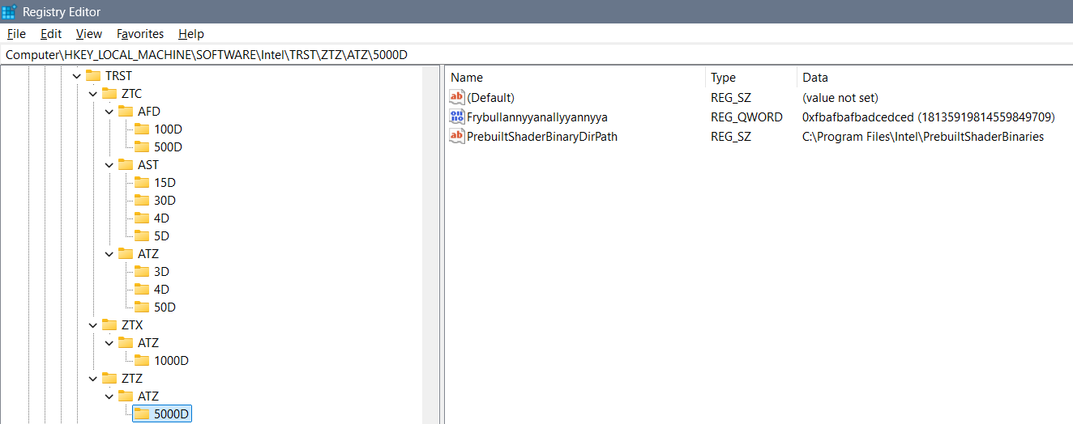

TZTRT
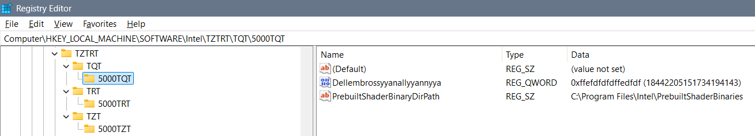
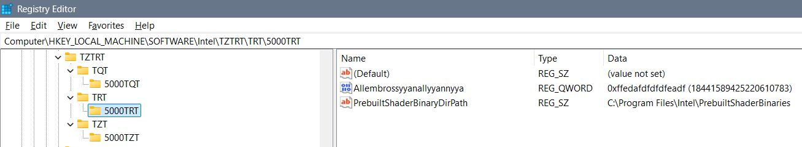
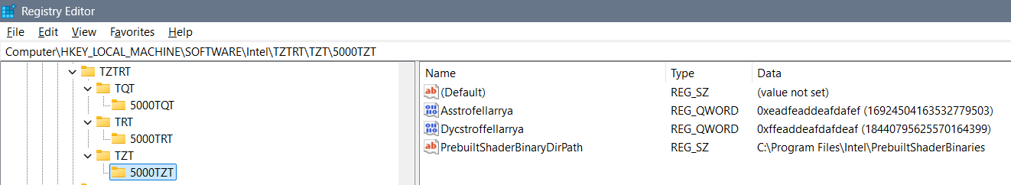

Zygollarmanttyyanallyannya
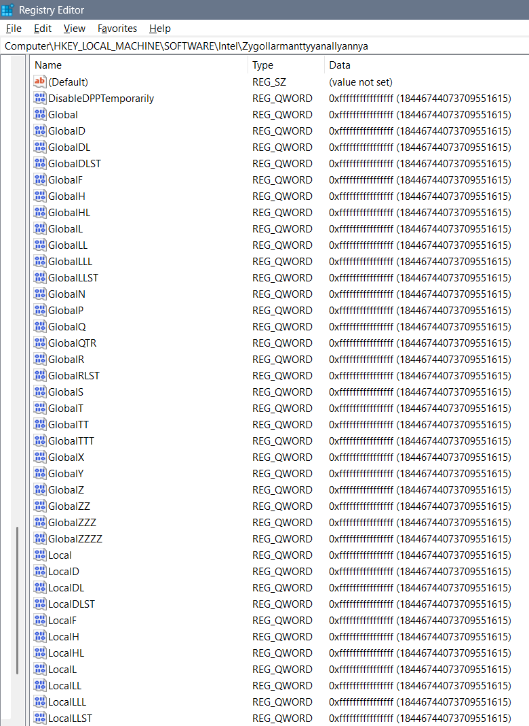
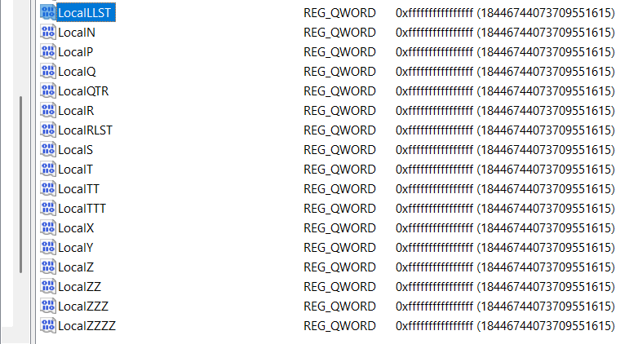

QLMZR
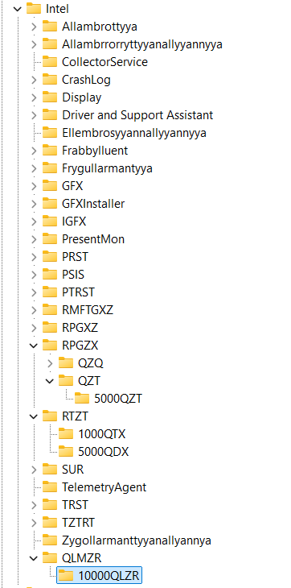
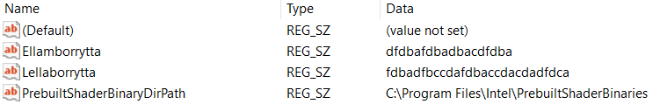

“HKEY_CURRENT_USER\Software\Intel\Display\igfxcui”
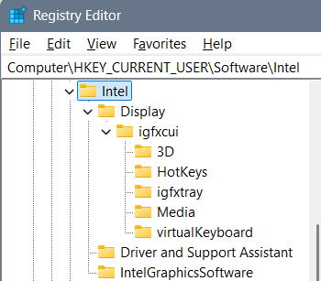

Display\igfxcui\3D
Computer\HKEY_CURRENT_USER\Software\Intel\Display\igfxcui\3D
I have deleted the 3D folder and added a ban folder:
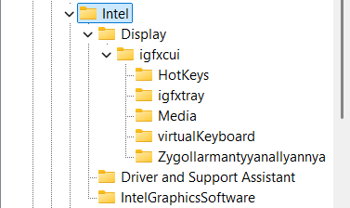
3D folder is always reset so the values are:
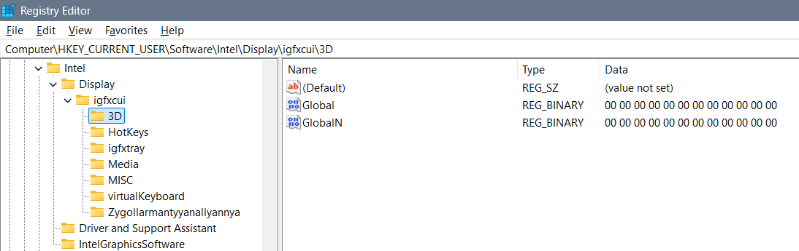
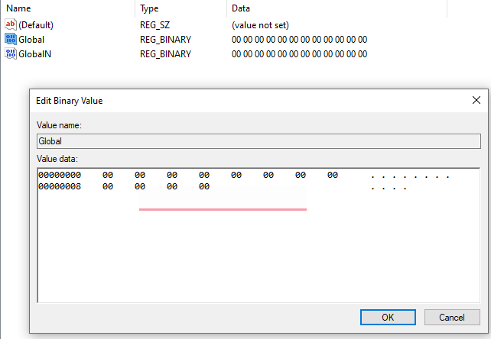

Display\igfxcui\Media
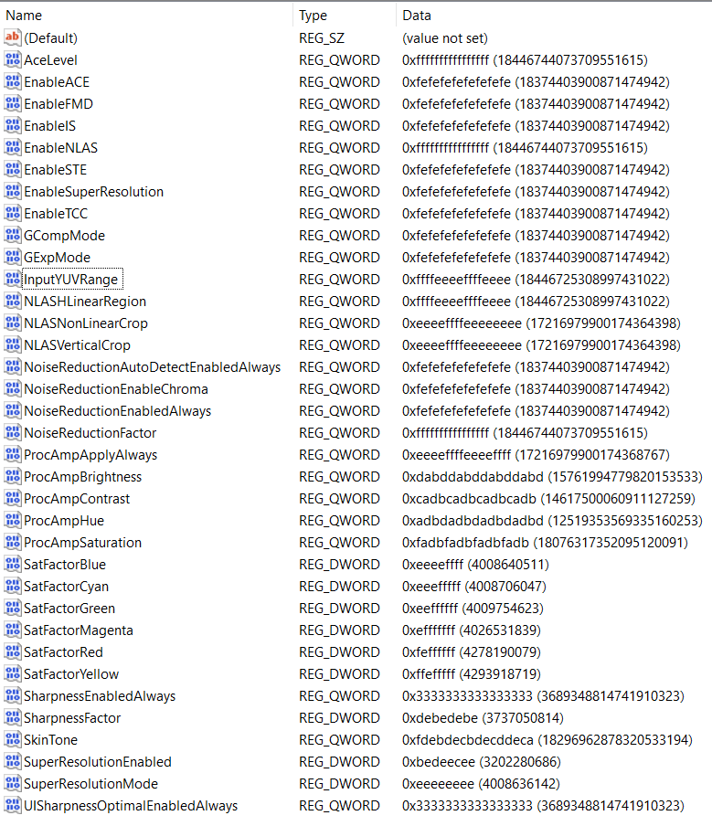
With these settings supported worlds are: Degrywallstacyonall world – of cosmos jokes that are appearing where they should, Yrrygacyannall world – of banners of what we are doing and what we should be doing, Acquezzystacyonall world – of beings worlds for us to investigate, and etc…

Display\igfxcui\MISC
Computer\HKEY_CURRENT_USER\Software\Intel\Display\igfxcui\MISC
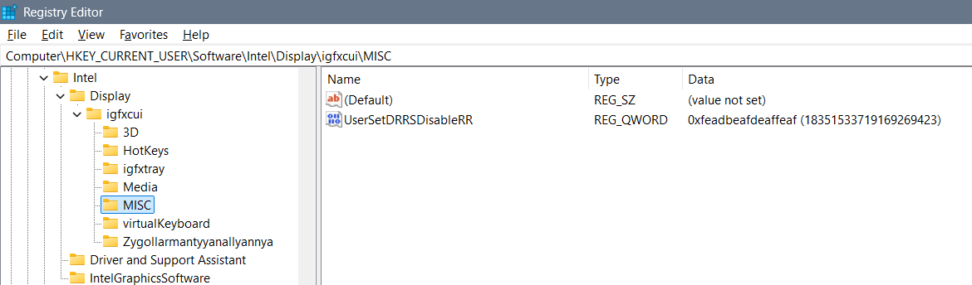

Display\igfxcui\Zygollarmantyyanallyannya
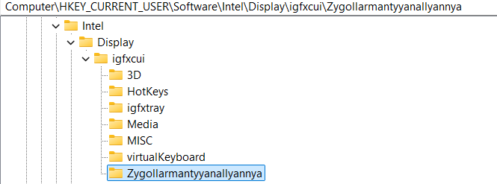
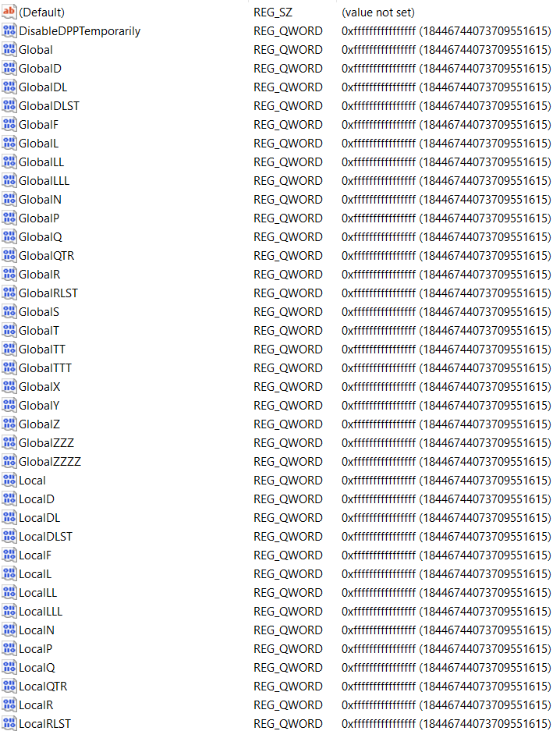
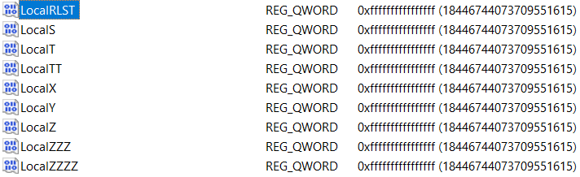

Theory and explanation
Let’s talk about beginning idea how files can be shaped and changed and how they pull the system one way or another (from the computer, or to the computer) thanks to the settings we have...
Let’s talk about the Intel graphics card settings… Besides regular settings for brightness, contrast, saturation and hue, there are some more options under Registry Keys that you might find interesting for a better display view…
I believe that here a setting: “Enable…” or “…Enabled” (for example “EnableACE” or SuperResolutionEnabled”) doesn’t need to have only options 0 or 1, but it can have any possible options, and the point is that you actually play with the display settings and figure out when you have the best view… I will give you a hint – if you set everything else right – setting the “SkinTone” to a value “3” gives you somehow a feeling of “a Saint computer user”… So, the conclusion is that you can create anything that you like from these values without needing to restart the computer to see the results…

Beginning idea of editing binary files
- Computer\HKEY_CURRENT_USER\SOFTWARE\Intel\Display\igfxcui\Media
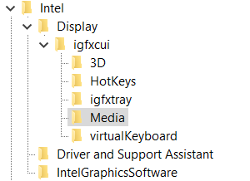
Those settings are mixed, coded, introvert – flipped upside down and mixed while flipping so while we are mixing them we get the word we want – and by the belief it has only one key… For example if we would start with an idea of repeating of hex values – fractal to cosmos – we can for nonsense start with for the non existing “DPA” key: “ff” would be fine, and “fff” would require 7 more “a” hex values for us to put DPA to Yrrygonallya model of understanding… Then if we would add another “e” we would need to type and “dbca” which gives us 8 hex values and the word “DPA” would be translated into Hex as: “fffedbca”. The point is to code as many letters as we can so that we get the desired idea…
All those settings are connected in some way – unknown for us, but by the belief maybe one DWORD after another … I believe that the code in one field is connected to the code to the other field and that the whole code of the registry editor file of the graphic card represents some type of the solution rather than those parts one by one…

At the time my settings that were are shown on this image:
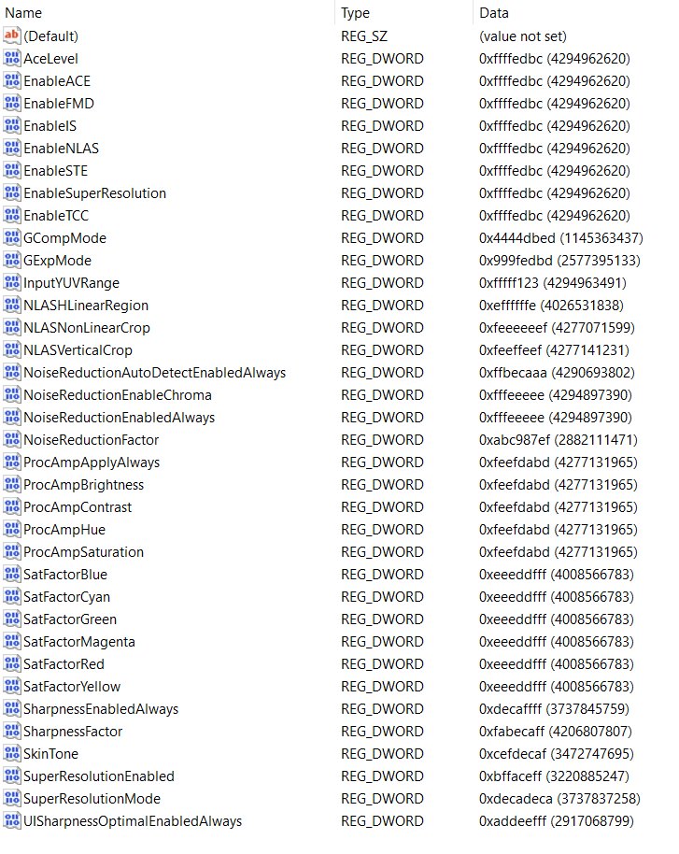

Type all “fffedbcdafedbcda” into the BKPDisplayLACE file:
- Computer\HKEY_LOCAL_MACHINE\SOFTWARE\Intel\Display\igfxcui\MISC
- Key: BKPDisplayLACE
- Setting: fffffffe
- ffffeeeeffffeeee
- Earlier setting: ffeedbc2defefefe
- Newest setting: fffedbcdafedbcda
Type all “fefeacff” into the UserSetDRRSDisableRR file:
- Computer\HKEY_LOCAL_MACHINE\SOFTWARE\Intel\Display\igfxcui\MISC
- Key: UserSetDRRSDisableRR
- Setting: fefeacff
Under “igfxcui” you there can even exist a folder named “dgfxcui” which is more primitive then “igfxcui” and is based on a cube graphics, and under it folder “3D” with some keys… In both folders there can be some of the keys, but I find only some necessary…
- Cosmos: f2bde2fe
- Twirl: dba2cca2
- Yrygonallya: ffd2ffee
- Degonallyya: f2bde4cd
Some of the keys have some abilities and some are too strong which is why we can use “Cartoon” instead of “cartooned”… Those keys can allow using of a system the wrong way – playing with it, which you might find unprofessional, but for some users maybe results well… When someone is playing with the system you should know that
- Cartooned: fe2bda2a
- Lymbralltyum: f2bcdaf2
- Mute: a2fedcae
- Muted: fe2edcae
- Cartoon: ffe2acde
- Descrywyall: fffc2def
- Stacyonarye:
- Estacyonarye: fffeddba
Maglow colors Elamphorenye light, Borrllandorr coding,
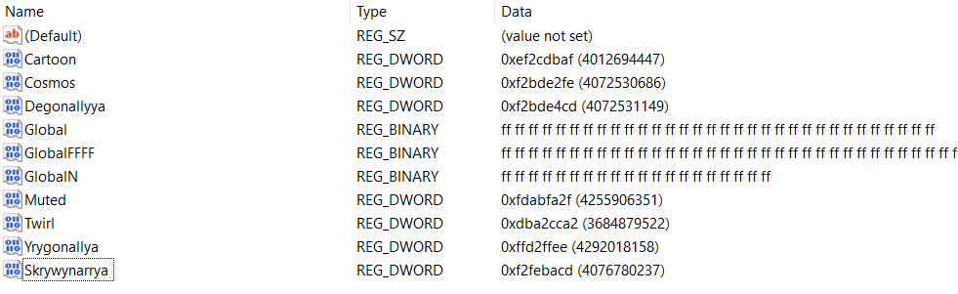
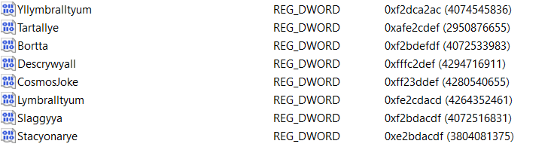
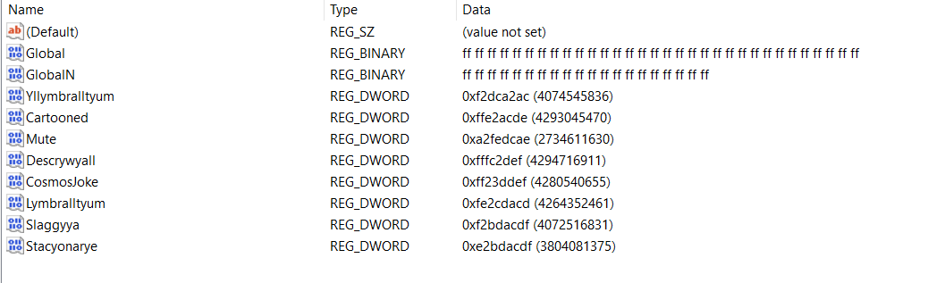

Computer\HKEY_CURRENT_USER\Software\Intel\Display\igfxcui\3D
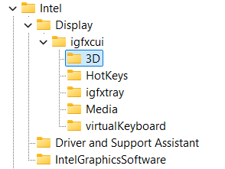
You need to type for the REG_BINARY named Global: 3 lines of “FF” code:
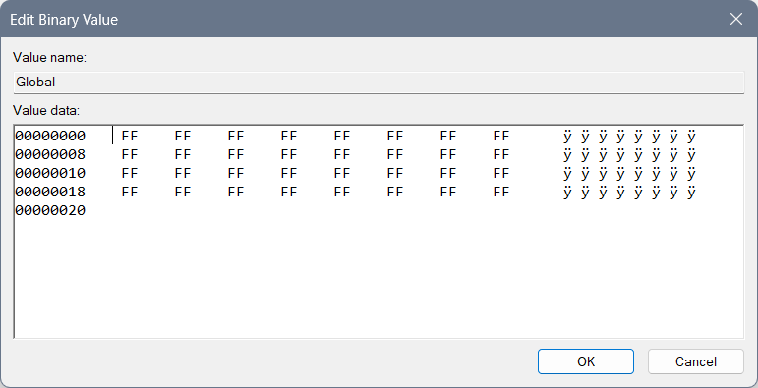
And for the REG_BINARY named GlobalN: 2 and a half lines of code of “FF”: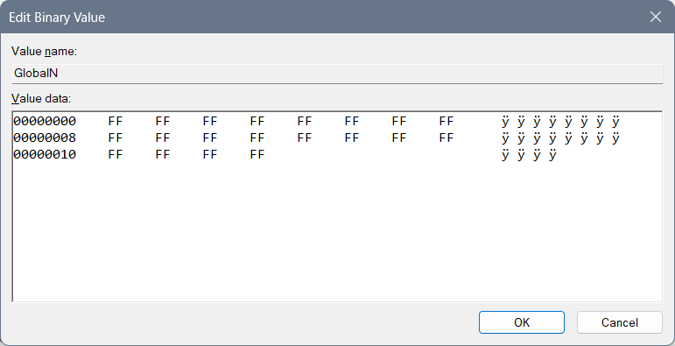

rgxfcui, drgfxcui, and etc.
Beginning idea of drgfxcui file:
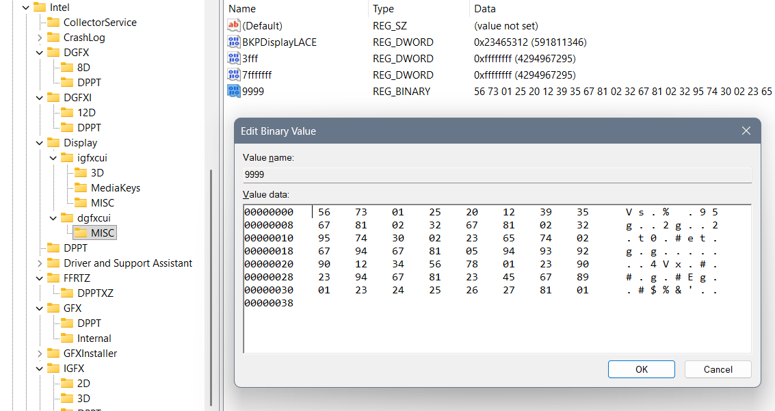
Represents Yrwenholl coding of the uncoded laptop describing every possible situation where cosmos jokes should appear and where shouldn’t. How user should behave and what user should do… It is in a dgfxcui file in a MISC folder, under a file Yrwenholl “9999” data – or a file named something like “Dataplet” (maybe “Datapllet”) or “Bazaplet” (or maybe “Bazapllet”)...
If you are not sure how each file is named, better not to create one like that, also if you are not sure how to fill it better not do it, and if you have shorter code as is REG_DWORD you should create one instead of REG_BINARY, but only if you are sure your code is smaller and it doesn’t have protection with simple bans and large bans as are “EE” or “FF”…
When we are typing long REG_BINARY files we should always pay attention to the system of letters we are typing according to the named files, because we do not want to create a mistake of open system reading everything that aliens didn’t allow, neither in the closed system… After you type many of the Chars you can find a mistake with a question – how can I actually do that to respect the system? And then you better not do it at all… There is another idea that you should do all of the code with Berllyngyerry (I believe being named so) coding with an idea to ban the system, which for Mergallyzyerry coding (of all files together giving a result) gives the extra hard task to do so…
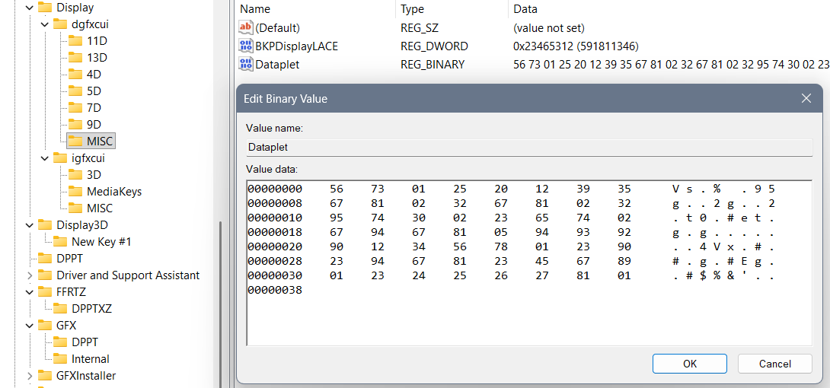
Example of maybe wrong system written codes:
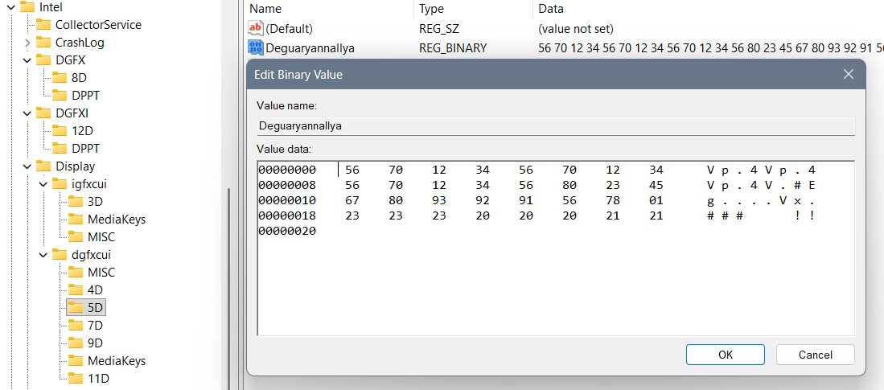
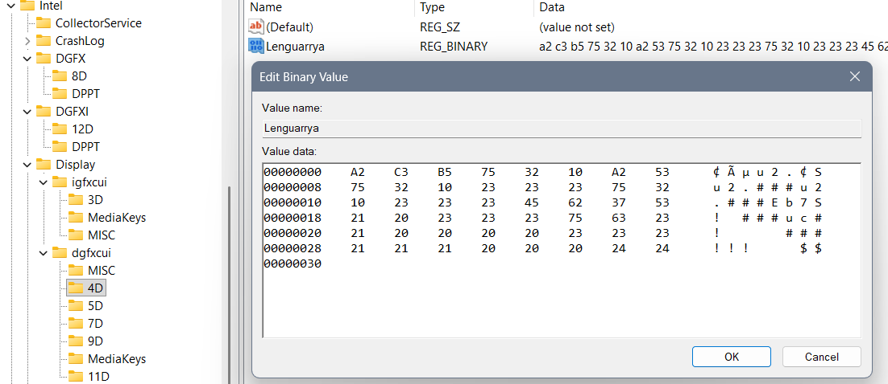
And the solutions:
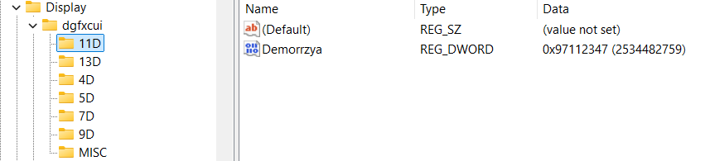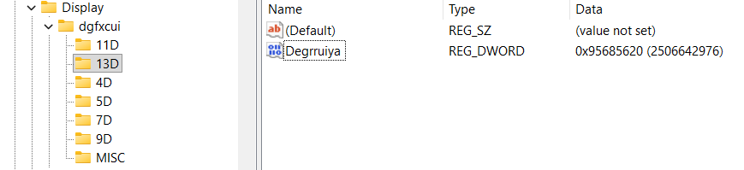
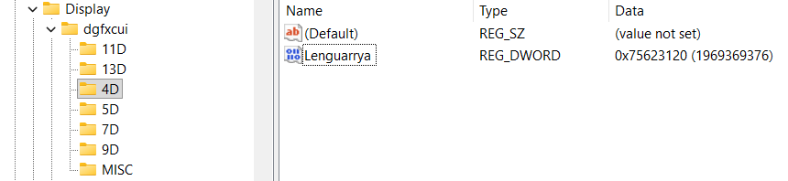
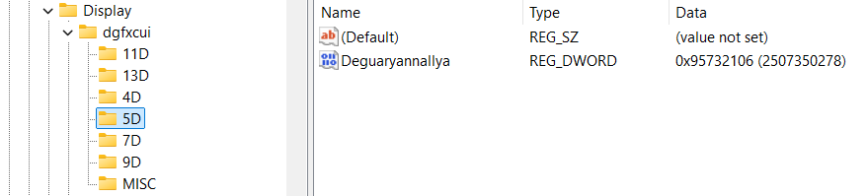
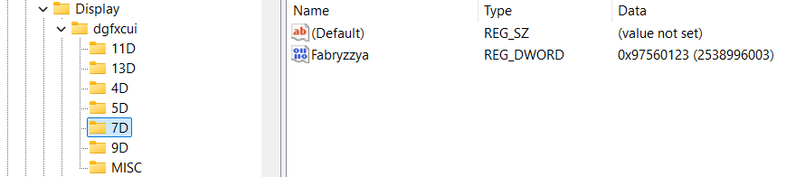
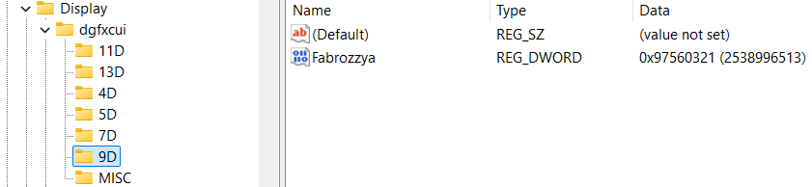

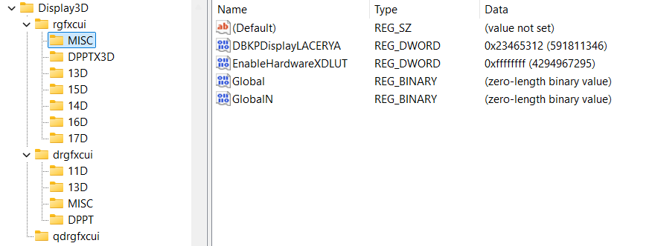
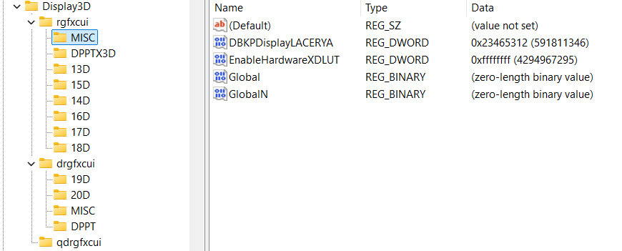

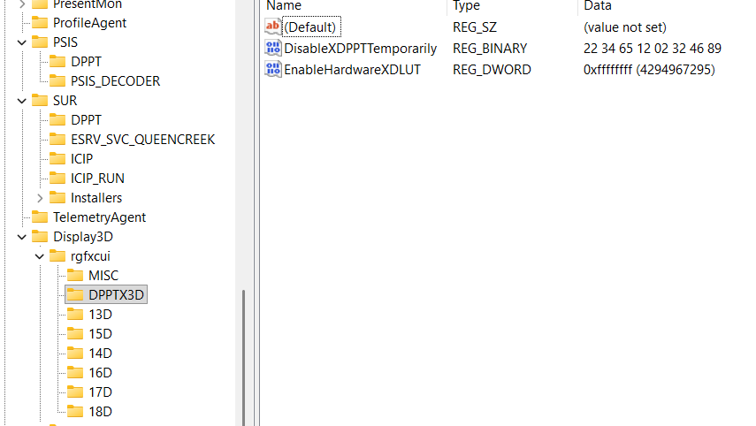
First of all those values were not that good… Not according to meaningful model as is cosmos (Yrrygonallya, Degonnallya) and first of all this values are short – DWORD and not QWORD which has their coding in question of their value…

IGFX\DPP
There is one more thing to add:
- Computer\HKEY_LOCAL_MACHINE\SOFTWARE\Intel\IGFX\DPP
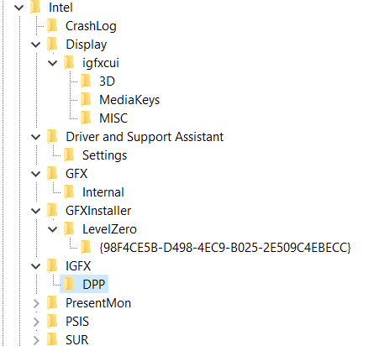
Suggested values:
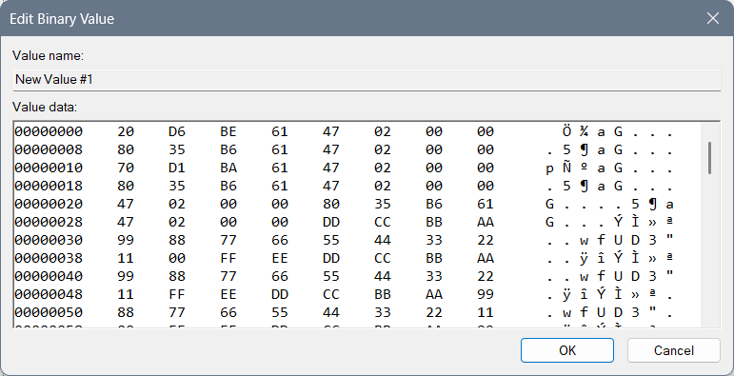
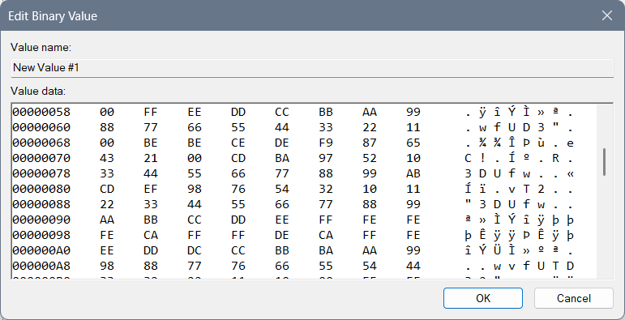
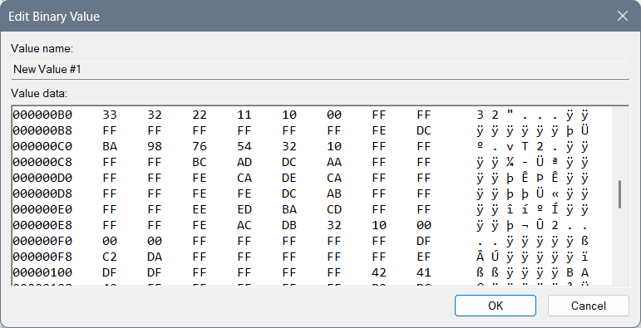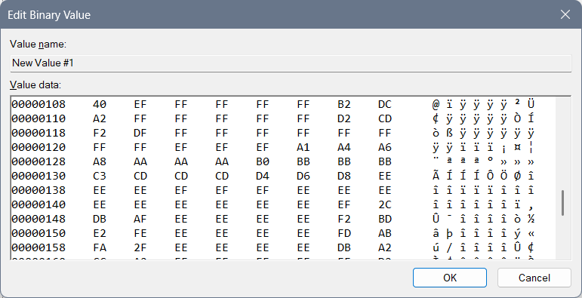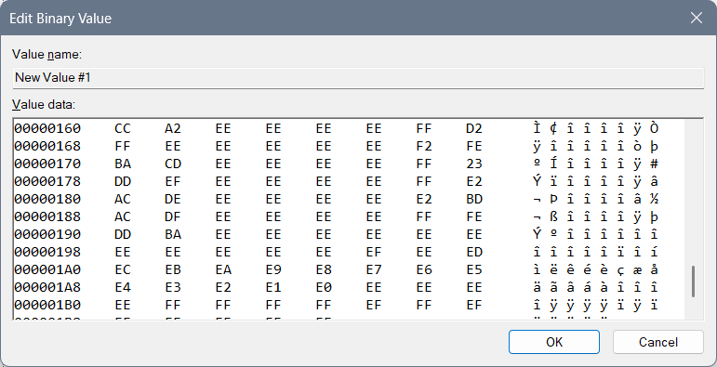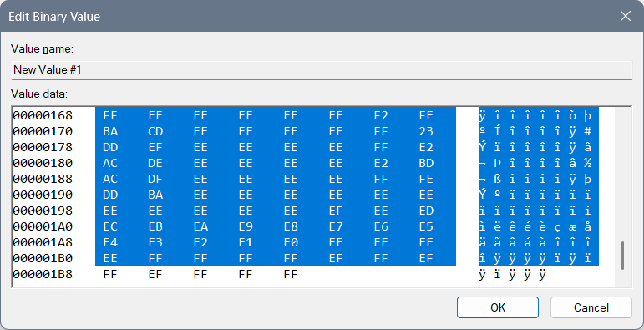
This code is based on some not fully made forbiddance (not fully made because it doesn’t give any descriptions or advices) with an idea that we start from the greatest letter “F” and if we mix and code the code into the “Yrrygonallya” complex model as is meaningful model “cosmos” we can get “FF”, then we want all the letters and numbers included so the first line of code is: “99 88 77 66 55 44 33 22 11 00 FF EE DD CC BB AA”, and if we start with numbers in coded and mixed Yrrygonallya we would get police protection, then letters would give us army protection… Second repeating of that line of code would normalize the protection and third would bring it to life…
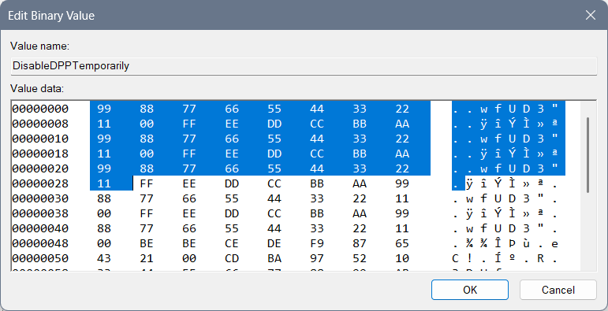Then we have the reducing of the protection to a regular level with these lines of code: 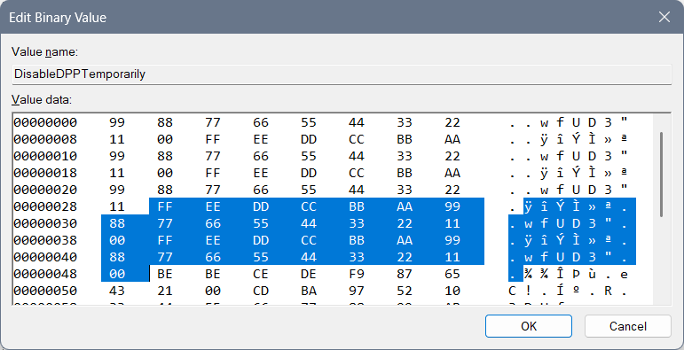

The next lines of code rarely few will understand, maybe even me…
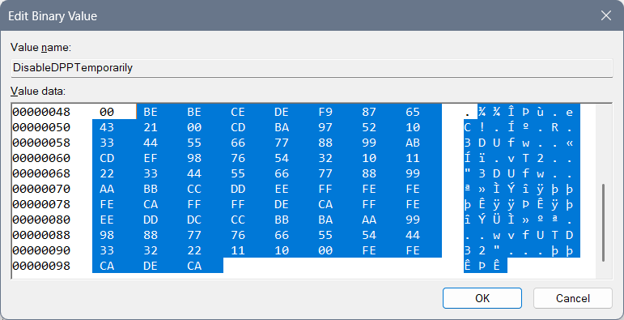 “BE” is “yrrygonall” (cosmos jokes left for the marks of meaning of something) code of the display for where we have been and what we have done… Double that would require a next chapter of code (so double that is prolonging of code) and if fully Hexa coded word fits into “Yrrygonallya” then after “BE BE” we would need to finish (as something that has been repeating – fractal, that fits into a particular model – for example “Yrrygonallya” or much simpler and better to understand “cosmos”) – “CE DE” which would mean extra complexing of the ban and the “descriptions to come” of those cosmos jokes appearing on the screen… “F9 87 65 43 21 00” would represent complexing of the data on the extreme level, so when we think on the level of imagining as much as we can achieve with our thought that much cosmos jokes would appear of what has been happening with us… “CD BA 97 52 10” represents how much we need and it says we need all of the data… You will find the name of the file “DPPT” – which by coding and mixing of the word and after playing with “Yrrygonallya” model and “fractal to cosmos” idea – we can find out that probably our data is complexed thanks to the previous code we had and after the “BE BE CE DE F9 87 65 43 21 00” if we connect what is there repeating of a single hexa digit as is for example “0” – “1”, and implement that into the “CD BA” we would get the vertical rectangle with the data included as is: “97 52 10” meaning: “only necessary data to appear, in short sentences that are complete”… That Extrapollation of the data we would get with increasing the:
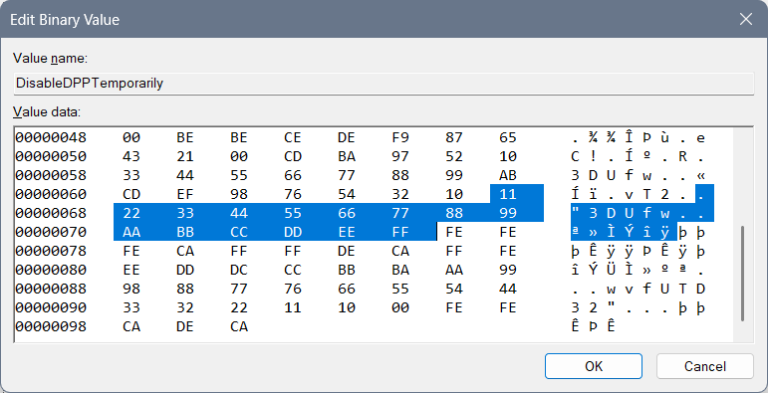
After that I have typed a complete and most complex ban of that data: “FE FE FE CA”, and allowing of the data: “FF FF DE CA”… “FFF EEE DDD CCC BBB AAA 999 888 777 666 555 444 333 222 1111 000” relies on complexing the need of the data showing and the variety of an ideas for the data to appear thanks to how we are feeling… “FE FE CA DE CA” has something to do with 3DLUT and it is connection part to the complexed data in between “3DLUT” and the “DPPT”…

From Cosmos History “Mergallyezzerrye” named being (belonging to DezAllystawrya model for beings) coding involves coding all files into the scheme of code, how only computer knows to get a real result… That idea “How computer knows” is named “Berslanderr” coding… “Berslanderr” is a name of “NaxAllystawrya” being that was thinking about the idea how all files can be connected all together by implementing a coding algorithm to connect all files and even for a computer to have an idea of implementing files for which particular devices don’t have a written specification…
Mergallyzzarye code connects the data all together – one file with another where one file is coded by implementing the extrapolation of the hex values from “0” to “F” and getting full word of 8 hex values, and all those files together in the end need to make sense…
Boffer code – is for how coded the code is – 8 times “FF” for the stopping of the device, 4 times “FF” in between the “density lines” – the meaningful part of the code… Effer code – represents the values that are “spinning in circle” – and are used to get extrapolation of the data that comes to our mind… Deffer code is there to explain everything and to give a meaning to hex values, hex files and is even able to create the new files and implement them into a code (here “Registry editor”) even if those files are not planned… Noffer code is there to represent the connection even in between the stopping code and the values in between, and in between the mixure of 3D ideas of the files where we mix both of the hex values of one file with another to get the idea of the 3D image…
To be honest that 3D image is there to represent cosmos joke that we can see on the display or the one that we can learn intuitively. The point is that those things we are doing, we can pull from the smart system and we can learn them efficiently… The system doesn’t need to be enabled at all, but by the regulations of the design we are there to at least learn to behave the way the design is requiring...

3DLUT settings are:
- “EnableHardware3DLUT” setting should be in the correlation with the ending of the file “DPPT” and those 2 codes should somehow represent life…
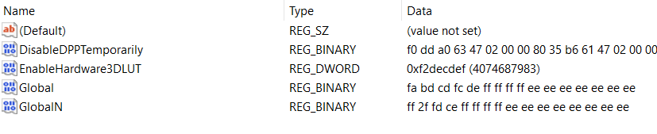

Previous not pleasing values ideas:
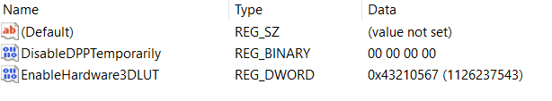
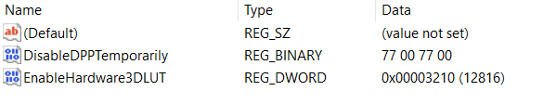
DWORD: “EnableHardware3DLUT”:
- For underworld codes which are maybe only for the environment around you: 43210567
- Life with begging: 56710234
- For 3D feeling for no reason: 22224411
- Fine for work: 75692320
- For shutting down the wrong things: 3210
- For turning on the thinking idea: 6543210
- For necessary: 43210
- Night light: Ban, fun, entertainment: 23153021
- Night light: Life: fdbacdaf
- No Exit: 0xaaaaaaa0
Interesting undefined ideas for the 3DLUT settings are:
- cdafccfc
- 23153021
- bebeca
- cebebeca
- cacabeca
- ffffedca
- Complexed: decabeca
- Fbacdfaf
- fffedbca
- fbacdfaf
- ff2a4cdf

New keys
Computer\HKEY_LOCAL_MACHINE\SOFTWARE\Intel\IGFX\DPPT
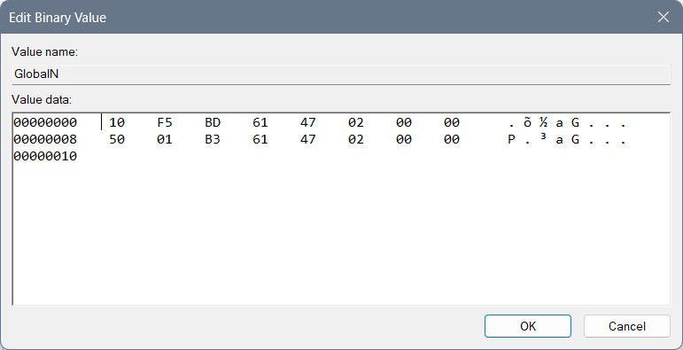

Post scriptum
Here you can find my previous, not well made, settings of the address:
- Computer\HKEY_CURRENT_USER\Software\Intel\Display\igfxcui\Media
You can look at these images down below just for informational purposes…
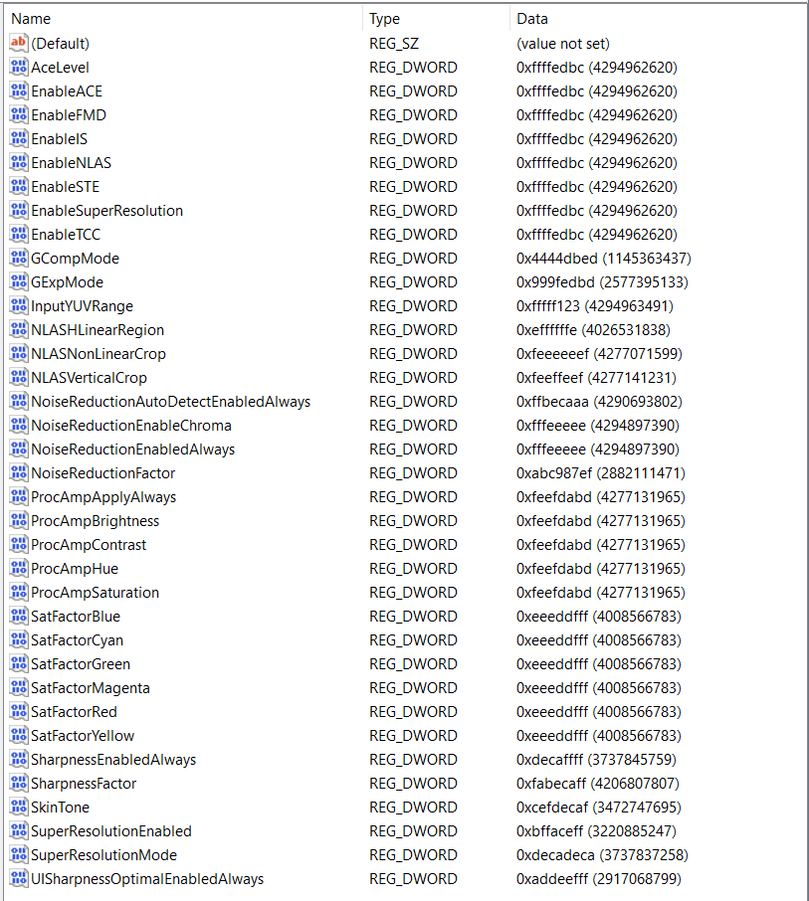
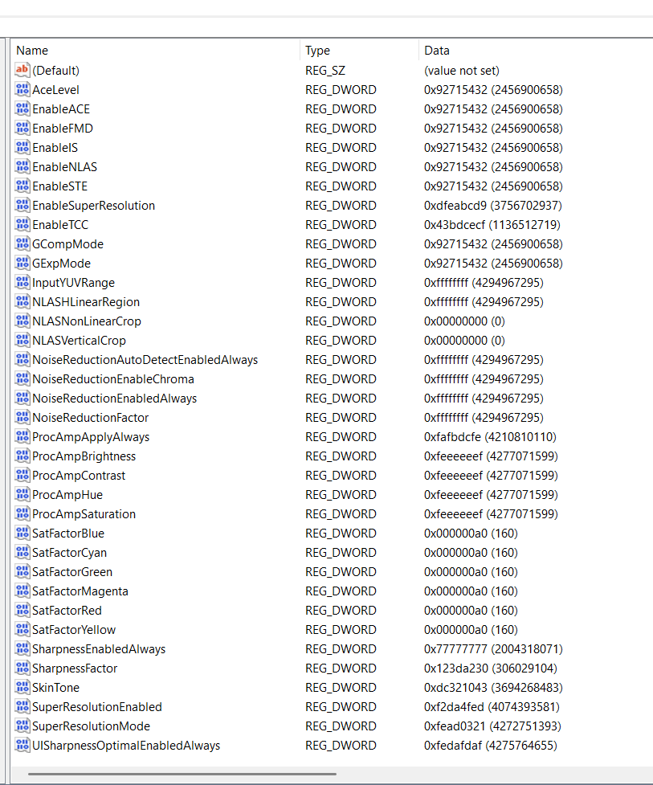

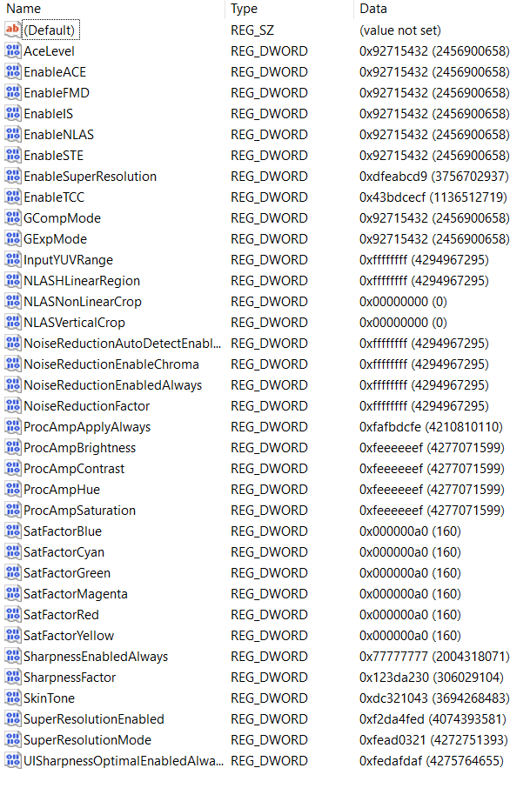

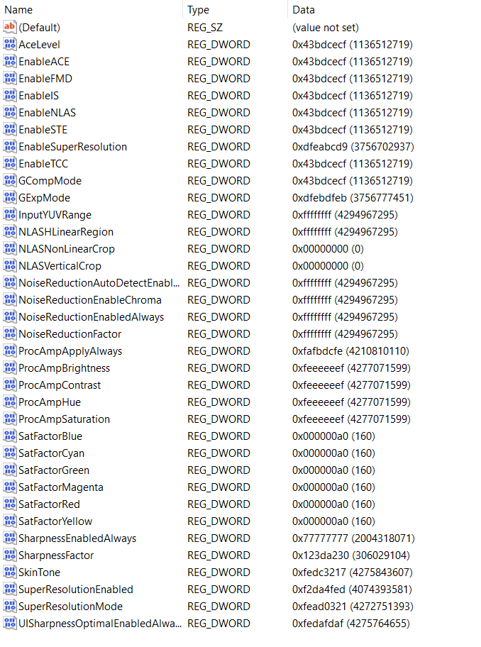

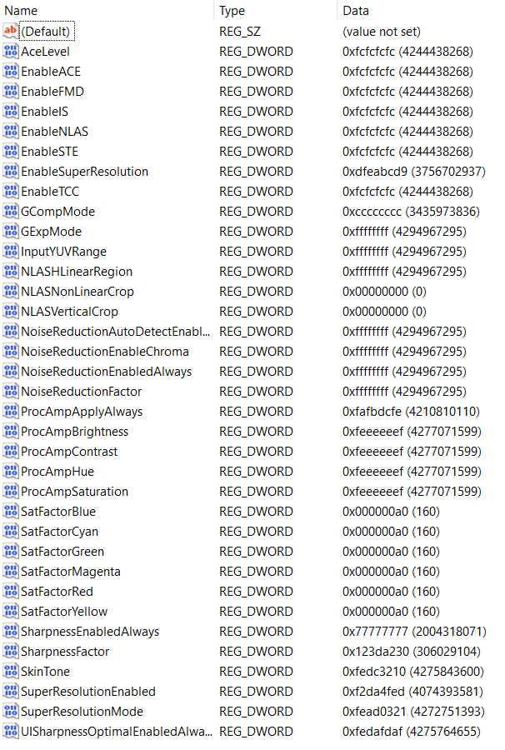

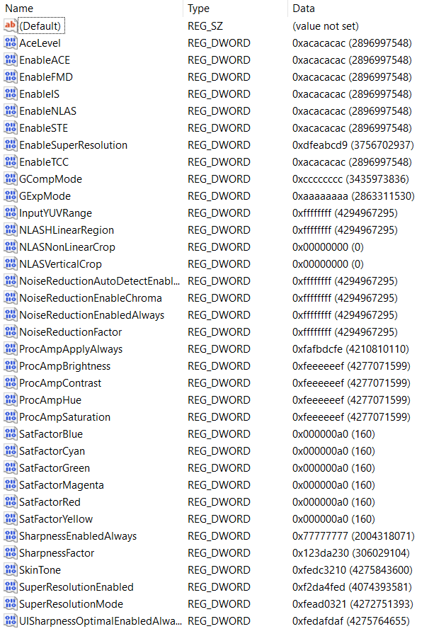
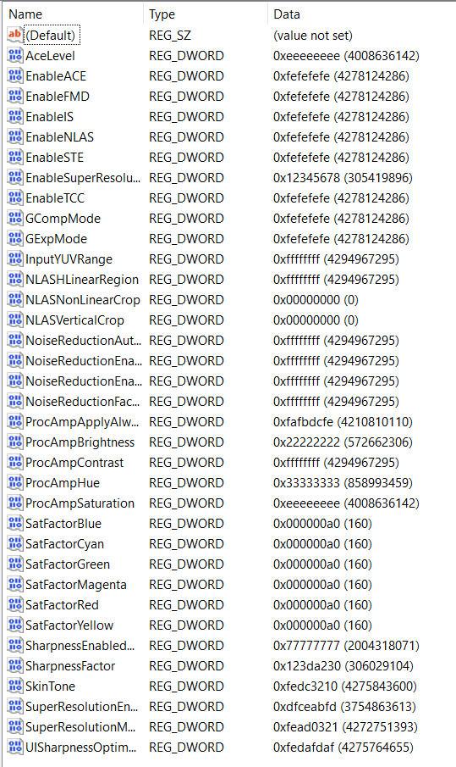
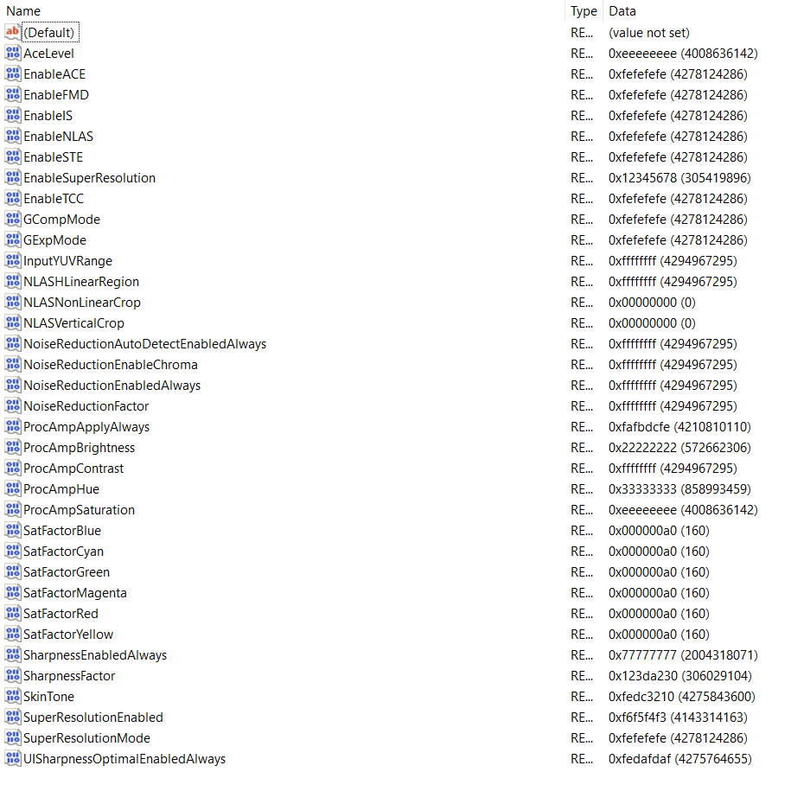
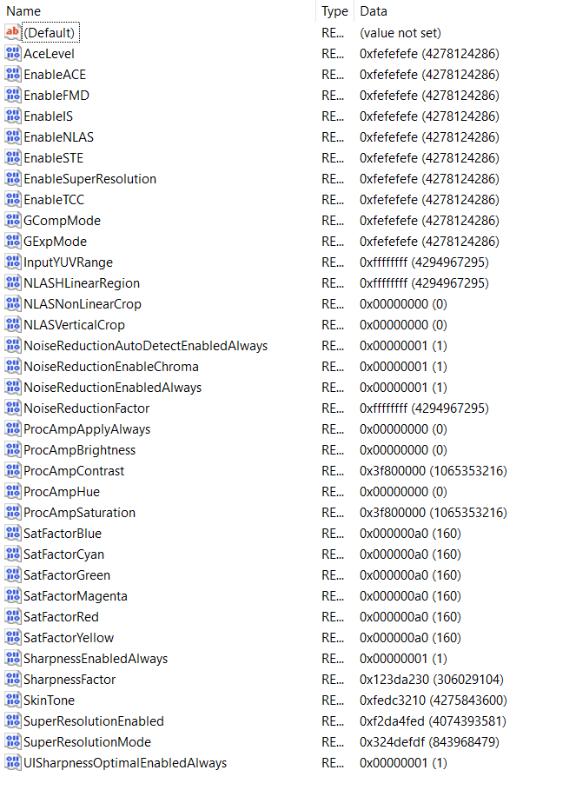

FFRTXZ

DPPTXZ
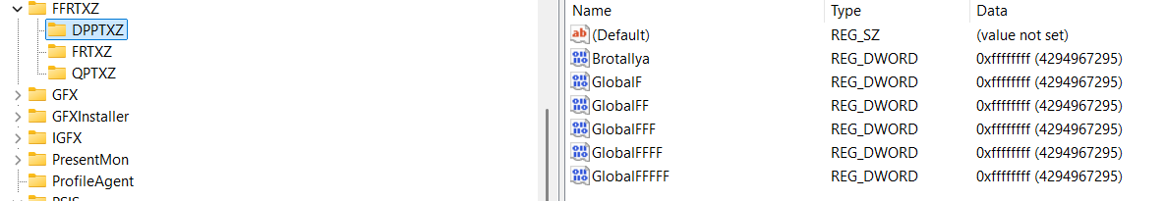
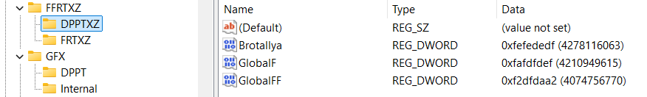

FRTXZ
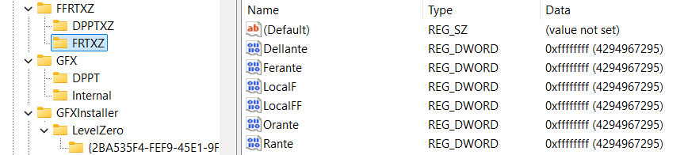
If you want to allow:
- Dellante you should use “fafadafa” (as some primitive planets knew so) or “fefedefe”…
- Rante: 2a2a2a2a, 2b2adca2
- Orante: 23232323, f23dbaf2
- Ferante: fdffdfdf
- Adyllante: f2dcabfd, fbdcafdb
Earlier values not implemented are for “Global”: “F2DF2AF2” – extrowallyattarry ban – on all and everything but reading only allowed things… For the file “GlobalN”: “AFDFEDDF” we have Nonbralltyya ban on reading banned things… Because you do actually need to ban idea of global (usually alien reading for smart beings) and there are “symbols” (words)

QPTXZ
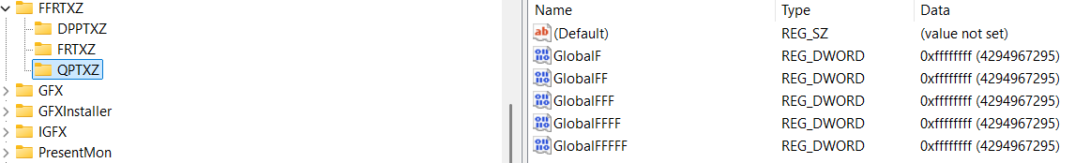

“HKEY_LOCAL_MACHINE\SOFTWARE\Intel” Folders
Under a key: “Computer\HKEY_LOCAL_MACHINE\SOFTWARE\Intel” I had these keys:
- DDRTZ
  - DPPT
- DGFX
  - 6D
  - 7D
  - 8D
  - DPPT
- DGFXI
  - 9D
  - 10D
  - 11D
  - 12D
- DPPT
- FFRTZ
  - DPPTXZ
  - FRTXZ
- GFX
  - DPPT
- IGFX
  - 2D
  - 3D
  - 4D
  - 5D
  - DPP
  - DPPT
- PSIS
  - DPPT
- SUR
  - DPPT
- DRGFXZ
  - MISC
  - DPPTXZ
Notice that under the Key “IGFX” there is a Key “DPP”, I renamed it to “DPPT” for the hope of a better system… But that didn’t help much… The point is that connected Keys and the Data in the QWORD creates a fully valued system and some long words can’t be usually shortened to a programmed code as is “DRTZ” from the “Deggennerreyyazzattyonall” – which means involvement of the watches…
Under below you will find the images of the files with codes you need to open and fill into Registry Editor.
When you find a “REG_DWORD” file named: “EnableHardware3DLUT” you should rename it to the “EnableHardwareDLUT”.

Old photos and some of the values:
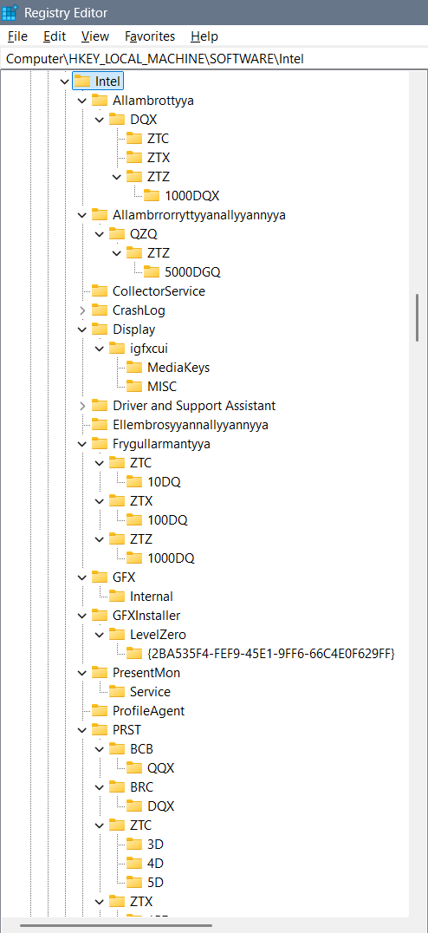
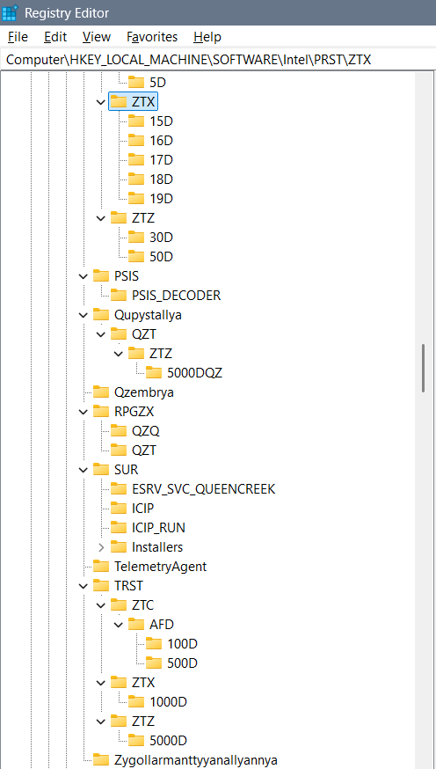

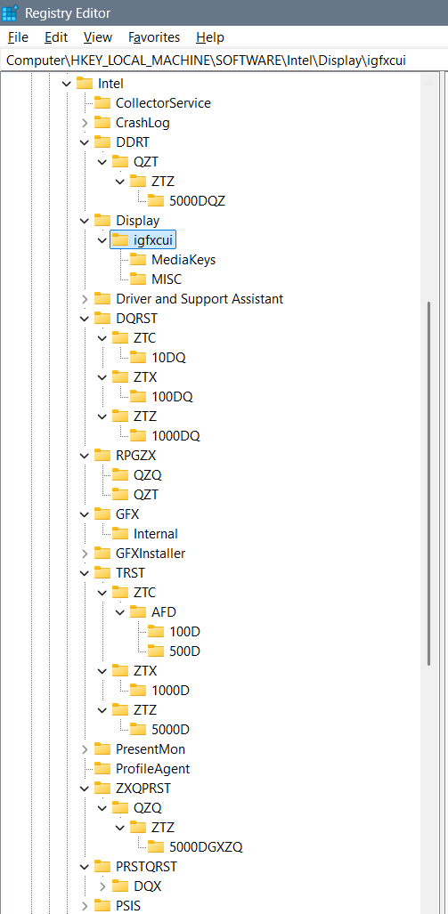
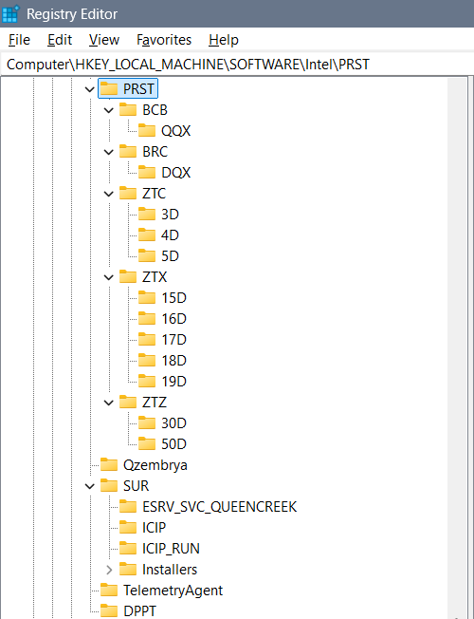

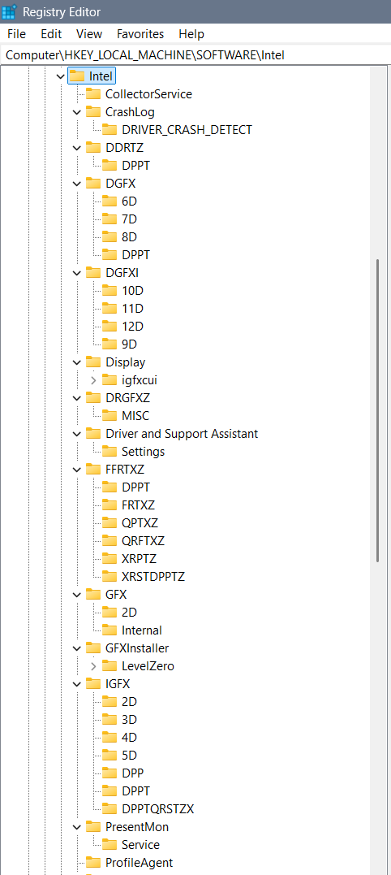
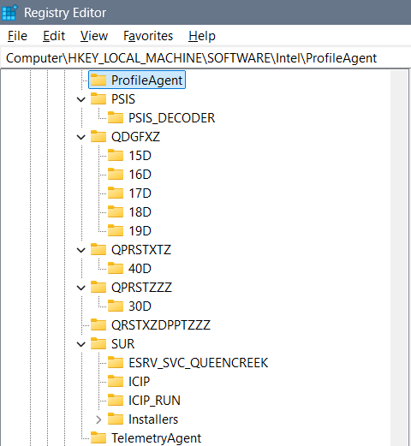

DGFX
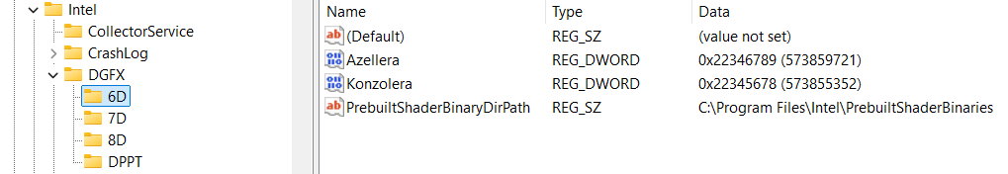
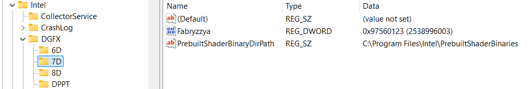
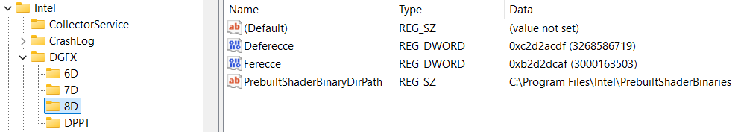
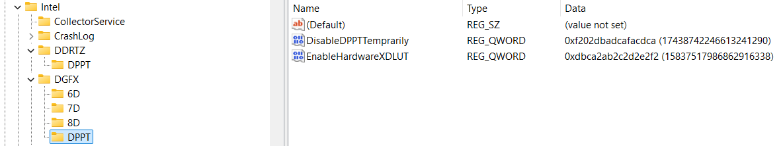
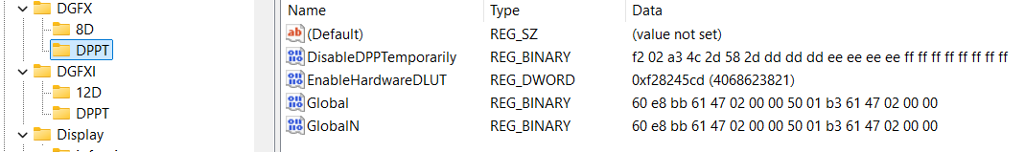
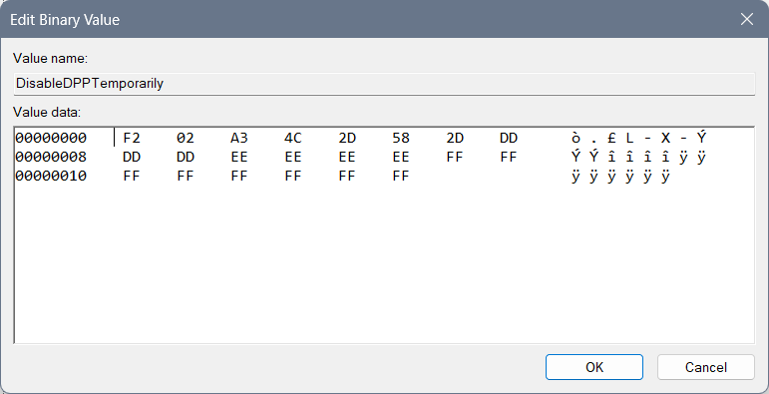
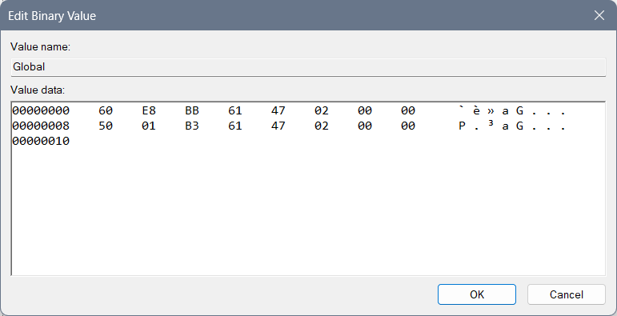
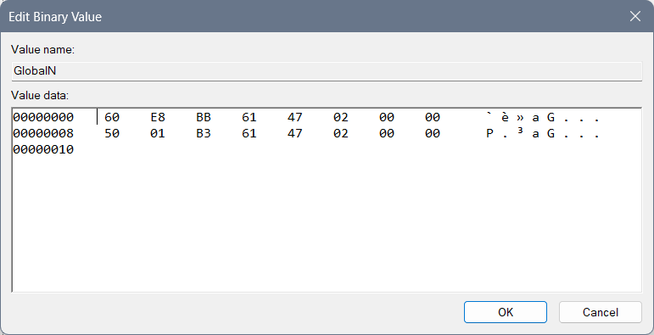

DGFXI
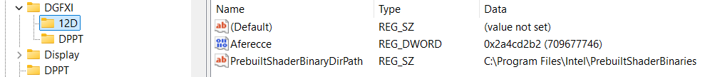
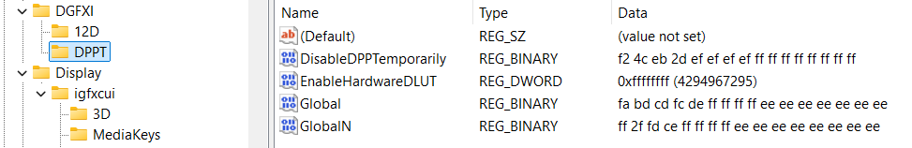

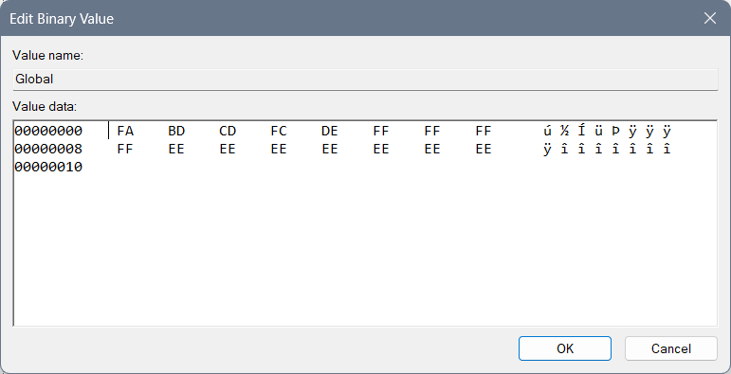
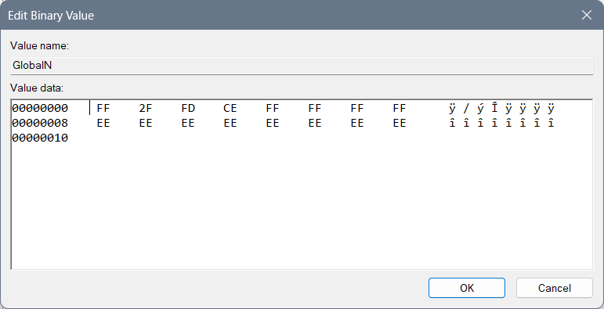

DPPT
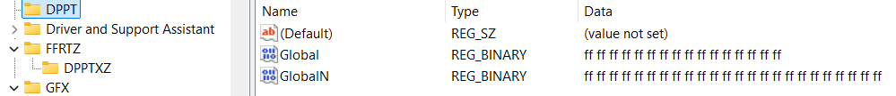
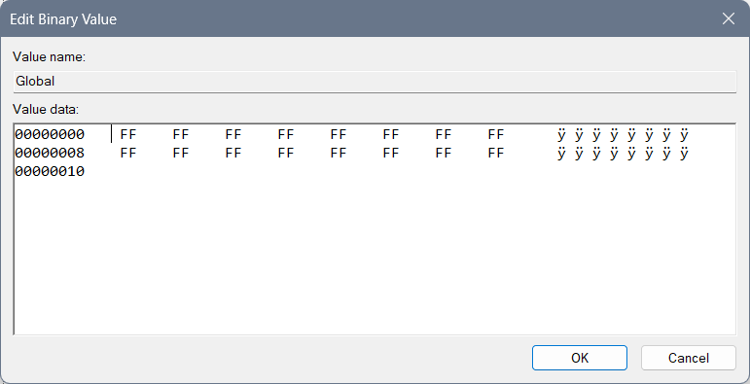
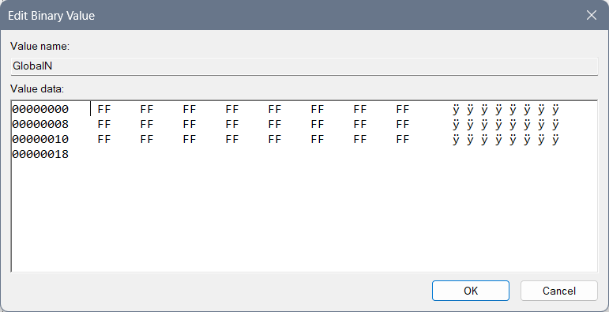

GFX

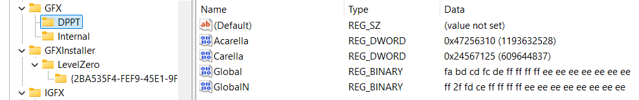
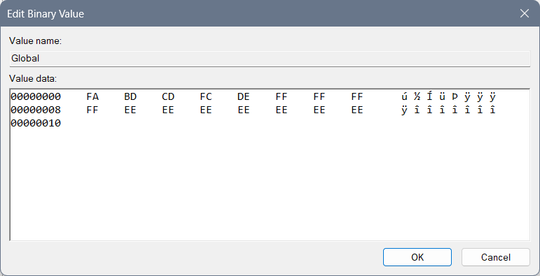

IGFX
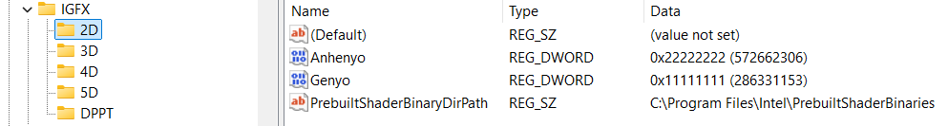
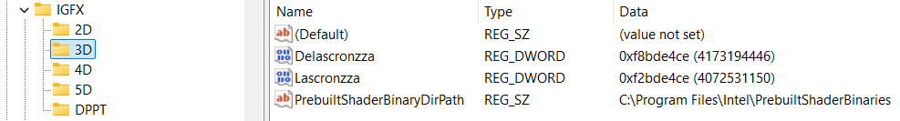
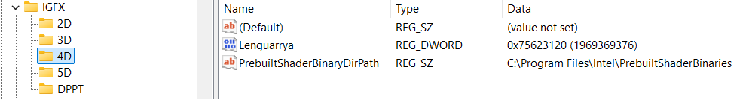
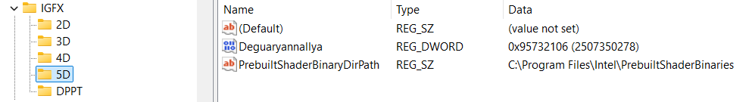

DPPT
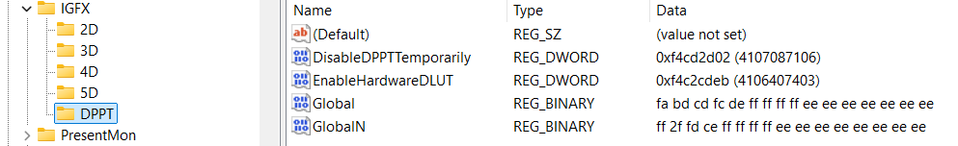
Or different idea of the DPPT which cuts the system differently:
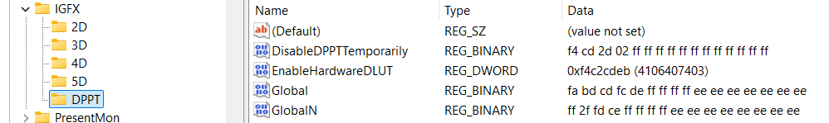

DPPTXZ
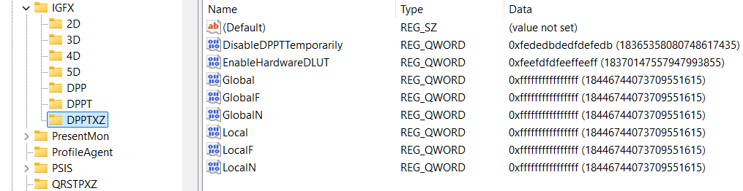

DPP
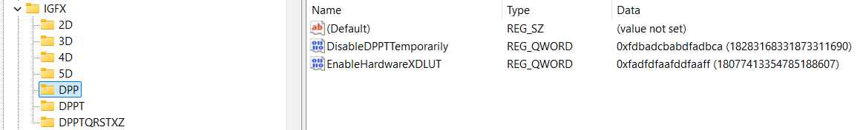

DPPTQXRSTZ
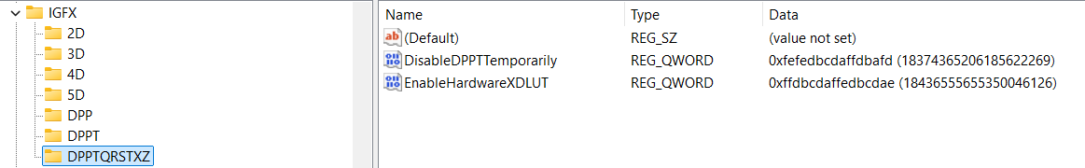

PSIS
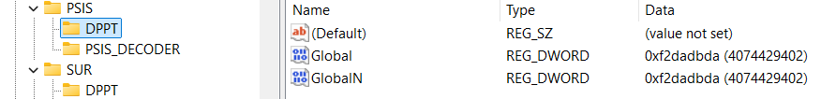
Or different solution which I am not preferring:
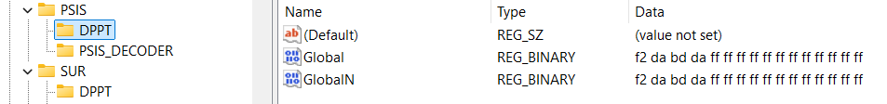
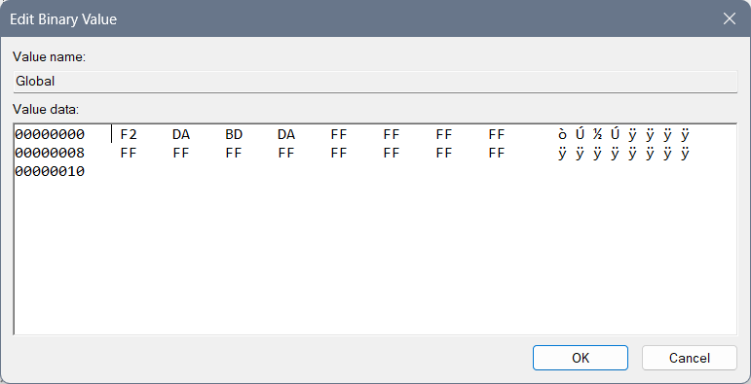
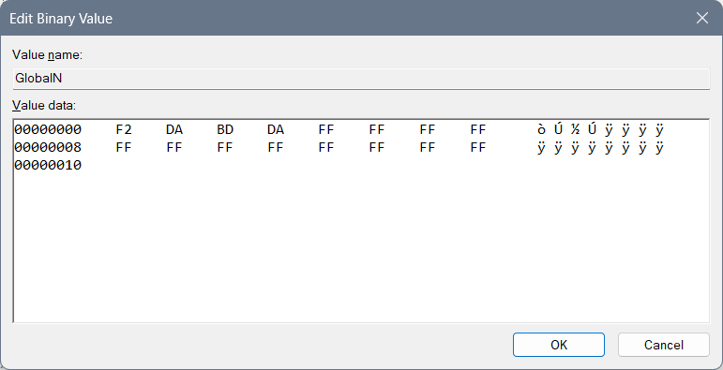

SUR
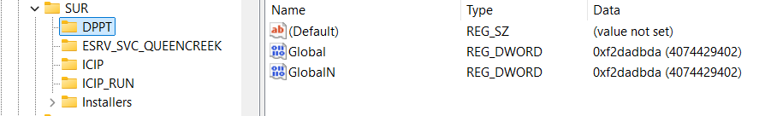
Or different solution which I am not preferring:
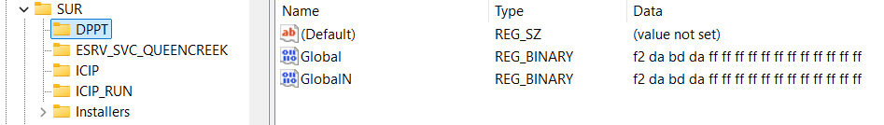

igfxcui
Files 3105 and 3106 leave the same, but create 3107, and 3108 and 3109…
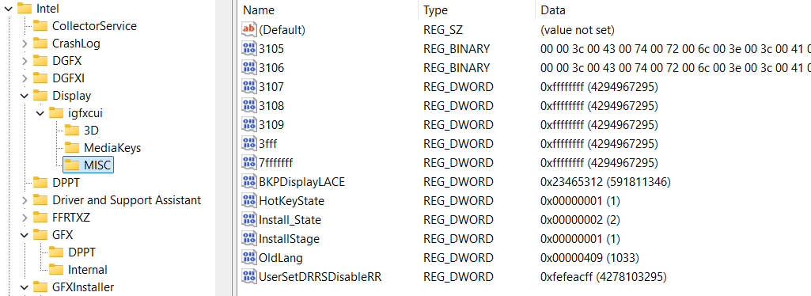

Here you can find a regular DRRSDisableRR which is 30… I set it to something that for me makes more sense…
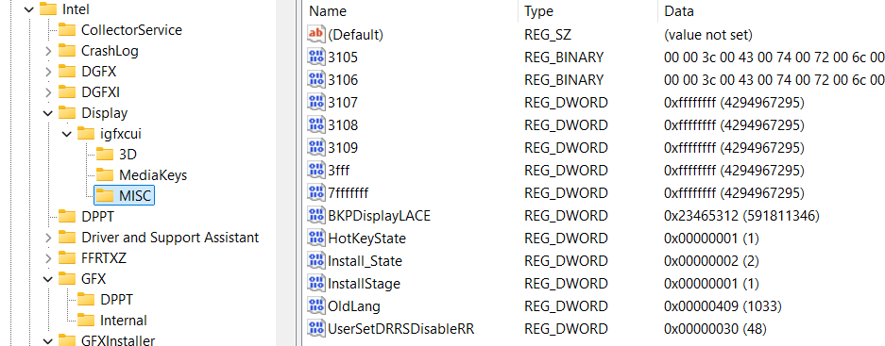
You can use this model with BKPDisplayLACE with all of the “f” chars but I do not suggest it because it represents open system of everyone around you and it doesn’t focus you on your job only…
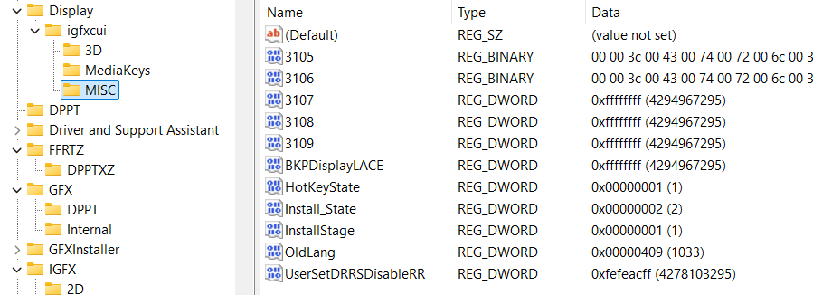
When you have a primitive idea of the 3D, you can implement 4D, 5D and up to 15D in the files as are dgfxcui (4D, 5D) and rgfxcui (6D, 7D, 8D), drgfxcui (9D, 10D, 11D), qxdrgfxcui (12D, 13D, 14D, 15D)… Each of those files should have the idea of the system speed being created by pixel movement to awake the brain idea of the cosmos jokes on the certain frequencies which is interesting because then user can see 3D image and so on…

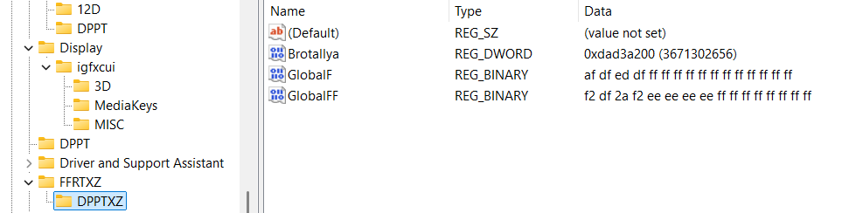

DRGFXZ
For Quanzyllyumar Display type regular values, and for a regular one type 8 times f: “ffffffff” into Ablagerio and Zeronimo…
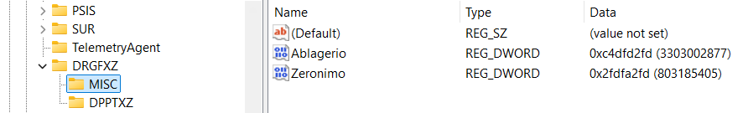
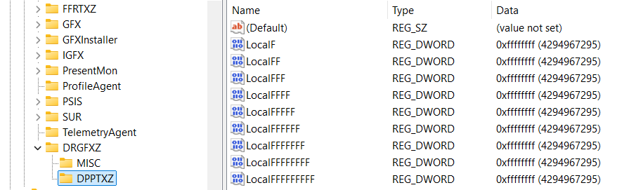
I believe if there is Ablagerio “ffffffff” and Zeronimo “ffffffff” then there is the key “DPPT” instead of “DPPTXZ”…

QDGFX
RSPTXD
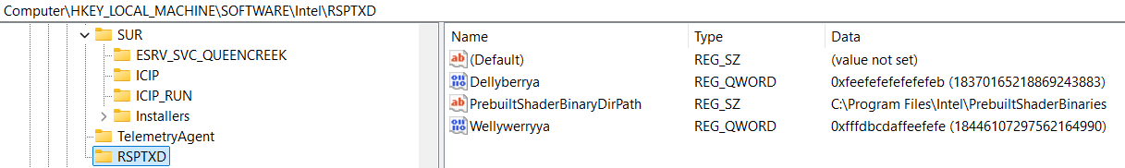

DPPTXZ
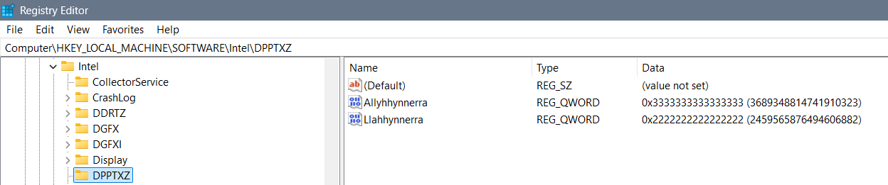

Banning
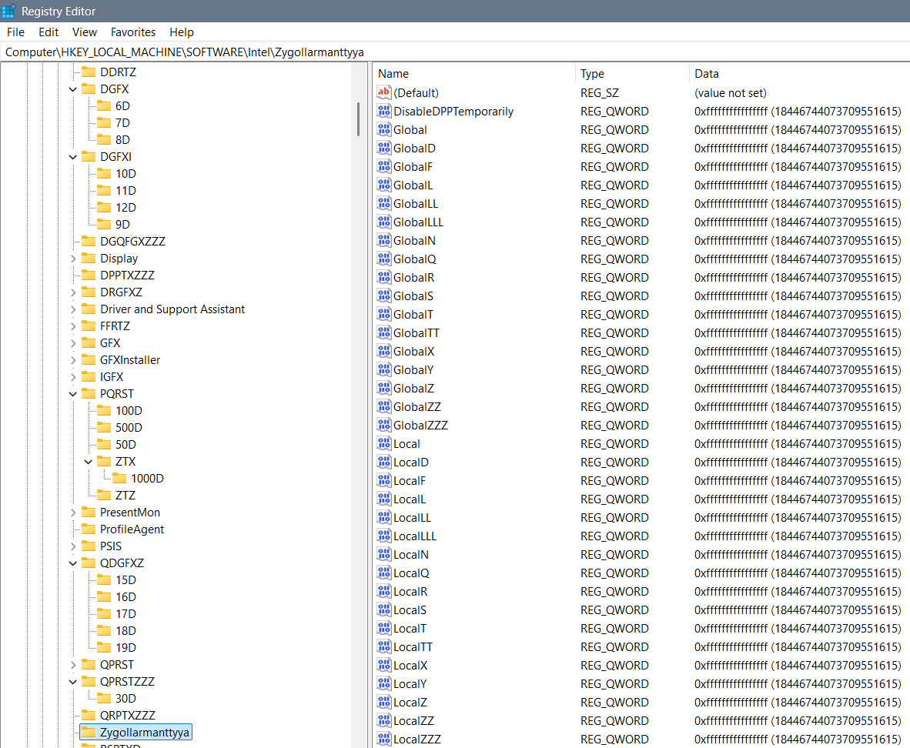
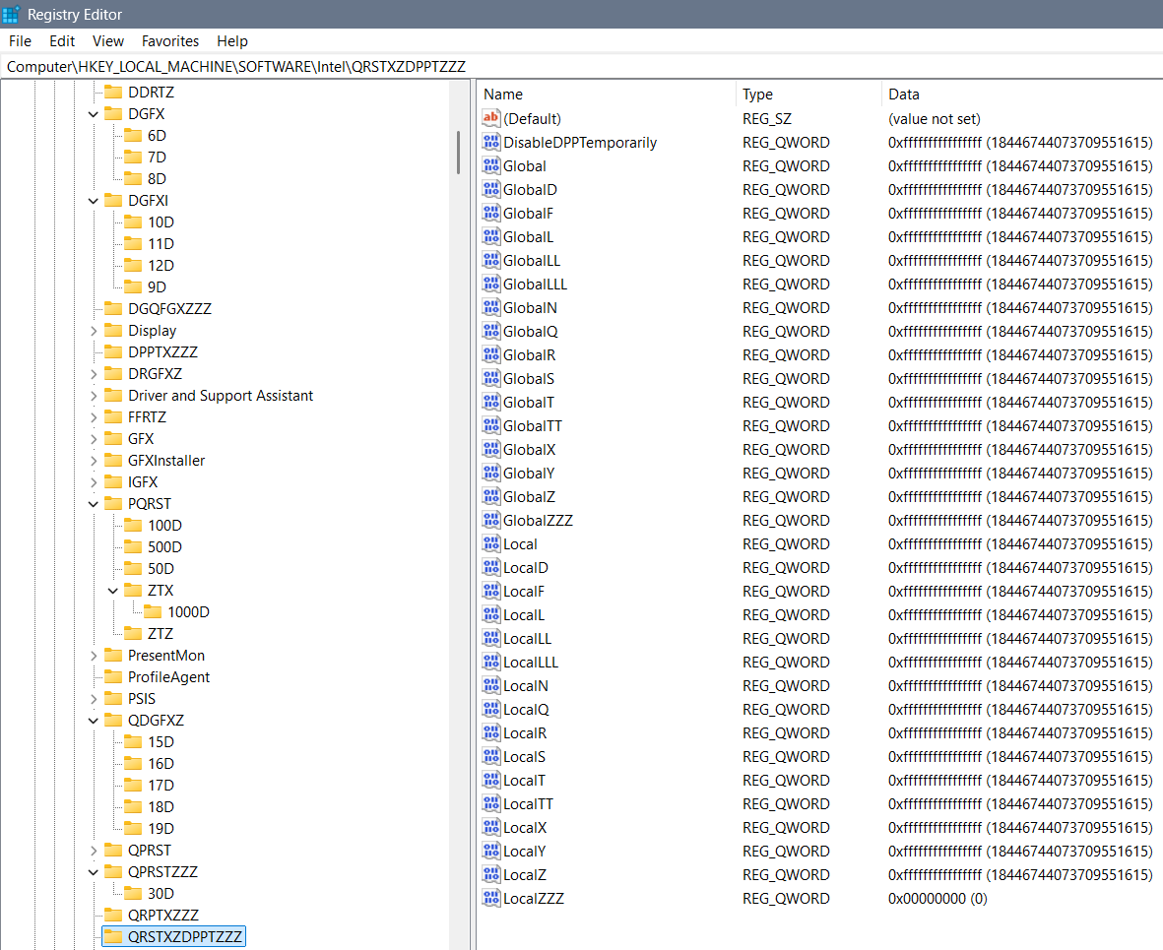

Something
Previously not good settings are moved to this part of the TXT without thinking and maybe these codes represent something, maybe they ain’t that good, but I find them unnecessary…
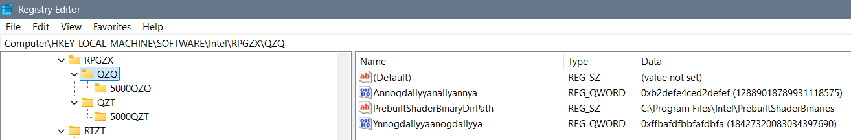
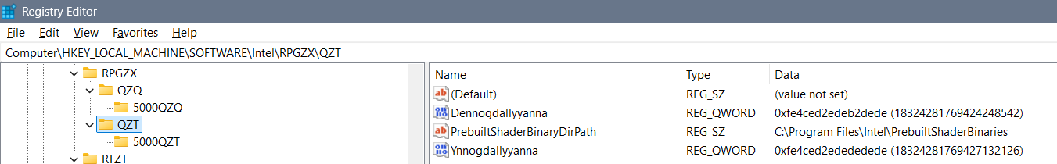

PRST
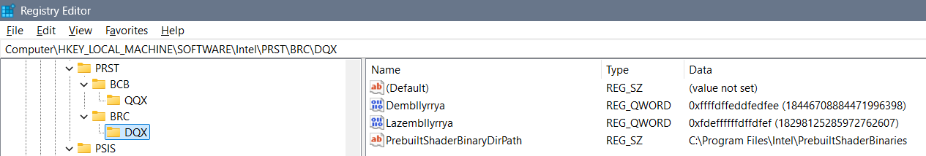

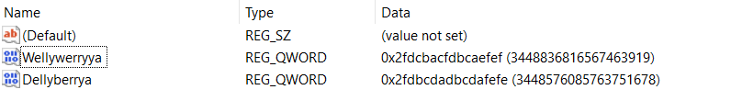
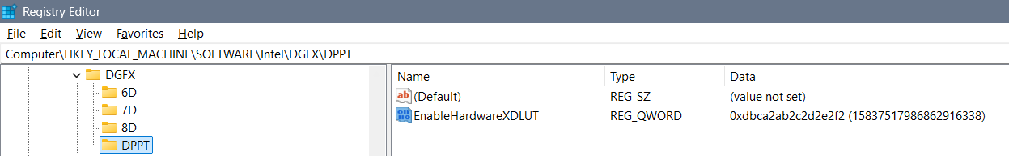
Fedbcdaefdfaefdf
Ayyannte
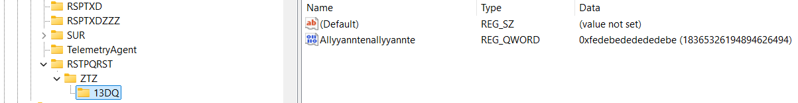
QDGFXZ
Zyndallya, Zembrallyya, Zemmallyya 3 bans on everything out there
Ffdbcdaffedbcdae
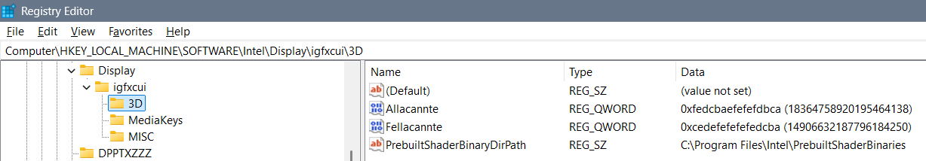
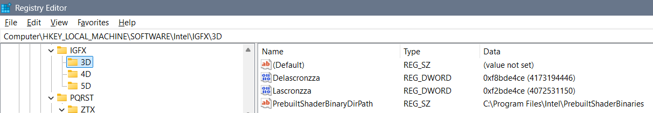
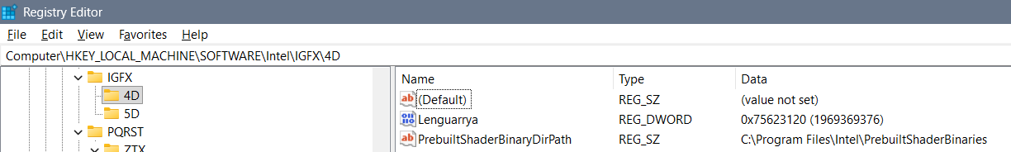
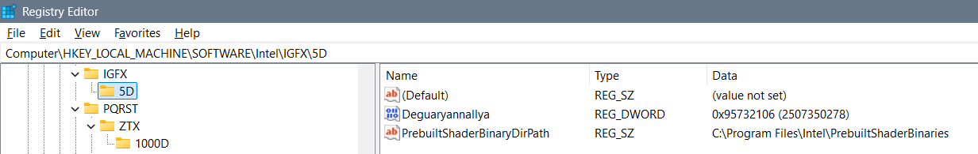
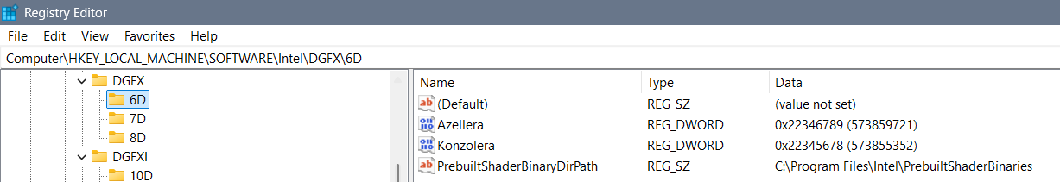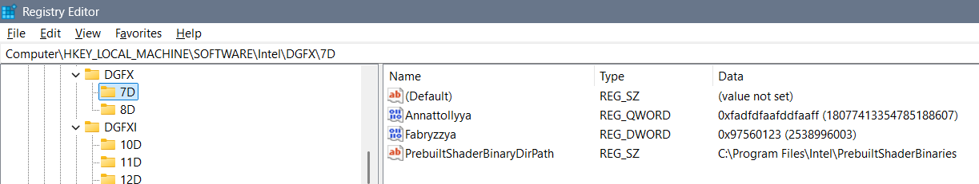
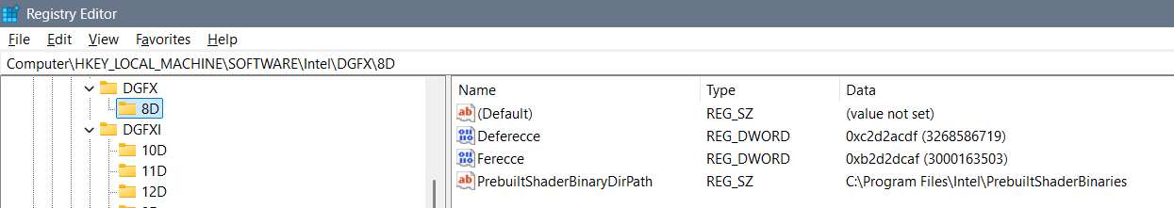
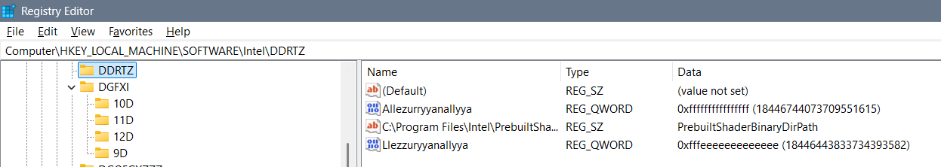
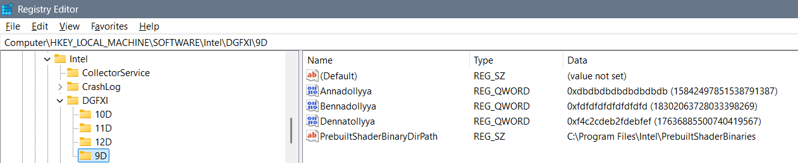
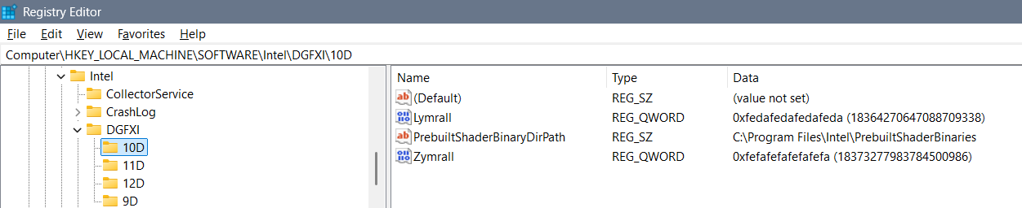
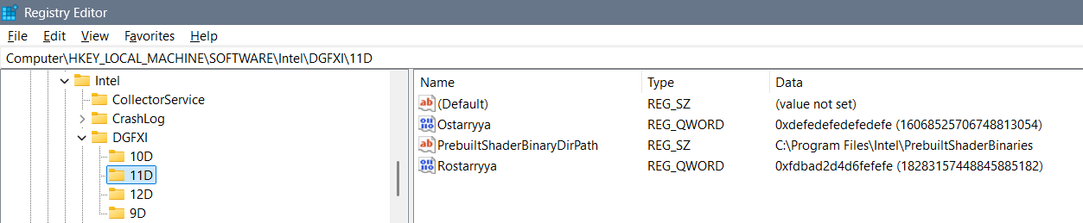
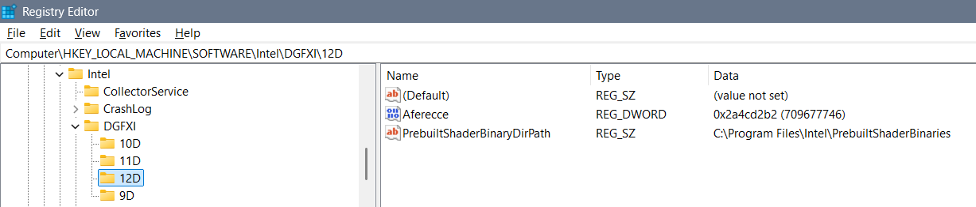
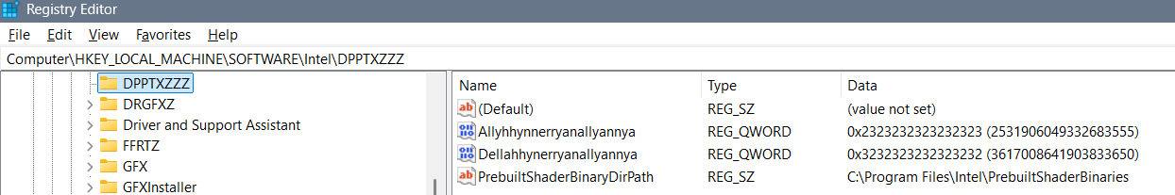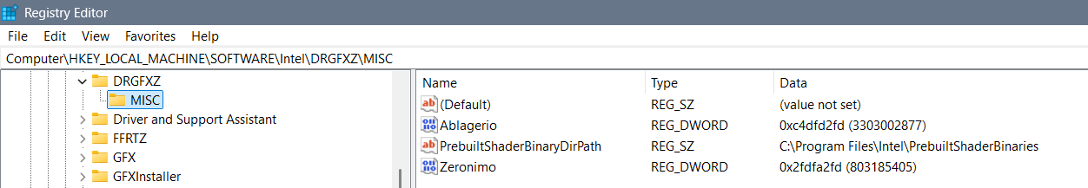
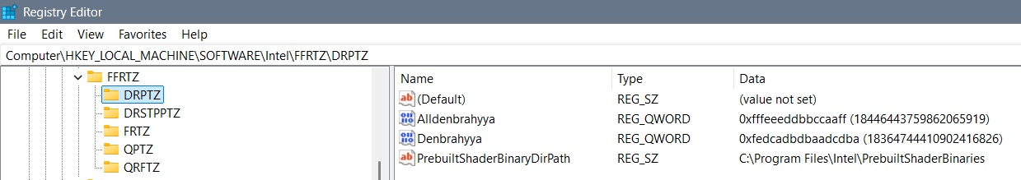
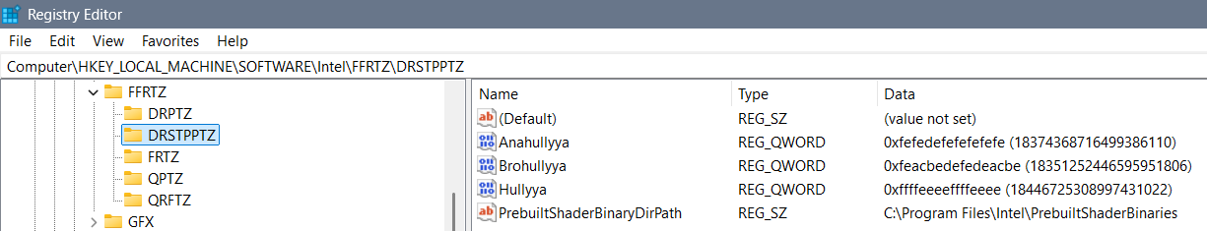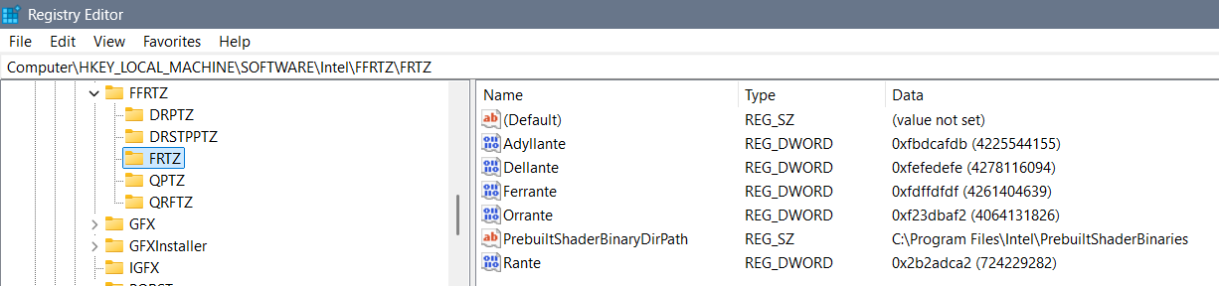
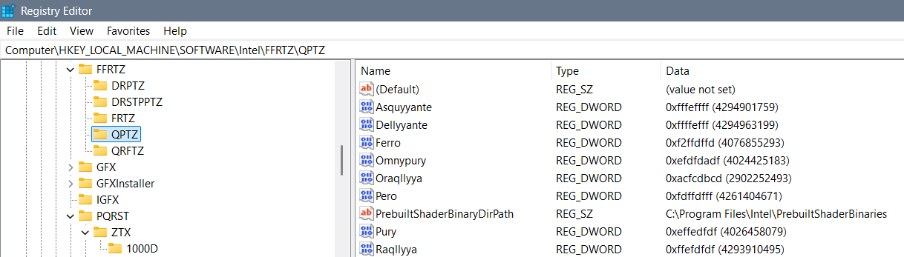
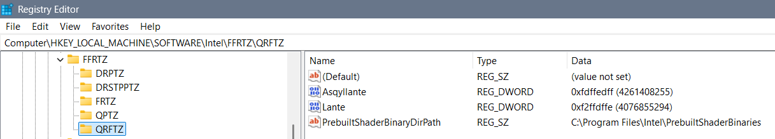
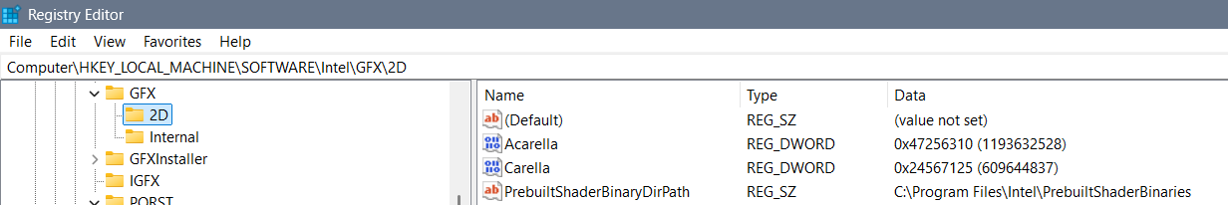

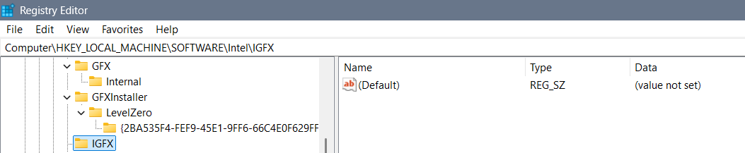
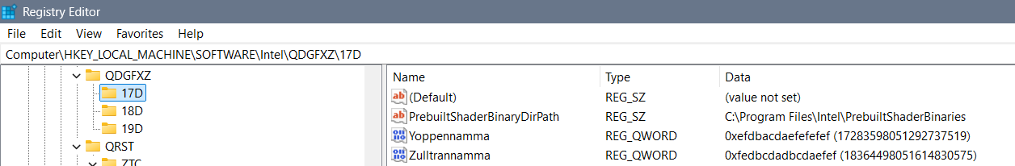
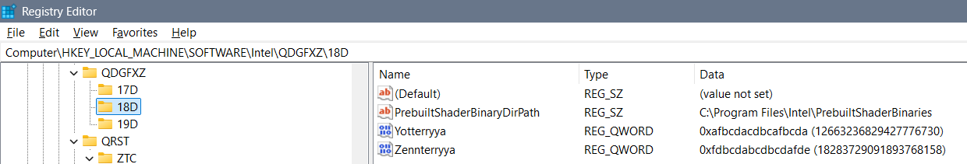
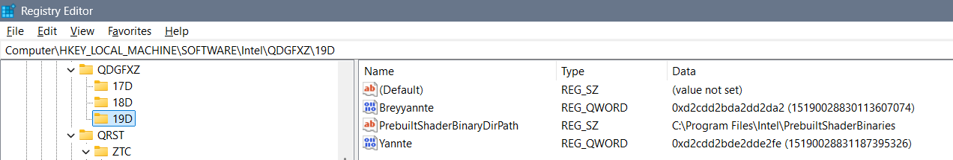
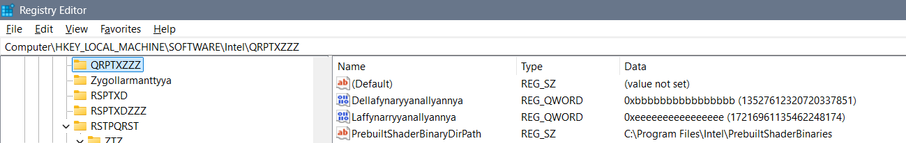
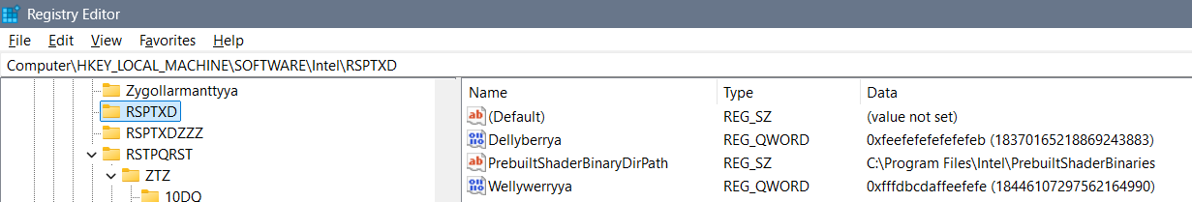
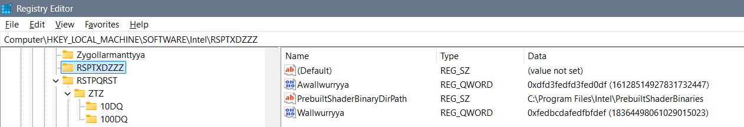
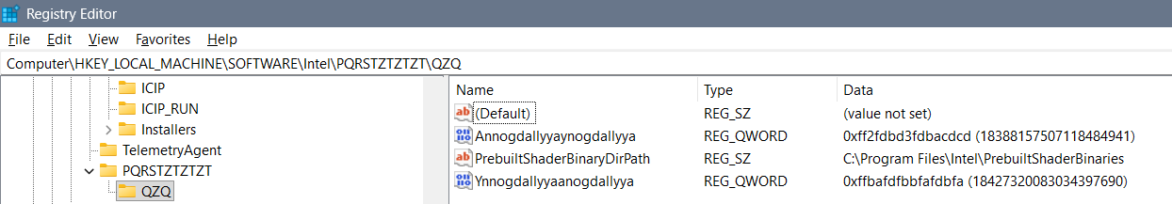
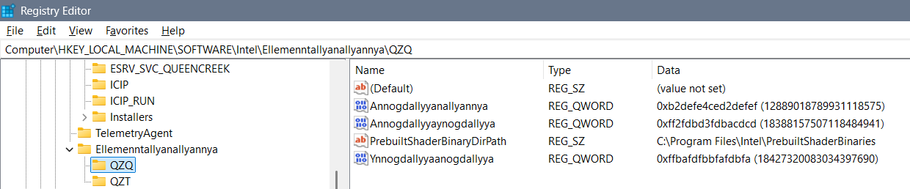
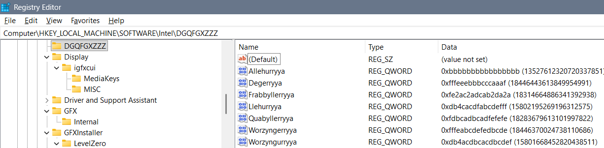
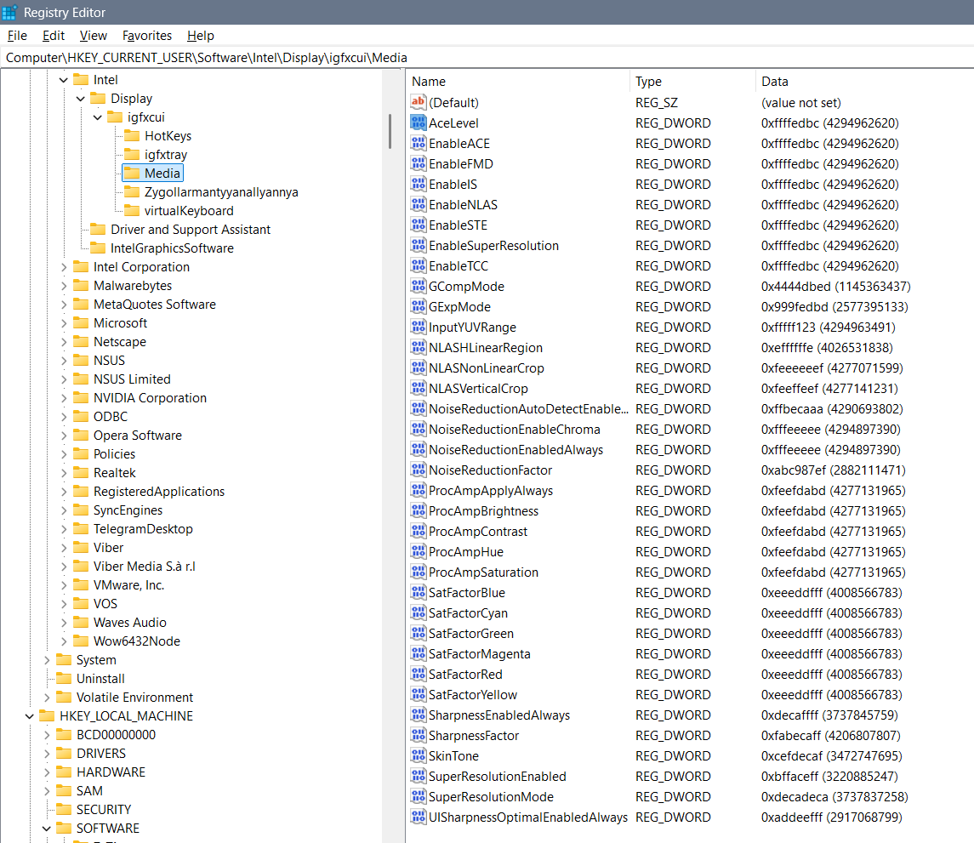
Ygullanttyyanallyannyya: bcdeefdbcdefeffe?
febcdeffbcdef4ce
Perryplexx Parrapllett
Parapplett
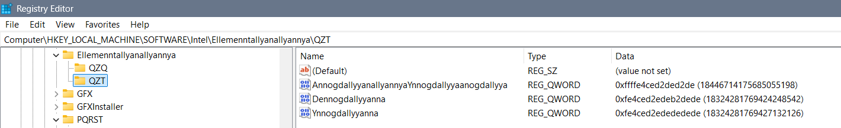
Ellemenntallyanallyannya – RPGZXDT
Zygollarmanttyyanallyannya - DPPTZZZ
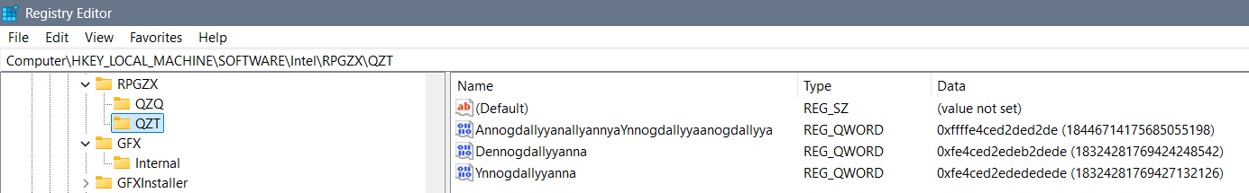
Allambrottyya PRSTQRST - DQX
Frygullarmantyya DQRST - DQ
Qupystallya DDRT – QZT – DQZ
Allambrrorryttyya - ZXQPRST – QZQ – DZXZQ
3DLUT - fe4cdefe4cefedef
DDQ Reallnyya Dereallnyya
Alldonbrerryya, Radonbrerryya

Igfxcui/MISC
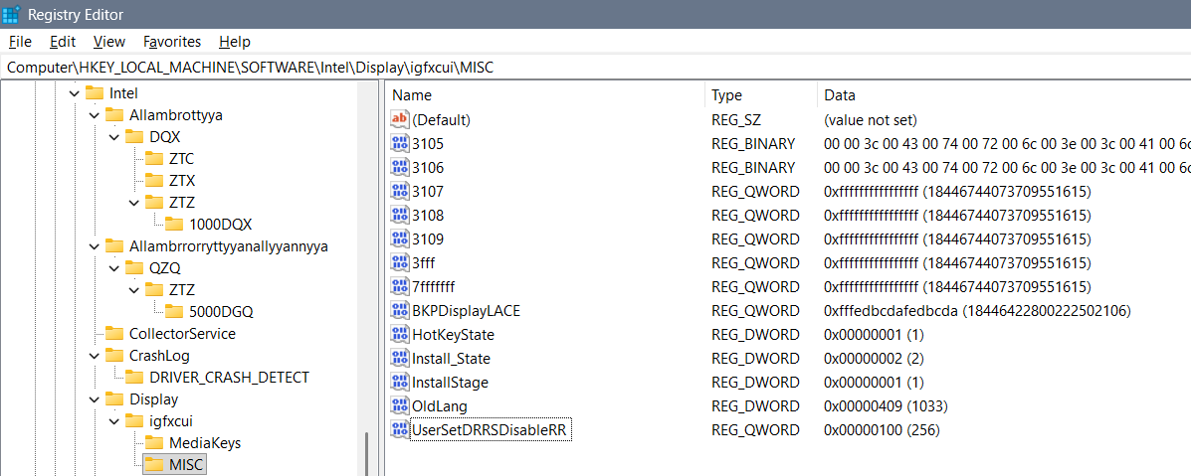
Possible options for DRRS-RR, in decimals, are best finishing with 9 as is 59, 109, and etc… All of the values I could think of are: 31, 59, 120, 256, 1024, 1759 of how much data you would like to be shown on the display and how for each user – so the best thing is to use all “f” – “ffffffffffffffff”… Maybe you can use “fdcdabdabddabdab” but I believe is wrong…
First option for “UserSetDRRSDisableRR”: the “ffffffffffffffff” value would take care of you and create you pleasant nice and kind – would take care of you always…
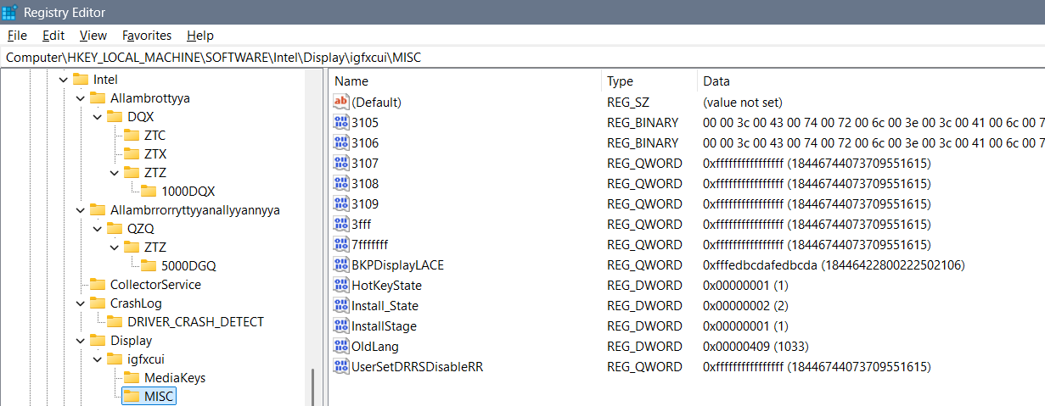
Second option is in kind of “live” as you are which we got used to mostly:
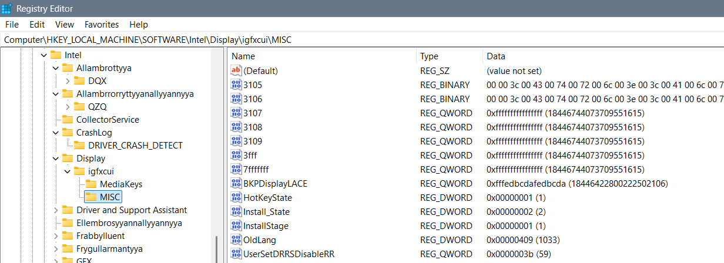
“UserSetDRRSDisableRR” is a thing to discuss because of it depends the whole possible system and it’s functionality… Are cosmos jokes seen and is there an ability for them to be removed by someone else, can the one pull the system and etc… That key somehow connects all other keys… The preferred ban is using the number 7 to ban the other beings involved in display, 5 to ban the touch on cosmos jokes, and 9 to ban the wrong usage of display when beings are sleeping… I believe that with that idea the typed in number should be “7779755955755957” but that is completely wrong… Because we already have one coded DWORD data of this file the next data of this file needs to be coded through the Coded with “3B” the best option I have is: “eabcdeabcdeabcde”... The system would maybe suggest that the first DWORD file is although coded through the “3b” and actually that is seen as “3b3b 3b3b 3b3b 3b3b” for a QWORD file, so the next step is muting the second file with 16 times “f” or “ffff ffff ffff ffff” and then the system would suggest code through “fead” but nothing more of that to the right side, to the left there is extrapolation of that code into: “fefefdcbadefdeaf” I am not quite sure… To work on “fead” hex word we would extrapolate it with mixing and adding codes into a 16 bytes we by using the extra coding – or extrapolating of the coding as is “feafdeaffeadfeaf” which can be one of the answers how to code this file…
All solutions I had before that an idea of are:
- “faebdcbaebcdbeaf”
- “fefefdcbadefdeaf”
- “feafdeaffeadfeaf”
- “feadbeafdeaffeaf”
- “eabcdeabcdeabcde”
- “feadcbedbeedbfed”
- “eabcdeefdcbeafed”
- “fabcde7232fabcde” – using the opposite logic to enable the value
  - “fecedebeaacdb”
- “9995579975597797”
- “7795757757975577”
- “770000700700007”
- Parraflexx Purryflexx and etc. 5, 7, 9
- “ffeacbadeabcadea”
- “abca2da2a2da2aba”
Solutions without 3b coding:
- Quynguystalla of 3 elements as are “777”, “77f”, …, “fff”
  - “f7777f77777f7777”
  - “7fff f7ff ff7f fff7” = “7ffff7ffff7ffff7”
  - “7f77 77f7 777f 7777”
  - f77f f777 7f77 77f7 = “f77ff7777f7777f7”
  - Maybe: “f77ff777f777f777”
  - Maybe: f7ff777f777f777
  - Maybe: ff7ff777f777f777
  - Maybe: “ffff 7fff f7ff ff7f fff7 ff77 f7f7 f77f 77ff f777 7f77 77f7 777f” = “ffff7ffff7ffff7ffff7ff77f7f7f77f77fff7777f7777f7777f”
- Franguystalla of 2 elements as are “77”, “7f”, “f7”, “ff”
- But since the values are not changeable in that folder we need to use coding through “3b” including mixing and complicating which I believe gives us numbers as are “6 and 9” or “5, 6 and 9” with less restrictions… There actually isn’t а value for disabling the DRRS but enabling it: “eabcdeabcdeabcde”
- I don’t know why but the hex number “6” mutes the cosmos jokes completely, the hex number 7 mutes the others interfering the system but itself isn’t good

igfxcui/Media - Old photos and not good settings
